Again from Stan Meyer’s memoirs you can see that proton energy from the Sun is one source of energy Intra-dimensional transfer. 70% of the Earth is covered by water that catches the photons from the sun.  Where does “All” of that energy go? It’s distributed, some goes to heat, some reflects, some is captured molecularly and/or atomically.

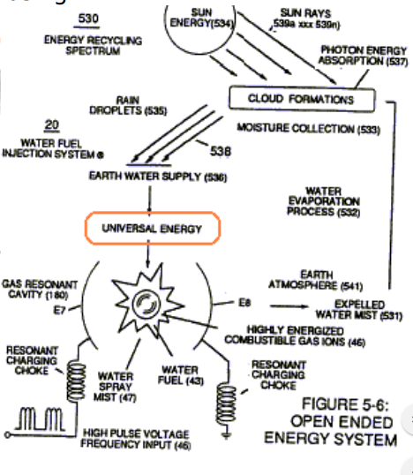

Depending on the outcome of water in nature the energy level changes as shown here. Stored and released..and re-charged like a battery.

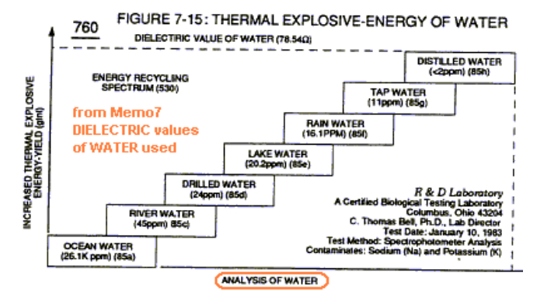

The observation of a “Thermal Cyclone” from Sun heat energy changes  are only one Energy input.  There’s a list of intra & inter – dimensional energies that work on atoms & molecules.  So, there are other ways to cause cyclonic action in water.  Meyers did this with the electrical force in a resonant state with water to release energy from the universal energy pathway in order to sustain covalent switch off of the oxygen to hydrogen bonds of the water molecule. A side effect of this process is cyclonic motion.

Microwaves input rotational energy into water causing spinning, friction, and heating. IR Energy heat & cyclonic motion.  There are many other ways to pass energy to water and it’s atoms in order to observe cyclonic motion.  The resonant stuff pulses.