Oslo, Berlin, Reykjavik, November 19th 2014:

The Chemistry in Contrails
Assessing the Impact of Aerosols
from Jet Fuel Impurities, Additives and Classified Military Operations on Nature
by
Harald Kautz-­‐Vella

I would like to thank all the people who have contributed to this study by gathering detailed information
about the single aspects of this big jigsaw puzzle.
Without their dedicated work this paper would not have been possible.

Special thanks to:

-­‐ Kristin Hauksdottir, who carried my soul through the first half of this research, made it grow with endless remarks and questions; and contributed chapters and knowledge where my own skills failed to deliver.
-­‐ to Cara St. Louis that revealed the transhumanistic background of the chemtrail-­‐agenda and handed me over a beautiful book to translate.
-­‐ Manuela Binieck, who has solved the mystery of the Morgellons disease with her photographic skills.
-­‐ to my partner, my family & friends who lived with the burden of all the negative things I attracted during the time I researched to the topic Black Goo.
-­‐ To M. Purdey, who lost his life due to his love for the truth

Abstract

The starting point of this study was to research damage occurring on crops in Norway in the year 2012. Chemical analysis of the crops as well as associated soil and rain samples showed relative high values in barium and strontium. Together with aluminum and titanium this is known to be the chemical fingerprint found when analyzing dying crops and trees in areas with frequently occurring persistent contrails. Thus this damage is often associated with aerosol spraying i.e. geo-­‐engineering as a possible source for the damage observed. However the total amounts of heavy metals measured in the samples were too low to explain the damage as the impact of intoxication by bio-­‐available metals i.e. metals in solution.
From the historic development of geo-­‐engineering techniques as well as from technologies utilized within the military domain the mixture of both amorphous and mono-­‐crystalline Al₂O₃ and mono-­‐crystalline (Ba, Sr_{x}) TiO₃ can be derived as the two most common compounds that should be in use. But these crystalline particles do not show up in standard chemical analysis, unless one uses hydro-­‐fluorine acid, which is hardly ever the case. Regarding the fact that these crystals can be manufactured on-­‐board in spray-­‐ pyrolysis within the jet engines, the widely measured fingerprint could be understood as the rejects of the Al₂O₃ production as well as the of the (Ba, Sr_{x}) TiO₃ nano-­‐particle production, or as deriving from additional chemicals that could not be identified yet.
The nano-­‐particles themselves may stay up in the atmosphere up to 18 months, but will eventually come down with rain. Due to their tiny size they can cross cell membranes of leafs and roots and enter the plant tissue. Beyond the known mechanisms of intoxication by bio-­‐available elements as observed and researched in the context of acid rain, this opens up a second set of mechanisms possibly leading to plant damage.
(Ba, Sr_{x}) TiO₃ nano-­‐crystals are non-­‐soluble and would thus accumulate both over the time and in the food chains. (Ba, Sr_{x}) TiO₃ has piezoelectric properties, the highest optical refractivity of all minerals known, cancels out UV-­‐light, and has the ability to up-­‐convert infrared to visible light, which leads to outstanding effects within non-­‐linear optical systems. When embedded in the plant tissue they very likely would affect plant growth by actively canceling out exactly the frequency of ultra weak biophotons exchanged between the DNAs, which is responsible for the regulation of cell division. The fibers of plant are known to perfectly conduct infrared. Kristalls that get inside these fibers would up-­‐convert any light that is transmitting information between the roots and the upper part f the plant. Additionally, these piezo-­‐electric nano-­‐crystals ionize when hit by terrestrial electromagnetic radiation. This should heavily interfere with the electric cell potential, making the plant vulnerable to the attacks of fungi. When found as mono-­‐crystalline nano-­‐ particles, also Al₂O₃ has some outstanding optical qualities, as well as an “informational” impact on biological systems. Thus both (Ba, Sr_{x}) TiO₃ and Al₂O₃ are reducing the ability of nature to self-­‐organize. These three theoretical derived mechanisms would exactly mirror the effects observed with plants: retarded plant growth, “burned” dots on the surface, death by fungus infections. Additionally, (Ba, Sr_{x}) TiO₃ and Al₂O₃ nano-­‐particles bio-­‐

accumulate in the food chain and show up in mammals and humans. Research has been found where they are suspected to play a key role in diseases related to the nervous system. For example, the “transmittable” agent in transmissible spongiform Encephalitis (TSE) has been identified as a (Ba, Sr_{x})TiO₃ nano-­‐crystal. i.e. Creutzfeldt Jakob which is the human form of this disease. These crystals recombine with organic compounds and become part of the nervous system – thus creating an interface between the nervous system and external electromagnetic fields.
Climate change and the urgency to lower the earths temperature has been used officially as a reason to look seriously into the topic of geo-­‐engineering. Actual execution of the program is denied. Behind this public discussion there is a broad spectrum of military applications already utilizing a piezoelectric particulate plasma, as well as applications connected to the intelligence community, utilizing the same plasma background to track and influence single individuals and possibly apply methods of collective mind-­‐control. These technologies used by the intelligence community involve synthetic biology as a part of self-­‐assembling nano-­‐machines that are able to form a technological interface to the human DNA light communication. These technologies have been developed as part of the transhumanistic agenda. The entire concept is referred to as smart dust. These technologies are widely marketed in the framework of “integrated geospatial intelligence solutions”.
Since there are so many indications that these military and intelligence programs are up and running without democratic influence, information about classified operations and organizations will be presented and discussed.

Detailed Summary

During the last few years there have been many reports from concerned citizens about a new type of damage occurring to plants that is different from the damage known from acid rain: Grass simply stops growing; trees drop their bark and die. It has been speculated that these damages could be caused by high values of aluminum, barium, strontium or titanium found in the chemical analysis of affected plant tissue, rainwater and soil-­‐samples. There has been an increasing suspicion and worry among people, of a possible link between these high metal findings and the increasingly frequent occurrence of persistent contrails.

In order to discuss the chemistry in contrails and its impact on nature one needs to distinguish between

-­‐ the impact of lead, sulfur and halogens from fuel impurities or additives in civil and military jet propellants,
-­‐ single, bio-­‐available ions to artificially create cloud formations as well as reflective particles released by intended geo-­‐engineering programs designed to combat climate change
-­‐ and the spraying of high-­‐tech aerosols for military and intelligence purposes.

In order to explore a possible link between one or more of these sources to retarded plant growth we decided to perform a chemical analysis on damaged grass (phleum pretense) and associated soil samples from the Oslo area. The results from this chemical analysis showed slightly elevated levels of barium and strontium in the grass, and an surplus of barium in soil exposed to rain in comparison to soil not exposed to rain, which makes it likely that the barium found in the ground partly comes from aerosols.

On one hand the link of retarded plant growth and elevated values of barium and strontium as reported by other environmental groups in connection with aerosol-­‐spraying could be confirmed. Regarding the mechanism of bio-­‐accumulation the content of heavy metals was in a range to be considered as being dangerous to mammals and humans. Still, compared to countrywide values and experience with heavy metal pollution from the early times of industrialization as well as the acid-­‐rain area in the 70s, the total values of aluminum, barium, strontium and titanium were in a range that had to be considered as not toxic enough as bio-­‐available elements to explain the damage observed at the plants themselves. Under the premises that there is a connection between the values in heavy metals found and the affection of plant growth the only solution was to look for non-­‐ soluble particles containing aluminum, barium, strontium and/or titanium that were affecting plant growth not due to their chemical, but due to their mechanical, electromagnetic or optical properties.

The method of chemical lab-­‐analysis we used did not reveal in which form the metals found were present, but there is a number of indications that make it very likely that a part of them might be brought in as aluminum oxide (Al₂O₃) and barium-­‐strontium-­‐titanate

(Ba, Sr_{x}) TiO₃.

-­‐ Al₂O₃ is mentioned as a reflective particle in the Welsbach patent as the main compound in climate engineering by aerosol spraying.
-­‐ US military sources mention besides Al₂O₃ also (Ba, Sr_{x}) TiO₃ piezo-­‐electric crystals to be in use as an aerosol for military purposes. This nano-­‐crystal could very likely be formed during the combustion process when various barium, strontium and titanium salts are added. At least one can state that the synthesis of (Ba, Sr_{x}) TiO₃ in spray pyrolysis at 750 deg. C, declining to 600 deg. C, like given in a jet engine, would highly resemble one established industrial production method of these nano-­‐ particles, called spray pyrolysis.

(Ba, Sr_{x}) TiO₃ has a melting point of 2000 deg C and is not soluble in water, thus it would not appear very soon as barium, strontium and titanium in bio-­‐available form, but does have electro-­‐physical properties that theoretically could lead to plant damage.

Once we were thinking about the topic of solubility, the question arose, whether these non-­‐soluble particles would show up in chemical analysis at all. Barium-­‐titanate is soluble
in sulfuric acid, strontium titanate only in hydro-­‐fluorine acid. Interviews with a number of institutes conducting heavy metal monitoring for state authorities revealed, that they all use nitric acid in their testing method, which would neither reveal barium-­‐titanate, nor strontium-­‐titanate, nor mono-­‐crystalline aluminum oxide. Amorphous Al₂O₃ would show up to a certain percentage only. This means that from the state side there is no reliable monitoring of these nano-­‐particles happening at all. Privately gathered values need to be co-­‐checked on the measurement-­‐method. Only analysis’ with hydro-­‐fluorine acid delivers valid results.

These nano-­‐crystals would be taken up by plants as a whole and would remain unaltered, and thus also would have the potential to bio-­‐accumulate. Embedded within the plant tissue these crystals will keep their intrinsic and electromagnetic properties. As an unintended side effect, this nano-­‐crystal is likely to cause retardation of plant growth when absorbed by plants following three possible different mechanisms:

- Plant growth may be inhibited due to interruption in cell communication. When hit, the (Ba, Sr_{x}) TiO₃ nano-­‐particles absorb 90% of the weak inter-­‐cellular UV signals, also known as biophotons, exactly on the wavelength responsible for cell division.
- The capillaries of plants, especially the fibers that build the trunk of trees, are ideal infrared-­‐conductors. It is very likely, that this is the way the root gets the information what kind of nutrition is needed in the crown. A second function could be the regulation of the temperature within the plant. The attendance of piezo-­‐crystals within the capillaries would up-­‐convert this IR-­‐light into the visible spectrum and disrupt the informational aspect of these signals.
- The electromagnetic cell potential in plants may be disturbed and set out of balance when (Ba, Sr_{x}) TiO₃ nano-­‐crystals within the plant tissue are hit by terrestrial EMF,

microwave or radar-­‐radiation. Due to the piezoelectric properties of (Ba, Sr_{x}) TiO₃ such radiation induces a change in the crystal-­‐geometry that releases free electrons. This would dis-­‐balance the cell potential. A balanced cell potential is fundamental for plant health and growth.
In addition to these possible damages done to plants single publications have been found that report on negative effects of aerosols like (Ba, Sr_{x}) TiO₃ on mammals and humans.
Two studies discuss the bio-­‐accumulation of these nano-­‐crystals in mammals and humans
that leads to a damage of the nervous system. The crystals attach to the sensory receptors and trigger them by releasing electrons and/or photons due to an external acoustic or electromagnetic impulse. According to these studies these piezo-­‐crystals attach to the receptor cells of the nervous system. There they are mantled by layers of organo-­‐metallic material, that interconnect the crystal with the nerve. Triggered by an external electromagnetic or acoustic stimulus, the receptor cell are enable to process these external stimuli. A third report anecdotally showed how the presence of something that was detected as containing barium on the surface of snow was associated to weakened bio-­‐ photon activity of humans, accompanied with symptoms of non-­‐treatable headache.

Taking this as a working-­‐hypotheses, the next step was to find out how much of these piezoelectric particles might be deposited to see if the total amount could be in a range of being of any danger to plants.

Of cause, a direct measurement is not possible. These particles are not soluble in acids and therefore do not show up in standard environmental monitoring. However it is possible to monitor heavy metal-­‐depositions. Assuming that the titanate-­‐synthesis in jet engines will be as accurate as in industrial processes and that there should be some excess metal that will be measurable in nature, it made sense to monitor the official data. From the metals contained in barium-­‐strontium-­‐titanate only barium has been sufficiently monitored by state authorities. The data from Germany covering the last 15 years show that the values of airborne barium referred to as dry deposition went down by 95%. This is accredited to improved industrial standards and reduced industrial exhaust. There is also a significant reduction seen in other heavy metals. Pollution deposited with rain is measured through the absorption of the pollutants in grass and referred to as wet deposition. This is a bit misleading because actually it covers both wet and dry deposition. During the same period, values for this composite wet and dry deposition of barium have been almost doubled.

Got measure absolute values it makes sense to directly measure the content of barium in Rainwater. For the year 2012 the data gathered from private rain samples directly reveal an average of 0.003 mg barium per liter from which one can calculate a wet deposition of 865 t of Barium on the German territory per year – this value is supported by the data of the state authorities for wet deposition, last published for the years 2009-­‐2011. Being specifically bound to rain, the detected barium must be considered as originating from aerosols of unknown origin, since industry and mining can be canceled out as sources.

As mentioned, this is barium showing up on testing methods involving nitric acid. The amounts of nano-­‐particles deposited can only be estimated based on these measurements.

Estimating an affectivity of 85% for the nano-­‐particle synthesis this would hint to a total of 4901 tons barium, or 14.873 t of (Ba_{0.5}, Sr_{0.5}) TiO₃ that are deposited but not detected by the state run heavy metal monitoring. Besides (Ba_{0.5}, Sr_{0.5}) TiO₃ also (Ba_{0.25}, Sr_{0.75})TiO₃ is a widely used formula. In this case the total values estimated would need to be doubled.

Official values from Germany as an industrialized country in the middle of the continent were compared to values collected by the State Veterinary Institute in the less populated Norway. Total values in Norway were in average about 4 times higher than the ones measured in the German grass samples, but it turned out that in Norway a big part of these metals are from natural sources. High values of barium found in Norway are mainly associated to the uptake of dust from barium-­‐rich soils; strontium is associated to the uptake from salts from the Atlantic. The chemical analysis of moss done to gather the values does not distinguish between natural barium compounds and artificial barium compounds. Again, barium-­‐strontium-­‐titanate nano-­‐crystals would not show up at all.
These results hint again to non-­‐toxic levels of barium compounds as bio-­‐available metals, however the data were of no value to detect the total amounts of nano-­‐crystals deposited in Norway.

Concerning the impact of these nano-­‐crystals on mammals and humans we reviewed a few papers and scientific lectures published to this topic. Especially the contribution of M. Purdey strongly hints to the fact, that these nano-­‐crystals create an interface to the nervous system. He discovered this while he was doing extensive research on TSE and Creuzfeldt Jakob, the human form of this disease.

Once dealing with aerosols sprayed for military purposes we felt the need to look into a second topic, referred to as the Morgellons disease. It turned out that the same nano-­‐ particulate plasma utilized by the military community, that leads to the negative effects on plant growth, is also part of a program run by the intelligence community involving synthetic biology and self assembling nano-­‐machines as part of a system to track and influence civilians. The entities involved can be found when one looks for the term “Integrated Geospatial Intelligence Solutions”. Due to the existence of the Morgellons disease, which is nothing else than the explosive spreading of this synthetic biology within single individuals, who’s immune system is unable to handle the growth, the documentation and the proof of the existence of this program seems much easier than the proof of the particulate plasma. The components of this artificial biology could be described from air samples, from the lesions of Morgellon victims as well as from the scientific papers of the official transhumanistic research, that precisely describes how the system works. Observation of components of this transhumanistic technology showed that the controlling signals are transmitted, i.e. that this system that is designed to influence the DNA-­‐light communication – thus controlling all aspects of human life – is in action.

Due to the fact that there is a partly irrational discussion going on around the term “chemtrails”, we felt the need to add a chapter about the political aspects of geo-­‐ engineering. This chapter both tells a brief history of geo-­‐engineering and analyzes the layers of belief systems the entire topic is surrounded by in the public reception. The crossing lines of these two ways of approaching the topic of geo-­‐engineering hopefully will

help to free the numbers in the scientific part of this study from belief systems like stating that “there is no geo-­‐engineering done at all” or “just on an small experimental scale”.

Besides the officially announced state-­‐run programs heading into the direction of geo-­‐ engineering, we monitor a number of companies who are involved in the network conducting the recent activities discussed in this paper: apart from the driving forces CIA and US-­‐Navy intelligence with no information available to the public, we monitored the private company Raytheon being responsible for HAARP Alaska, the production of radar, microwave and ELF transmitters as well as for laser weapon systems and satellite based aerosol monitoring as part of the star wars program. In the civil domain the company is into flight control and weather forecast. Also, Raytheon was for a few years into aircraft manufacturing of airplanes specialized on aerosol spraying.

Smoking gun evidence recorded via satellite lead to the Marion Island Meteorological station, that turned out to be involved in privately funded, South Africa-­‐state-­‐run scalar wave applications very likely used to ionizes the local aerosol layers, to turn them into a controllable plasma.

We have found no published peer-­‐reviewed research on the effect of (Ba, Sr_{x}) TiO₃ and of mono-­‐crystalline Al₂O₃ on plants, mammals and humans. Equipment and infrastructure to implement these technologies even on large(r) scale is already in place.

We urge for proper research on the impact of aerosols on plant growth, microorganisms, plankton, insects, and animals under controlled lab conditions. Aerosols need to be found safe for every aspect of our biosphere before they are released into nature. We urge for a full scale publication of all military and intelligence technologies and would like to see them back under democratic control.

As to the Morgellons disease, despite – according to different sources – up to 300.000 registered victims, this disease is officially declared to be “delusional parasitizes”. This statement is a slap in the face of the people who suffer, who dye of a disease that can be shown and verified under any simple microscope, and this clearly proofs the involvement and guilt of state authorities, that obviously went far beyond any democratic control.

We urge for proper research of damage done by transhumanistic technologies that have been released onto mankind without knowledge and agreement of the victims, and call for investigations regarding the violation of the Nueremberg Treaty, of not into bio-­‐terrorism.

CONTENT
1. Introduction ……………………………….………………………………………………….….. 10
- Direct toxicity, synergistic effects of toxic elements,
subsequent damage in the ground………………………….…………………………… 13
2.1. Back-­‐engineering JP-­‐8…………………………………………………………... 15
  - Nano Particles from special military applications ……..…….……… 19
  - Understanding particle sizes…………………………………………………… 21
  - Chemical vs. electro-­‐physical effects
of barium-­‐strontium-­‐titanate………………………..……………………….. 21
- Scientific background to electro-­‐optical effects …….……………………………... 22
3.1. Non-­‐linear optics………………………………………………………………..….. 22
3.2. Biophotons………………………………………………………………………….... 25
3.3. Optical properties of nano-­‐crystals……………………………………….... 28
- Nano-­‐Toxicology… 29
  - Damage related to barium-­‐strontium-­‐titanate 40
4.1.1 Effects on plants… 32
    - Effects on plankton 34
    - Setting the electromagnetic cell potential
of plants out of balance 34
    - Effects on mammals and humans… 35
  - Damage related to aluminum oxide 40
5. Optical Analysis …………..……………………………………................................... 45
  - Trans-­‐humanistic technologies I – Extracellular Systems… 46
  - Microscopic analysis of nano-­‐particles…………………………………... 55
- Trans-­‐humanistic technologies II – Intracellular System 59
- Quantitative Analysis… 61
  - Atmospheric barium deposits in Germany 61
  - Research in Norway 63
- Politics, infrastructure and possible military use 70
- Project “Cloverleaf”… 75
  - Military purpose 75
  - Involvement of civil airlines… 77
  - Organizations involved 80
  - Evidence for the validity of some unconfirmed information 85
  - Dismantling the cover story 86
  - Organizational patterns… 91
- Are we terra-­‐forming ourselves
or are we terra-­‐formed by an alien species?………….…………………………….…... 96
- Actual development 105
- Open letter… 107
External data… 110

Introduction

-­‐ to the term geo-­‐engineering
The topic of geo-­‐engineering has three aspects that need to be first differentiated before we can look at how they are historically interwoven:

  - There has been an ongoing development of jet propellants and their additives by the US-­‐air force and the NATO. The chemistry of the additives currently in use is classified information – some of the additives have been identified by civil-­‐right-­‐ initiatives and private researchers as 1,2-­‐dibrom ethan (EDB), perfluoroctane sulfon acid (PFOS), perfluor octane acid (PFOA) and lead tetraethyl. These additives contain fluorine, sulfur and brome and must be regarded as an important source of the aerosols H₂SO₄, HF, HBrO₃, which lead to persistent contrails1. These additives are highly toxic contact poisons and are suspected to be responsible for multiple-­‐ chemical-­‐sensitivity (MCS) and the gulf-­‐war-­‐syndrome (GWS).
  - There is an official line of research that mainly evaluates options of climate engineering to combat global warming. This research processes huge amounts of money but officially projects all “practical applications” into the future. It claims to conduct “small experimental programs” only. It mainly propagates sulfur oxide and reflective particles like Al₂O₃ flitters as possible aerosols.
  - There is a strong involvement of the US military in the development of both geo-­‐
engineering in the classical meaning and advanced military applications involving piezoelectric nano-­‐particles ((Ba, Sr_{x}) TiO₃) and mono-­‐crystalline aluminum-­‐oxide varieties for 3D battlefield monitoring, radar-­‐range-­‐enhancement and advanced defense and weapon systems, including the star wars program. There are similar programs run by the intelligence community.

In the jet fuel development the main aim is to adopt the jet fuel to the low temperatures at high altitudes, to adjust the point of ignition to the engine technology and to lower the consumption as much as possible.

The geo-­‐engineering idea roots back to WWII with German scientists which after the end of the war were taken over by US military to do research mainly in the framework of the Project ‘Paperclip’ that transferred about 10.000 German top scientists to the US intelligence community. The official aim of geo-­‐engineering is weather manipulation to protect the agriculture and civil society, although on scientific level from the very beginning ideas like melting the poles to get access to natural resources played a major role2.

The main military applications today seem to depend on nano-­‐size piezo-­‐crystals creating a controllable plasma background for 3D radar monitoring as well as a plasma layer for

1 PATRICK MINNIS, J. KIRK AYERS, RABINDRA PALIKONDA, AND DUNG PHAN: Contrails, Cirrus Trends, and Climate.
Atmospheric Sciences, NASA Langley Research Center, Hampton, Virginia.
2 Derived from private discussions with people who had family members involved in these research programs.

advanced applications like weather manipulation, earth quake weapons and, when combined with satellite based laser technology, the star wars program. The idea to create an artificial plasma layer very likely popped up after successful research on weather manipulation by the HAARP device in Alaska and other HAARP-­‐like transmitters, utilizing the natural ionosphere as a controllable plasma layer. From this point the idea to create a artificial plasma layer at lower altitudes than the ionosphere was not very far out.

In the US the borders between governmental research, military research and applications, the activities of the intelligence community and university-­‐ and company based research and applications are difficult to define. In this financially interwoven network a growing number of whistle blowers are drawing attention to a classified project “Cloverleaf”. It is supposed to serve military-­‐, agency-­‐ and governmental and privately-­‐owned-­‐company-­‐ aims by spraying large amounts of aluminum and titanium based aerosols using the infrastructure of the CIA, NASA and the US-­‐Navy as well as civil airplanes altered for additional spraying.

However approaching the topic from this angle at this point of this paper would lead to discussions involving belief systems. This will be discussed in greater detail in the last chapter, for now we just want to mention one of these whistle blowers, the person who is known as the inventor of the titanium-­‐based aerosol system. Since the 1980s Jim Phelps from the Oak Ridge laboratories in the USA had researched the impact of aerosols from airplanes on nature and climate and had found out that jet-­‐fuel-­‐impurities and additives were responsible for the following:

- the loss of ozone at the poles due to fluorine-­‐compounds
- global dimming due to persistent contrails and enhanced formation of cirrus-­‐clouds
- global warming, because these cirrus-­‐clouds hold back infrared radiation from the ground and
- growing problems with toxic flour-­‐aluminum compounds forming in the soils.

In 1996 Phelps suggested solving 3 of these problems by adding titanium oxide, which forms less toxic compounds than aluminum, to the jet fuel. This concept was meant to prevent the ozone loss and the forming of toxic flour-­‐aluminum compounds by binding the fluorine to titanium-­‐oxide already in the sky, and additionally reduce global warming by seeding reflective particles, that would block even more sunlight and let through infrared from the ground. Additionally, when combined with Barium and Strontium, these piezzo-­‐ crystals photo-­‐ionize, thus they block sunlight during daytime and let through infrared during the night. Jim Phelps today openly accuses the US military as well as the intelligence community to abuse his invention, which was meant to solve jet fuel related environmental problems.

-­‐ to the damage on plants

There have been many reports from concerned citizens about a new type of damage occurring with plants. It is different from the known damage by acid rain in the 1970s, where large areas of spruce forests died in Germany. The symptoms observed back then

were first the dying of the tiny roots of the trees after suffering from heavy metal poisoning, followed by a loss of the needles and the death of the tree. Now grass is reported to simply stop growing, trees to drop their bark and die. It has been speculated that these damages could be associated with the increasing occurrence of persistent contrails on one hand, and presumably linked to the high values of aluminum, barium, strontium and titanium found in chemical analysis of plants tissue, rainwater and soil-­‐ samples on the other hand.

During the year 2012 we were confronted with the problems of a number of Norwegian farmers who lost parts of the second harvest of hay. Additionally, the increased appearance of striped clouds was a cause for unease. These clouds appeared in the morning and eventually in the afternoon covered the normally blue summer sky with a milky haze at a high altitude. One of the farmers associated the drizzle falling later on such days to damage done to tomato-­‐plants and lettuce. The farmers, who had taken chemical analysis of rain samples and the grass retarded in growth, asked for help interpreting their lab results.

-­‐ to our scientific approach
Our starting point was the worry that aerosols could disturb plant growth to an extent where it affects the harvests and thus the livelihood of mankind. At the same time, we were aware that the topic of geo-­‐engineering, also referred to as chemtrails, was controversial and caused heated discussions. From the information available in public, it was hard to get a picture of what was actually happening. In this context we felt the need to search for consistent information, and to check the theories against scientific data. This meant in detail: to find out if high atmospheric spraying is already taking place, if yes which aerosols are in use and how big the amounts actually sprayed might be. The second task would be to find out in what way these aerosols might affect plant growth to explain the damage observed.
The only anomalies showing in the results near Oslo concerned high aluminum in rainwater samples, increased barium in soil exposed to rain. Strontium and titanium were present within the countrywide average. These are elements discussed as parts of aerosols used for military purposes. The measured amounts of the elements themselves had to be regarded as chemically non-­‐toxic to plants. We therefor took a closer look into the patents and papers involving these methods to see if there could be some overseen mechanisms affecting plant growth. It became clear that the optical and electro-­‐physical properties of these nano-­‐crystals could be essential in understanding how plant growth can be severely affected by these aerosols.

A six-­‐fold line of research has been undertaken to examine the possibility of a relationship between slowed plant growth and deposition of aerosols released by airplanes for military purposes and eventually for purposes of geo-­‐engineering

- Going through the patents and papers about aerosols for geo-­‐engineering, the patents of aerosols for military purposes and the normal jet-­‐fuel and jet-­‐fuel

additive-­‐chemistry in order to see what substances to look for, and look for research proving their safety.
- Review research on plant communication and growth.
- Discussing the physical properties of aerosols regarding possible mechanisms that could damage plants.
- Analyzing samples of grass with reduced growth and of the earth underneath to define what part of the findings could have an aerial source.
- Reviewing official data of wet and dry deposition of heavy metals.
- Look at the operational and political aspects of aerosol-­‐spraying.

In the following chapters we will first summarize some scientific background knowledge about toxicology in general and discuss the additives used in Jet Propellant 8, the Jet fuel used by US army and NATO forces. Additionally we used the only available original paper on “chemtrails”, to understand the basic mechanisms of this technology and name some of the compounds that might be involved today. This paper is the course material for a course in chemtrail-­‐chemistry at the US Air Force Academy dating back to the year 1990.

As a second topic we will summarize some background information about biophoton-­‐ research and the non-­‐linear optical properties of (Ba, Sr_{x}) TiO₃ nano-­‐crystals. Against this background we will discuss possible mechanisms of damage that (Ba, Sr_{x}) TiO₃ nano-­‐ crystals cause to nature. These effects will be discussed regarding plant growth, marine life and possible effects on mammals and humans. Following this theoretical part we will review the data available of barium, strontium, and titanium depositions in Germany and Norway over the period of the last 15 years and try to distinguish between industrial pollution, natural deposits and other aerosol deposits. To backup the scientific finding we will then again look at historical and political aspects to evaluate the probability of our data.

Direct toxicity, synergistic effects of toxic elements, subsequent damage in the ground
The entire topic of toxicity is rather complex. We start by taking a look at some basic principles:

-­‐ The level defining toxicity

Plants and all living beings need most metals in minute amounts to be healthy. In a way, nature on the continents is still addicted to the statistic distribution of rare metals as found in sea water, where we all came from, and is trying to stabilize this statistical pattern in the chemistry of the cell water. The metals we need, can be absorbed in so called bio-­‐available form, in solution as cations, or from organic decay products as organic complexes. Up to certain levels higher amounts of metals will be tolerated by the plant or living being without any harm done. Above these levels the metals will cause damage and function as a toxin.

-­‐ Lead and Mercury

To this rule there are two exceptions: lead and mercury. Neither lead nor mercury is good for any living being. They are toxic already in the minutest level, cause serious damage with higher levels and are eventually lethal. The tolerance for lead varies between plants and mammals. Plants tolerate more than mammals.

-­‐ The compound defining toxicity

Metals can be present in nature in many forms. Due to their structure and reactivity they can react with other elements and form many different compounds. The same metal can be toxic in one compound and neutral in another compound. For example the uptake of aluminum can happen in form of 200 different known compounds, from which especially the fluorine-­‐compounds are known to be highly toxic, while both fluorine and aluminum can appear in compounds that are less toxic than the direct combination of both.

-­‐ Synergy of metals can manifold the toxic and lethal effect

Toxicity does not always add up the way one would expect. Sometimes the combination of two toxins multiplies in an extraordinary way. The following experiment shows this synergistic effect clearly: 1/20 of a lethal dose of lead (Pb2+) that kills 1 of 100 mice, was combined with 1/20 of the lethal dose of mercury (Hg2+) that also kills 1 of 100 mice. The combination did not kill 2 mice, but all 100 of 100 mice.3

-­‐ Complex synergies caused by lack of other essential minerals

A second type of synergistic effect occurs when there is a lack of an essential element with similar atomic structure. Strontium, which is regarded as non-­‐toxic4 to humans, is even given as a medicine to strengthen bones. However if the body suffers from a lack of calcium5, the uptake of strontium can lead to bone deformation.

-­‐ Magnitudes of released toxins – nature vs. man made

To get a feeling for what is normal in nature and what is man made we will look at general amounts of pollution, with the example lead. There is a natural worldwide pollution by volcanoes and bush & forest fires that amounts to 19.000 tons lead per year set free into the atmosphere. The amount of lead released by the burning of coal and fuel in the early industrial period exceeded this natural amount by more than 100 fold. Up to the 1960s these amounts were mostly blown into the atmosphere via high chimneys, without

3 Boyd E. Haley: "Mercury toxicity: Genetic susceptibility and synergistic effects", p. 537
4 First draft Peter Watts; Paul Howe: England. Concise International Chemical Assessment Document 77: STRONTIUM AND STRONTIUM COMPOUNDS. WHO publication
5 Lara Pizzorno: The Truth about Strontium Supplements, Side Effects, DEXA Results, Efficancy and More. Online at: http://www.algaecal.com/Blog/the-­‐truth-­‐about-­‐strontium-­‐supplements-­‐side-­‐effects-­‐dexa-­‐results-­‐efficacy-­‐and-­‐ more/11333 on Jan. 3rd 2013.

filtering units. Since then at least in the US and Europe filtering technologies have been introduced that reduce the output – comparing the early 80s to today – by an average of 95%.

-­‐ Direct metal pollution vs. secondary release of metals via acid rain

If one compares the content of heavy metals against the content of sulfur and halogens in coal and oil derivatives, one finds that sulfur and halogen concentrations are far higher than concentrations of metals. Coal of bad quality can contain up to 3% sulfur, while the heavy metal content might be in the range of a few mg/kg. 1 mg/kg equals 0,0001%.

The sulfur and the halogen compounds released by burning will connect with water droplets and result in acid rain. Following the forest decline in Germany in the 1970s the mechanisms of damage by acid rain have been thoroughly studied. The main consequence is that the acidity brings SiO₂ in the soil into solution, and thus releases metals into bio-­‐ available forms that used to be bound to the SiO₂. This can affect soils as well as rivers. In soils this leads to a dying of the tiny roots of trees. In rivers these released metals, mainly aluminum, caused death of fish.

Looking at total values, this means that when sulfur and halogens are turning into acid rain they can release about their molar equivalent of metals once getting into the ground. Thus the amount of metals released by acids can by magnitudes higher than the amount of metals directly released by the same amount of fuel. Thus the first thing to have a look at when talking about heavy metal intoxication with bio-­‐available metals is the quality of the jet fuel itself regarding sulfur and halogens. Among the different known fuel types especially one draws attention: Jet Propellant 8. It is the fuel used by the US air force and the NATO and is also about to enter the market for civil air traffic.

Back-­‐engineering JP-­‐8

The aim of the US military was to have one fuel for all purposes: to fuel the kitchen stove to cook a meal in the army camp, to run the jeep, the tank, helicopters and airplanes. It should be possible to use the same fuel no matter if the action was happening in the arctic, the desert or at altitudes of 40 000 feet. A second aim was to have a fuel that in the situation of combat would not ignite so easily when one was attacked. A third aim was to have this fuel available commercially – which reduces the internal logistics. This resulted in what is called Jet Propellant 8. The so-­‐called JP-­‐8 is identical with normal Jet-­‐Fuel Jet-­‐A1, except of 0,02% additives.

The chemical formulas of the additives used in JP-­‐8 are classified.

However, it is possible to deduct some of its content from the information available.6 The military turbo prop transporters run their engines on a compression of 25 bar. This demands fuel with lead tetra ethyl, as unleaded fuel would already explode at a compression of 20 bar. As a second additive leaded fuel needs dibrom or dichlor ethan7. Up to the early 80s lead and halogens were used in car fuel in much lower concentrations. The exhaust from cars in this period resulted in levels of lead in the air causing widespread health damages. Due to the high toxicity of lead it became forbidden to use it as an additive to fuel.

Due to this toxicity the military developed a system where higher amounts of these poisonous additives would be added in situations of high risk only: whether it was when refilling airplanes in the air or being in combat, in certain situations the fuel needed to be less explosive8.

It is known that during the first Iraq war the US airplanes added 25 liters of halogen based additives to the fuel at each tank filling in order to lower the flame point. Depending on the size of the plane this equaled 2-­‐5% of the total fuel consumption. It is not known how often nor under what conditions these extra-­‐additives are used during times of peace.

To have these additives fast and equally distributed when injected it needs a tenside that is already contained in every regular tank filling: perfluoroctane sulfonacid (PFOS) and/or perfluoroctane acid (PFOA) would be solutions to this task. PFOS and PFOA are among the most toxic chemicals known.

Both PFOS and PFOA nowadays happen to appear in nature and in the blood of humans. To convey a sense of the size of the problem we refer to the study “Survey of PFOS, PFOA and other perfluoroalkyl and polyfluoroalkyl substances” by Carsten Lassen, et al9. The paper is Part of the LOUS-­‐review from November 27th 2012. There is a Version for Public Consultation available. Values of lead were measured in the soil near to US-­‐military airports and reached up to 1.767 mg/kg. 30-­‐40 mg/kg was the average countrywide pollution at the time of measurement.10 Thus this back-­‐engineering of JP-­‐8 seems to make sense.
World production of JP-­‐8 was back in the year 2000 already at 4.5 billion gallons (17 billion liters) per annum. Assuming these additives were used in high dilution (0,02%), the amount burned together with JP-­‐8 back in 2000 amounted to 3.4 million liters concentrated poisonous liquids. The measured pollution at the ground might come from

6 Marion Hahn: Umweltkrank durch NATO-­‐Treibstoff? Neues zu einer umstrittenen Theorie. umwelt·medizin·gesellschaft
| 16 | 4/2003
7 Marion Hahn: Umweltkrank durch NATO-­‐Treibstoff? Neues zu einer umstrittenen Theorie. umwelt·medizin·gesellschaft
| 16 | 4/2003
8 Air Force Times 18.1.1999
9 Carsten Lassen, Allan Astrup Jensen, Alexander Potrykus, Frans Christensen, Jesper Kjølholt, Christian Nyander Jeppesen: “Survey of PFOS, PFOA and other perfluoroalkyl and polyfluoroalkyl substances”. Danish Ministry of the Environment. Environmental Protection Agency.
10 Marion Hahn: Umweltkrank durch NATO-­‐Treibstoff? Neues zu einer umstrittenen Theorie.

burning residues as well as from the release of un-­‐burned fuel when taking up fuel in the air, where the last pipe filling is lost after disconnecting, or when intentionally releasing fuel from the tanks for security reasons before landing.

In addition lead and halogens are added (2-­‐5%) in combat, eventually combat simulations or maneuvers like refilling during the flight11. The total amount is unknown, however this technique is increasing the output by the factor 100 to 250 when applied, depending on plane size.

The cocktail of EDB, PFOS, PFOA and lead tetra ethyl is known to have synergistic poisonous effects on mammals and humans, probably leading to the gulf war syndrome (GWS) and multiple chemical sensitivity (MCS). These additives are also associated to the depletion of the immune system and reduced fertility.

Following this “back-­‐engineering of JP-­‐8, there are a number of compounds released into nature by exhaust from airplanes:

- From the burning of the fuel itself (CO₂ and NO_{x} forming H₂CO₃, H₃NO₄),
- the burning of fuel impurities (mainly SO₂ forming H₂SO₄)
- and the burning of fuel additives (forming H₂SO₄, HF, HBrO₃, PbO).
- If the burning process is not fully happening we eventually will have to look at additive residues (dibrom ethan (EDB), perfluoroctane sulfonacid (PFOS), perfluoroctane acid (PFOA)).
- The acids, H₂CO₃, H₃NO₄, H₂SO₄ and HF are of great concern as they set free secondary toxic compounds when they are absorbed in the ground, following the mechanisms referred to as acid rain.

All sulfur and halogen compounds burned with the jet fuel act as aerosols leading to persistent contrails and increasing the appearance of cirrus clouds. Due to the fact that this phenomenology is regarded as contrails in the public discussion it becomes obvious that the distribution of nano-­‐particles for geo-­‐engineering and/or for military purposes might be hiding within these sulfur-­‐ and halogen induced haze.

According to an longer interview with an employee of the German military the entire organization of the jet fuel supply within the NATO forces is aimed to serve the key role of JP-­‐8, i.e. the three different JP-­‐8-­‐classes with their classified components. Everything is organized in a way that JP-­‐8 is used without having people asking questions about the ingredients. Apparently the chemistry of JP-­‐8 does not seem to be what it is claimed to be: dirty diesel of low quality. According to the former employee of the German Air Force we interviewed, JP-­‐8 is burning much faster then both kerosene or diesel fuel, smells different and extracts the oil from the skin when being in direct contact, leaving the skin completely white. Additionally it causes heavy headaches when breathed in.

11 Marion Hahn: Umweltkrank durch NATO-­‐Treibstoff? Neues zu einer umstrittenen Theorie

During the Gulf war JP-­‐8 has been used to hide the US troops following the first row of tanks in clouds of smoke by evaporating the fuel on the hot exhaust pipes of the tanks. This has been suspected to be the most important cause of the so-­‐called gulf war syndrome when it comes to US soldiers.

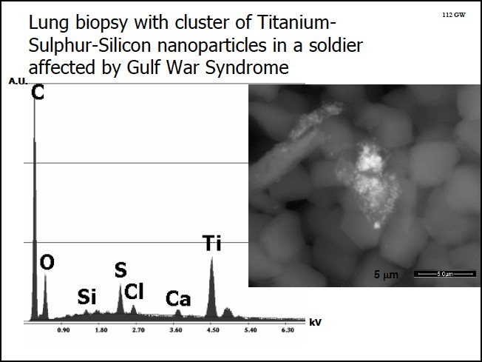

Picture and analysis taken from the lung biopsy of a gulf war veteran.

Besides the carbon-­‐black from the smoke Analysis of the particles in the lung tissue of a soldier effected by the gulf war syndrome shows sulfur, titanium and oxygen. Like the interview with the German military employee this hints to the possibility that the metal salts for the nano-­‐particle production within jet engines that is going to be discussed in the next chapter are part of the JP-­‐8 additives.

Nano-­‐particles from special military applications
In the year 1990 the U.S. Air Force Academy, Department of Chemistry, created a script for the chemtrail class, including the examination-­‐forms. This script is available to the general public on microfiche. Of cause this script does not provide the precise formulas used in chemtrailing, but the combination of basic knowledge, the chemical reactions taught and repeated and asked for in the exams, give a rather clear picture of the chemical processes the students are trained to get creative on.

The script names HCl, NH₄OH, and NaOH, KMnO₄, Al(NO₃)₂, Ba(NO₃)₂, Cu(NO₃)₂, Fe(NO₃)₃, FeSO₄, Pb(NO₃)₂, Mn(NO₃)₂, AgNO₃, Na₂CO₃, NaCl, NaI & NaNO₃12 as metal salts to be added to the combustion process. The script discusses the oxidation and reduction in the burning process and the examination forms ask for the possible interaction of these metal salts, when following the rules of chemistry during the combustion process. This is what in civil industry is called spray pyrolysis. Further it separately discusses the possible reaction with halogen acids, especially HBr, apparently being an outcome of the combustion of JP-­‐8. The goal of spray pyrolysis is to create defined nano-­‐particles. The injection of the compounds mentioned in the manuscript into jet engines will lead to the production of nano-­‐particles with an unknown range of properties formed as a result of the pyrolysis of the metals and metal oxides during the combustion process.

Another topic that is part of the chemtrail-­‐script is the polymerization of nylon and electrolytic coating of surfaces with thin metal layers. This corresponds with findings of aluminum coated nano-­‐nylon fibers in rain samples that have been reported by many concerned citizens taking and analyzing rain samples. In the military language these fibers are referred to as spoofer sprays.

Including nylon based fibers into the overall concept shows that already back then two different distribution systems must have been established, pyrolysis in the jet engines and spraying through extra nozzles, because substances like nylon cannot stand temperatures higher than 250 deg. C.

It needs to be stated at this point, that the script is from 1990 and it is not possible to say precisely in what way the technology has been further developed, and from this script only it is also not possible to say to what extend the technologies described have been applied. The titanium-­‐based method to bind fluoride introduced by Phelbs six years later, in 1996, obviously is not yet part of that script, just like the development of titanium based nano-­‐

12 Chemtrails. Chemistry 131 Manual Fall 1990, Department of Chemistry, U.S. Air Force Academy. See also: Kammler, Hendrik K.; Mädler, Lutz; Pratsinis, Sotiris E.: Flame Pyrolysis of Nanoparticles. WILEY-­‐VCH. Chem. Eng. Technol. 24 (2001) 6. See also: M. Enhessari, A. Parviz1 K. Ozaee, H. Habibi Abyaneh: Synthesis and characterization of barium strontium titanate (BST) micro/nanostructures prepared by improved methods. Int.J.Nano Dim.2(2): 85-­‐103, Autumn 2011

crystals formed during the pyrolysis as intelligent ionizable particles that can be controlled by radio-­‐transmitters.

To get an idea of the state of the art we assume that according to the method introduced by Phelbs Titanium is added to the set of chemicals in use, and that the pyrolysis must meet the conditions within a normal jet engine.

Spray pyrolysis is a promising technique for producing various materials in a wide range of composition, size and morphology. Powders and films can be successfully prepared. The powders characterization confirms that powders are composed of spherical submicronic particles with internal nano-­‐crystalline structure. Spray pyrolysis involves passing an aerosol of a precursor solution through a graded temperature reactor, in which the individual droplets are thermally decomposed to form the oxide particles. In this work, the precursor solution for BST (Ba_{0.8}Sr_{0.2}TiO₃) was prepared starting from titanium citrate, barium acetate and strontium acetate. Stoichiometric amount of strontium and barium acetate were dissolved in water and two solutions were mixed together. (…) To obtain dense particles, without carbonate, it was necessary to optimize temperature and heating rate of thermal treatment (temperature at the first chamber of the furnace, 750 °C; temperature at the second chamber of the furnace, 600 °C). The powder mixture was prepared from
47.95 wt.% of BST and 52.05 wt.% of SiO₂. Results of X-­‐ray diffraction analysis showed that almost single phase BST powder, with traces of (…) was obtained under the optimal processing conditions.

The script from 1990 only mentions NO3 as an anion associated to the metal input. Recent sources report that methane is used to introduce the metal salts into the combustion process. Regarding this, one might assume that the formula recently used is based on titanium-­‐citrate, barium-­‐acetate (C4H6BaO4) or strontium-­‐acetate (C4H6SrO4). If this is not connected to the medium used for the dispersion it could as well be barium nitrate (Ba(NO₃)₂) and strontium nitrate (Sr(NO₃)₂) instead, as it has been in 1990. Of cause, other metals like iron or lead can be in use to dote the resulting crystals for special applications.

As it looks like there are two different methods of spray pyrolysis: Infrasound dispersion of water-­‐soluted salts and the use of methane based additives that are mixed with the jet fuel before use. Maybe the NO₃-­‐system relates to the water based pyrolysis and the methane-­‐based system to the additive-­‐system used in military context.

Besides (Ba, Sr_{x}) TiO₃ also Al₂O₃ can be created in spray pyrolysis. However within the temperature range of a jet engine in normal flight the nano-­‐particles should come out in an amorphous structure. To achieve a mono-­‐crystalline quality it needs temperatures in the range of 1700 deg. C, that are present in normal jet engines only in the starting phase. In military applications the temperatures needed to melt and recrystallize aluminum-­‐oxide should be achieved in rocket and afterburner technologies. This technology seems to be standardized: Afterburner and rocket-­‐propulsion requires so-­‐called Aluminum-­‐fuels.
Additionally aluminum oxide crystals can be doted with other metals during the process of creation to achieve defined qualities. Dotation with for example chrome would create ruby nano-­‐crystals, dotation with iron and titanium would lead to the creation of sapphires.
Sapphires for example are known to be non-­‐soluble in all acids, which could be a desired attribute for particles that are meant to be stable in nature for a long time.

Understanding particle sizes
The understanding of what is possible especially with nano-­‐crystals has not yet reached the general public.
To convey a sense of what actually is possible we calculated the values for the aerosol barium-­‐strontium-­‐titanate with a particle size of 10nm. This aerosol is already in military use but also is in discussion for civil geo-­‐engineering to combat climate change as a separating agent to prevent aluminum-­‐oxide-­‐flitters to agglutinate. 1 gram of these (Ba, Sr_{x}) TiO₃ nano-­‐crystals has the amazingly large surface of 2500 square meters. It is possible to spread these nano-­‐crystals so unbelievable thin that 1gram can totally seal 685 square meters. 300 tons would be enough to cover a country of the size of Germany with a optically sealed one particle thick layer.
When it comes to the measurement of particles and the metals they contain after being released to nature one faces a few difficulties: The measurements refer to the basic elements detected in chemical analysis, not to different compounds. Additionally one has to choose whether to have only bio-­‐available metals measured, which is metal elements in watery solution, or if one wants to detect all metal present. The latter analysis does not show if the compounds the metal comes from is already in solution, is soluble but still solid, or if a detected metal is part of a non-­‐soluble nano-­‐crystal or particle. The result from a lab analysis therefore delivers a limited knowledge of the chemical toxicity the plant, soil, microorganisms and other living beings are exposed to. Additionally the values given can lack precision. If the matter analyzed contained crystals not soluble in nitric acid or fluorine acid, depending on the analytical method used, the content of these crystals will not show in the values delivered by the labs.

Such an analysis will to a certain degree indicate the degree of pollution, especially when comparisons are made between exposures of different places or over a long time-­‐span.
One cannot read possible toxic synergies directly from this type of data nor can the mechanical and optical qualities of crystals be detected.

Chemical vs. elector-­‐physical effects of barium-­‐strontium-­‐titanate
When it comes to heavy metals connected to geo-­‐engineering, especially barium, strontium and titanium, the first logical reaction would be to say that even if considerable amounts would be sprayed today, it would still be minute compared to levels of industrial pollution in the late 1960s, early 70s, when filtering technologies were not applied in coal and oil power plants, and that it would be minute to the levels of heavy metals released in the ground by acid rain.

This might be the case as on the German territory about 100 tons of Barium are deposited per year coming from natural sources, i.e. resulting from volcanism, uptake of minerals from the ground, the ocean as well as from bush and forest fires, and 100 times more,

about 10.000 tons of barium was the estimated deposit from industrial sources in the 1960s and 70s. And another two zeros could be added to the numbers when one calculates the heavy metals (incl. Al) released in the ground as the molar equivalent of the sulfur and the halon causing the acid rain13. These are higher amounts than what one can imagine to be sprayed into the upper atmosphere.

We can’t know in advance the threshold of nature’s ability to adapt to known toxic or other compounds. From the data available it does not look like there is a direct damage done to plants by barium, strontium and titanium as bio-­‐available elements in the present magnitudes.

If we would assume that the high levels of Barium are coming from military applications, it is difficult to say how much of it is raining down in a bio-­‐available form as metal salts, and how much of it is coming from insoluble nano-­‐crystals. Barium-­‐strontium-­‐titanate nano-­‐ crystals are not soluble and would not be expected to become part of the bio available chemistry.

What one should expect is bio-­‐accumulation of the non-­‐soluble crystals in the food chain, with possible mechanical, optical or electrochemical effects.

In chapter 3 and 4 we will have to go to physics to understand the process.

Scientific background to electro-­‐optical effects

Non-­‐linear optics
Light is scientifically defined as being both a transversal electromagnetic wave and a number of particles, photons, traveling together, carrying a defined amount of energy each. Actually the photon, the particle aspect, becomes relevant for abstract calculations and for the case the light stops traveling, is caught, absorbed, then the entire energy of the wave that had been scattered in space is manifesting at one defined spot, is transferred into heat or electric potential when exciting an electron, or further up in complexity into chemical bound energy like in photosynthesis. The wave aspect of light is very useful and precise when observing continuous transmission of large amounts of photons from one random/chaotic source of light. For this type of light, science knows the possibility of polarization. Light is polarized when the direction of a transversal wave structure is reduced onto one optical plane. Polarization occurs due to reflection or is produced by special filters consisting of a grid of parallel lines with a distance smaller than one wavelength, so that waves that are not parallel to the grid cannot pass through. Another, separate phenomenon is coherence. It occurs when the wave pattern of all photons involved are in phase. The light quality created by laser technologies is coherent.

13 For detailed explanation see Chapter 4.2.

Polarization is order in space. Coherence is order in time.

Going back to the origins of electrodynamics, one finds that the definition of light not always was limited to include transversal14 electromagnetic waves only. Maxwell, the father of modern electrodynamics, tried to describe the transmission of light from the very basic mathematical principals known to be valid for any wave-­‐transmitting medium. He observed waves in water, both acoustic under water (longitudinal := parallel to the direction of propagation) and surface waves (transversal := perpendicular to the direction of propagation), acoustic waves in air (longitudinal), waves in solids like seismic waves (both longitudinal and transversal), observed continuous, harmonic waves following the sinus-­‐form, standing waves being the result of two transversal waves traveling in opposite direction, wave fronts, shock waves, and hovered all this onto an abstract mathematical level. From there he stepped back and assumed that the same mathematics should apply on the transmission of electro-­‐magnetic waves traveling in some kind of transmitting ether. Thus he described electromagnetic waves with all three, theoretically given possible solutions to the general wave equation he had developed from watching plain nature, naming transversal, longitudinal and scalar wave functions. For the calculation of this complex system he used quaternions15.

So light is understood as an electromagnetic wave consisting of a number of units with defined energy content, called photons. “Single photons”, understood as particles, of cause always add to each other in a way, as one would expect from “particles” to do so,
but their ability to interact with matter, their visibility in our reality, adds to each other or deletes each other according to their field effect. The interference of large amounts of photons from a chaotic source results in transversal waves. The other two solutions to the general wave equation that occur only at wave fronts and by interference of different wave fronts, were dropped by mainstream science. Only a few researchers like E. T. Whittaker16, 17 followed up the full notation. Later this side-­‐path became a specialized field within non-­‐ linear optics18.

With the introduction of pulsed laser technologies in the early 1990s, the first experimental set-­‐ups and applications were developed utilizing properties of longitudinal electromagnetic fields19, 20, appearing at the wave fronts of the laser-­‐pulses, as well as

14 In transversal waves the motion of the particles is 90 degrees to the direction of propagation. A typical example would be waves on the surface of the ocean. In longitudinal waves the particles move in the direction of propagation. A typical example would be sound. Some media can carry both wave types. The distance of the core of an earthquake is analyzed by the time difference between the arrival of the longitudinal (quick) and the transversal (slow) wave.
15 A Treatise on Electricity and Magnetism, in 2 Volumes, Oxford 1873, 2. Auflage 1881 (Hrsg. W. D. Niven, noch mit Maxwells Änderungen in den ersten acht Kapiteln), 3. Auflage 1891 (Hrsg. J. J. Thomson).
16 E. T. Whittaker, "On the partial differential equations of mathematical physics," Mathematische Annalen, Vol. 57, 1903,
p. 333-­‐355. 11 V.K. Ignatovich, "The remarkable capabilities of recursive relations," American Journal of Physics, 57(10), Oct. 1989, p. 873-­‐878.
17 E. T. Whittaker, "On an expression of the electromagnetic field due to electrons by means of two scalar potential functions," Proceedings of the London Mathematical Society, Series 2, Vol. 1, 1904, p. 367-­‐372.
18 Amnon Yariv, Optical Electronics, 3rd edn., Holt, Rinehart and Winston, New York, 1985. Chapter 16: "Phase Conjugate Optics -­‐-­‐ Theory and Applications."
19 David M. Pepper, "Nonlinear optical phase conjugation," Optical Engineering, 21(2), March/April 1982, p. 156-­‐183. On p. 156
20 See also David M. Pepper, "Applications of optical phase conjugation," Scientific American, 254(1), Jan. 1986, p. 74-­‐83.

scalar waves in the interference of two different pulsed laser sources. The shorter and sharper the pulses, the higher the relative amount of longitudinal and scalar field-­‐structure becomes.

Pulsed lasers were utilized mainly for cutting materials with less heating up of their surface. They are state of the art by now. Due to the bio-­‐relevance of scalar fields further advanced research was mainly kept in the military domain, and was not allowed in civil research and application. The only exception to this rule, as mentioned, is some research in non-­‐linear optics done in the civil university domain, as well as medical research, where scientist try to influence biological processes with ultra weak pulsed laser signals.

Scalar waves can been produced by wave coupling21 of two longitudinal waves, generated by two pulsed laser beams. It was possible to observe a fusion of the two beams resulting in a partly optical annihilation of those beams, a process in which one wave behaves like a “master wave”, the other one as a “slave”. Annihilation does not mean the waves completely cease to exist, but they transfer a part of their energy content into a state that is not measurable, they are mathematically spoken pushing the energy content into another dimension, into scalar potential. Scientifically one would say that during such a fusion of two longitudinal waves a “pump wave” controls a “time reversed replica wave”, which means it makes this replica wave act as if it is flowing backwards in time22.

The experiments in non-­‐linear optics back in the 1990s were a very exciting moment for science because it was the first controlled process that involved effects of virtual time reversal23, 24 in electromagnetics and thus made it possible to utilize this negentropical process. Negentropy is the opposite of entropy. Entropy is the tendency in nature that things loose order; that heat equally distributes, that everything tends to the lowest possible level of energy in equilibrium to the surrounding. Negentropy is the ability to spontaneously build up order and concentrate energy. Negentropy is naturally occurring in biology and in fluid dynamics – generally spoken in non-­‐linear systems, that show some kind of self-­‐reference and thus are able self-­‐organize and to build up fractal order.

See particularly the striking photographic demonstration of time reversal of disorder on p. 75.
21 Wave coupling is a special effect in optics. Normally longitudinal em-­‐waves are adding to each other, are overlaying without influencing each other. If they get to similar to each other in frequency and direction of propagation this can change. Suddenly they relate to each other, merge into one wave-­‐set whose components are not able to propagate independent from each other. This is called coupling. Wave coupling happens mostly at 0 and 180 degree, some more complex coupling phenomena also occur at 30, 60 and 90 degree. One beautiful example for wave coupling comes from acoustics. Acoustic waves are longitudinal and thus able to couple.
22 An example to understand the special properties of longitudinal waves: When a sound studio is set up normally the size and form of the room generates some resonant frequencies that are comparably to loud when things are recorded. To lower the intensity of these resonant frequencies a little absorber-­‐box is build that has exactly the same frequency defined by its internal geometry as the unwanted frequencies in the room. The box has a hole and is stuffed with rock wool. Now this box that is normally hung up in one of the corners starts to resonate, sends out a signal to the room, and this signal turns into a pump wave, forcing the unwanted frequencies into the state of time reversed replica waves that then directly flow into the little hole in the box and are there being absorbed by the rock-­‐wool. Hard to understand – but reliable in practice. And it is obvious that all this sound can not disappear in this little hole by chance quick enough to kill the slightest echo.
23 Robert G. Sachs, The Physics of Time Reversal, University of Chicago Press, Chicago, Illinois, 1987.
24 Carl Barus, "A curious inversion in the wave mechanism of the electromagnetic theory of light," American Journal of Science, Vol. 5, Fourth Series, May 1898, p. 343-­‐348.

These experiments are important because they give the scientific base, understanding and proof that touches many other fields of research, opening science up to a broader, holistic understanding of nature.

-­‐ It gives a basic understanding of mental processes like telepathy and the so-­‐called synchronicities in life.
-­‐ This understanding can also lead to a completely new generation of energy technologies25, 26.
-­‐ Scalar waves – created by a set of two coupled longitudinal waves optically annihilate each other – are the key to understanding the non-­‐local interaction observed in quantum physics, referred to as quantum entanglement. The most outstanding property of scalar waves i.e. quantum entanglement is that they don’t transfer energy, but instantly transfer information. The word “instantly” here means not only far beyond the speed of light, but of information being here and there “at the same time”.
-­‐ So negentropy is the physical process that is the basis for the ability of self-­‐ organization, especially of organisms, and thus gives understanding of the basic principles of life. Especially the term scalar potential is of big importance. Scalar potential is what also is called “life force”, a measure for vitality of nature, for its ability to self-­‐organize. Shape in nature, beauty that is connected somehow to the rules of the golden ratio, is the tendency of this life force to manifest in what science would call “scalar potential eddies”, vortices, that develop a fractal order and display the rules of the golden ratio as part of the self-­‐organization of their fractal order.

In this context single photon emissions – like observed with biophotons we are going to discuss in the next chapter – can be regarded as the most “pure” longitudinal waveform consisting of one longitudinal wave front only, with a very high potential to get involved into scalar interaction. This is not simply light. This is light looking for possibilities to fuse, merge, build up order.

And when it comes to the discussion of piezoelectric nano-­‐crystals, we should remember that one type of optical applications utilizing these physics is referred to as self-­‐pumped phase conjugation (SPPC) applications.

Biophotons
The concept of biophotons dates back to the work of Alexander Gavrilovich Gurwitsch. The Russian biologist observed root-­‐growth of neighboring onion-­‐roots and found out that

25 T. E. Bearden and Walter Rosenthal, "On a testable unification of electromagnetics, general relativity, and quantum mechanics, Proceedings of the 26th Intersociety Energy Conversion Engineering Conference (IECEC '91), Aug. 4-­‐9, 1991, Boston, Massachusetts, p. 487-­‐492.
26 Floyd Sweet and T. E. Bearden, "Utilizing scalar electromagnetics to tap vacuum energy," Proceedings of the 26th Intersociety Energy Conversion Engineering Conference (IECEC '91), Aug. 4-­‐9, 1991, Boston, Massachusetts, p. 370-­‐375.

some kind of emission deriving from the tip of one root strengthened the root-­‐growth of the neighboring root. To find out more about the quality of this emission he separated the two roots with glass of different optical properties and found out that there must be a signal in the range of 260 nm27 (UV) emitted from the tip of one root that is triggering cell division in the other root.

For a number of years this research has been widely ignored. Later on, measurement devices for ultra week and single photon emissions were developed. The most important researcher who re-­‐introduced the topic into science was Fritz-­‐Albert Popp, a late German scientist and professor with a PH.D. in Theoretical Physics. He is the founder of the International Institute of Biophysics in Neuss (1996), Germany. Popp established biophoton measurements as an indicator for the health and age of living organisms. As an example, in Germany biophoton-­‐measurement is today used by the health-­‐authorities as the only possible way to detect the real age of chicken eggs. According to the measurements carried out by Popp the entire range of biophoton-­‐activity happens within the band of 200-­‐800 nm28.
During the 1990s in the western scientific community biophotons have been discussed mainly as a result of oxidative processes in cell-­‐tissue, and biophoton emission was for a long time assumed to be random with no functional importance in biology. But during the last decade the complex function of biophotons have been explored with advanced measuring equipment and statistical methods of evaluation. The findings showed in addition to the random photon emissions from chemical processes that biophoton-­‐ emissions – light signals – contain information of value to biological systems.

The breakthrough was achieved by the Indian researcher Ram P. Bajpal from the Institute of Self-­‐Organizing Systems and Biophysics, North-­‐Eastern Hill University, Shillong, India. Conducting experiments with germinating seeds, he clearly could link biophoton activity to biological order29.

Bajpal also linked this biophoton-­‐activity to non-­‐linear optics and quantum physics. Citing the abstract of one of his latest publications:

Coherence is a property of the description of the system in the classical framework in which the subunits of a system act in a cooperative manner. Coherence becomes classical if the agent causing cooperation is discernible otherwise it is quantum coherence. Both stimulated and spontaneous biophoton signals show properties that can be attributed to the cooperative actions of many photon-­‐ emitting units. But the agents responsible for the cooperative actions of units have not been discovered so far. The stimulated signal decays with non-­‐exponential character. It is system and situation specific and sensitive to many physiological and environmental factors. Its measurable holistic parameters are strength, shape, relative strengths of spectral components, and excitation

27 Nissen, Ted M.A. M.T.: Ultra-­‐weak Photon (Biophoton) Emissions (UPE)-­‐Background Introduction, Copyright © September 2006 Ted Nissen, online October 23rd 20012 at http://www.anatomyfacts.com/research/photonc.htm 28 Nissen, Ted M.A. M.T.: Ultra-­‐weak Photon (Biophoton) Emissions (UPE)-­‐Background Introduction, Copyright © September 2006 Ted Nissen, online October 23rd 20012 at http://www.anatomyfacts.com/research/photonc.htm 29 Bajpai Ram P., Bajpai PK, Roy D.: Ultraweak photon emission in germinating seeds: a signal of biological order. J Biolumin Chemilumin.1991 Oct-­‐Dec;6(4):227-­‐30.

curve. The spontaneous signal is non-­‐decaying with the probabilities of detecting various number of photons to be neither normal nor Poisson30. The detected probabilities in a signal of Parmelia tinctorum31 match with probabilities expected in a squeezed state of photons. It is speculated that an in vivo nucleic acid molecule is an assembly of intermittent quantum patches that emit biophoton in quantum transitions. The distributions of quantum patches and their lifetimes determine the holistic features of biophoton signals, so that the coherence of biophotons is merely a manifestation of the coherence of living systems.32

Major progress in the measurement of the visible part of biophoton-­‐activity was achieved by the Russian researcher Dr. Konstantin G. Korotkov 33, 34, 35, 36, with the development of the Gas Discharge Visualization Electro Photonic Capture Camera, that can capture images of corona discharge i.e. gas excited when hit by electrons leaving the plant or the human body along with its biophoton activity. The tradition of research Korotkov based his studies on first caught wide attention with the Kirlian photography in the late 60s.

This research started with the visualization of the visible part of biophoton activity. If one looks at the entire concept of biophotons of cause this is only a fraction of what is happening, especially if one includes the annihilated part of biophotons that would optically not show up. It is exciting how science slowly discovers the important role of this invisible part, the high amount of bi-­‐directional, annihilated biophoton pairs that via quantum entanglement interconnect biological systems also on long distances.

Like one would expect from quantum entanglement or in other words scalar waves, the information carried by such a wave is transmitted instantly, and is not limited by the speed of light. This effect has been proven concerning communication within biological systems – like with blood taken out and deposited thousands of kilometers away from the former owner. Still this blood instantly reacted on emotional stress of the body it belonged to – showing a transmission of information far beyond the speed of light.

The latest findings where delivered by Konstantin Meyl. Together with medical researchers in Spain he successfully treated terminal cancer by introducing modulated scalar waves into the body of the patient, which carried the information of killed cancer cells. According to Meyl the biophoton-­‐exchange within the visible spectrum is the highest order of a number of frequencies modulated on top of each other, starting of with the low frequent brain waves on one end, being crowned by the biophoton exchange within the

30 Both Normal and Poison Distribution are typical results from the measurement and statistic evaluation of random values concentrated around one central mean value.
31 Type of lichen used for the experiment
32 Bajpai Ram P.: Quantum coherence of biophotons and living systems. Indian J Exp Biol. 2003 May;41(5):514-­‐27.

33 Korotkov K. Measuring Energy Fields. Proceedings of the International Conference “Vastu Panorama”, Indoor, India, 2008.
34 Korotkov K. General principles of electrophotonic analysis. Proceedings of the International Scientific Conference “MEASURING ENERGY FIELDS”, Kamnik, Tunjice, 2007, pp. 87-­‐92.
35 Korotkov K., Williams B., Wisneski L. Biophysical Energy Transfer Mechanisms in Living Systems: The Basis of Life Processes. J of Alternative and Complementary Medicine, 2004, 10, 1, 49-­‐57.
36 Bascom R, Buyantseva L, Zhegmin Q, Dolina M, Korotkov K: Gas discharge visualization (GDV)-­‐bioelectrography. Description of GDV performance under workshop conditions and principles for consideration of GDV as a possible health status measure; in Francomano CA, Jonas WB, Chez RA (eds): Proceedings: Measuring the Human Energy
Field. State of the Science. Corona del Mar, CA, Samueli Institute, 2002, pp. 55–66. 2003

visible spectrum on the other.

To give a more precise picture: When technology utilizes waves of different frequencies to transport information a low-­‐frequency-­‐signal is modulated on top of a high-­‐frequent signal. According to Meyl, in biology this is the other way round. In biology, wavelength’s that stand to each other in a relation defined by the factor 3 are modulated onto each other in a way, that the higher-­‐frequent signal is overlaying the lower frequent signal. This exactly is the mathematical formula to create sharp, rectangular and thus longitudinal signals: by adding sine waves of 3, 9, 27 fold frequency. These sharp, i.e. longitudinal signals, have the ability to couple to scalar waves of an intensity that goes beyond the annihilated single photon emissions.

Scalar waves are not visible and can’t be shielded – which means that everything appears transparent for these waves. This might be the main reason why science was blind to the major role of optics in biological self-­‐organization.

Another fact illustrating the major role of the annihilated part of biophoton activity is that when a being dies, in the moment of death there is a burst of biophotons leaving the body – originating from the biophoton activity dis-­‐tangled at that very special moment – when cell communication is loosing its coherence.

Optical properties of nano-­‐crystals

In the discussion about geo-­‐engineering, (Ba, Sr_{x}) TiO₃ nano-­‐crystals are mentioned as one possible compound of the aerosol mixture.

Barium-­‐strontium-­‐titanate is an advanced nano-­‐crystal. To get an idea of this crystallographic family we might look at barium-­‐titanate that is described in Wikipedia as followed:

Barium-­‐titanate is a dielectric ceramic used for capacitors. It is a piezoelectric material for microphones and other transducers. The spontaneous polarization of barium-­‐titanate is about 0.15 C/m2 at room temperature and its Curie point is 120 °C. As a piezoelectric material, it was largely replaced by lead-­‐zirconate-­‐titanate, also known as PZT. Polycrystalline barium-­‐titanate displays positive temperature coefficient, making it a useful material for thermistors and self-­‐regulating electric heating systems.
Barium-­‐titanate-­‐crystals find use in nonlinear optics. The material has high beam-­‐coupling gain, and can be operated at visible and near-­‐infrared wavelengths. It has the highest reflectivity of the materials used for self-­‐pumped phase conjugation (SPPC) applications. It can be used for continuous-­‐wave four-­‐wave mixing with milliwatt-­‐range optical power. For photo refractive applications, barium-­‐titanate can be doped by various other elements, e.g. iron.
Thin films of barium-­‐titanate display electro-­‐optic modulation to frequencies over 40 GHz.
The pyro-­‐electric and ferroelectric properties of barium-­‐titanate are used in some types of uncooled sensors for thermal cameras.
High purity barium-­‐titanate-­‐powder is reported to be a key component of new barium-­‐titanate

capacitor energy storage systems for use in electric vehicles.37

Regarding the non-­‐linear optical properties of these crystals, there are a number of interesting qualities and applications. They can “up-­‐convert” photons, transforming input of a number of photons of a lower frequency into output of one photon of a higher frequency38. They can also alter the spin of photons39.

Being distributed in a cluster of relative large distances between nano-­‐crystals, like in aerosols or as an equally distributed pollutant in cell tissue, they can show optical qualities of second and third order40, a quality that is connected to the ability to create holographic pictures.41 These properties are utilized for holographic screening technologies utilizing 4 lasers turning a cloud of (Ba, Sr_{x}) TiO₃ nano-­‐crystals into a holographic screen42.

Nano toxicology
Nano toxicity, Nano pathology, Ecotoxicology are emerging fields researching the possible negative effect of nano-­‐particles on plants, microorganisms and all living beings including humans43. Natural occurring nanoparticles are found in volcanic ash, ocean spray and forest-­‐fire smoke, nanoparticles exist also as a by-­‐product from diesel emissions and depleted uranium weapons.

Research and production of engineered nano-­‐particles and nano-­‐fibers started in the late 1990ies. There is now an enormous push towards engineered nano-­‐particles. Nano technologies can be used in fields like pharmacy, mobile phones, computers, industrial coatings, chips, sensors, cosmetics, clothes, solar cells, agriculture, seeds, pesticides, packaging, bioremediation, aerosols and new fields like re-­‐engineering by building
bio-­‐inorganic complexes for crops, animals and other living beings, an advanced form of

37 Wikipedia, online at http://en.wikipedia.org/wiki/Barium_titanate on Nov. 22nd 2012.
38 G. Chen, T. Ohulchanskyy, A. Kachynski, H. Ågren and P.N. Prasad: Intense Visible and Near-­‐Infrared Upconversion Photoluminescence in Colloidal LiYF(4):Er(3+) Nanocrystals under Excitation at 1490 nm. ACS NANO 5, 4981, 2011.C. Yuan, G. Chen, P.N. Prasad, T.Y. Ohulchansky, Z. Ning, H. Tian, L. Sun and H. Ågren: Use of colloidal upconversion nanocrystals to energy relay solar cell light harvesting in the near infrared region. J. Mat.Chem. 22, 16709, 2012.
39 Jha, P. C., Rinkevicius, Z. and Ågren, H.: Spin multiplicity dependence of nonlinear optical properties. ChemPhysChem. 10, 817, 2009.
40 Second and third order as a phenomena can easiest be explained with some pieces of modern art. Everyone has seen these pictures where every ”pixel” is formed by a picture that has the everage color and brightness of the pixel it represents. The content of these little pictures would be the first order, the picture they create as a cluster of pictures would represent the second order. And so on. The term is thus associated to ”information”.
41 Y. Fu, S. Hellström and H. Ågren: Nonlinear Optical Properties of Quantum Dots -­‐ Excitons in Nanostructures. J Nonlinear Optical Physics & Materials, vol.18, p.195-­‐226, 2009. Z. Rinkevicius, J. Autschbach, A. Baev, M. Swihart, H. Ågren and P.N. Prasad: Novel Pathways for Enhancing Nonlinearity of Organics Utilizing Metal Clusters. J. Phys. Chem. A, vol. 114, pp. 7590-­‐7594, 2010.
42 Heid, Christy A.; Ketchel, Brian P.; Wood, Gary L. (Sensors and Electron Devices Directorate, ARL)
Anderson, Richard J. (National Science Foundation); Salamo, Gregory J. (University of Arkansas):3-­‐D Holographic Display Using Strontium Barium Niobate. Army Research Laboratory, Adelphi, MD 20783-­‐1197, ARL-­‐TR-­‐1520. February 1998.
43 Mytych Jennifer, Wnuk Maciej: Nanoparticle Technology as a Double-­‐Edged Sword: Cytotoxic, Genotoxic and Epigenetic Effects on Living Cells. Journal of Biomaterials and Nanobiotechnology, 2013, 4, 53-­‐63 53 doi:10.4236/jbnb.2013.41008 Published Online January 2013 (http://www.scirp.org/journal/jbnb)

GMO.44

Information around the opportunities within the nano-­‐technologies were collected and discussed by Gyorgy Scrinis, RMIT University, and Kristen Lyons, from the Griffith University:
Nanotechnology is attracting large-­‐scale investment from global food corporations, is backed by academic science, and has captured financial and ideological support from many governments around the world.
In terms of economic relations, nanotechnology provides new opportunities for the extension and further integration of corporate ownership and control within and between sectors of the agri-­‐food system.45
Nano technology opens a new field of biotechnology, which is the technology of merging of biology and technology creating synthetic life forms, which can self-­‐multiply and regenerate.

‘This enhanced capacity to reconstitute nature at the nano-­‐scale also introduces novel kinds of hazards and new orders of risk. There may be an inherent unpredictability and unmanageability associated with atomic and molecular level manipulations of nature. ‘
Dupuy and Grinbaum, (2006)

'Studies so far have focused on how we can use engineered nano-­‐materials in the environment for remediation of toxic chemicals. No one has yet looked at the possible consequences of these nanomaterials on organisms. We're leaping before we're looking.'
Dr. Eve Oberdorster, biologist, Southern Methodist University, Texas

'We must be careful about injecting loose nanoparticles into the human body and the environment. Exposure to large numbers of these particles could be harmful.'
Anthony Seaton, professor, Aberdeen University

‘Science is not done in a vacuum; it is not done in isolation. I would say it is a social function. Although scientists like to think that they are independent and doing their own thing, science does have wider consequences.’
Andrew D. Maynard. Ph.D. Chair of the Environmental Health Sciences Department, director the UM Risk Science Center. University of Michigan

Much of the research done shows adverse impact on plants and other living organisms. Other studies show a neutral or a positive impact on germination, root length and biomass on the plants tested. Nanoparticles are researched on for enhancing harvest, it is pursued with great force, and many patents are filed. Still the broader environmental consequences are not being researched sufficiently. How will natural life forms react? It is worth to notice that again and again the scientists in their abstracts urgently call for caution. What nanoparticles do to nature may be irreversible.

44 C. Remédios, F. Rosário, and V. Bastos: Environmental Nanoparticles Interactions with Plants: Morphological, Physiological, and Genotoxic Aspects University of Aveiro, Portugal (2012),
45 Gyorgy Scrinis: The Emerging nano-­‐corporate paradigm: nanotechnology and the transformation of nature, food and agri-­‐food systems. RMIT University, Kristen Lyons, Griffith University (2007).

At nano scales, the basic rules of chemistry and physics are not applicable.46
The width of the human hair is 80,000 nm, so nano-­‐particles with a diameter of just a few nm can pass cell membranes, enter and interfere in ways previously unknown.

‘A key concern regarding human exposure to nano-­‐scale particles is that they have many pathways for entering the body, such as through inhalation, digestion and through the skin. From there they may be able to pass into the bloodstream, penetrate cells, by-­‐pass immune responses, lodge in the lungs, and cross the blood-­‐brain barrier.’ 47

In a presentation at OECD, University of Modena, Italy showed photos of nanoparticles that have entered and are present in different organ tissues severely compromised by illness.

It is important to keep in mind that what might be positive in the first phase of plant growth, may have adverse effect when reviewing the total impact of that nano-­‐particle on the full plant life cycle. As described in the following paper from University of Texas at El Paso, USA: Interaction of nano-­‐particles with edible plants and their possible implications in the food chain. (2011):

The uptake, bioaccumulation, biotransformation, and risks of nanomaterials (NMs) for food crops are still not well understood. Very few NMs and plant species have been studied, mainly at the very early growth stages of the plants. Most of the studies, except one with multiwalled carbon nanotubes performed on the model plant Arabidopsis thaliana and another with ZnO nanoparticles (NPs) on ryegrass, reported the effect of NMs on seed germination or 15-­‐day-­‐old seedlings. Very few references describe the biotransformation of NMs in food crops, and the possible transmission of the NMs to the next generation of plants exposed to NMs is unknown. The possible biomagnification of NPs in the food chain is also unknown.

Most of the excising research on nanotechnology relating to the environment, plants and humans were assessed in a study made at the University of Aveiro, Portugal. The authors felt the need to communicate the following:
It is urgent not only to further elucidate the effects of NPs in plants in order to characterize the uptake, phytotoxicity, and accumulation of NPs, but also to understand how nanoscale materials can affect food chains and, ultimately, to human health risk assessment.48

Though, the toxic impact of nanoparticles is so far to be related to their large surface, and also the fact that nano-­‐particles can pass through the cell membranes in organisms. Nano fibers like carbon fibers or silver fibers, is shown to have comparable detrimental effect on health as asbestos, working in a similar way, the length of the fiber being important.49

46 In the ancient Greece the philosophers distinguished between form-­‐forces and matter-­‐forces. Nowadays the form forces are rediscovered under the term Meta-­‐Materials. In nano-­‐materials these form-­‐forces dominate the physics. 47 Friends of the Earth, 2006; Royal Society and Royal Academy of Engineering, 2004; Scrinis 2006b

48 Environmental Nanoparticles Interactions with Plants: Morphological, Physiological, and Genotoxic Aspects. University of Aveiro, Portugal (2012)
49 The threshold length for fiber-­‐induced acute pleural inflammation: shedding light on the early events in asbestos-­‐ induced mesothelioma. University of Edinburgh, Centre for Inflammation Research, United Kingdom, 2012.

A question with large implications can be asked: Is it really so that normal cell defense mechanisms cannot protect against nanoparticles and nano-­‐fibers? Scientific testing shows that nano particle can damage cell membranes; nano-­‐particles enter also through the blood brain barrier that should protect the brain, nano-­‐particles are shown to pass through the placenta that should protect the unborn baby from unwanted interference. It is shown that nano-­‐particles and fibers can cause ROS and oxidative stress, which is the beginning stage of many illnesses.

In this paper we will mainly look at the possible mechanisms of damage to plants by aerosols associated to geo-­‐engineering. Large scale dumping of nano-­‐particles on our biosphere is a risky endeavor. We will analyze the possible impact of nanoparticles from a theoretical viewpoint, looking at the interaction between the physical structures of nano-­‐ particles and biological communication within plants. We will move into the realm of quantum physics, biophotons, the special effects of clusters and global scaling.

Damage related to barium-­‐strontium-­‐titanate
In this chapter we will try to apply the knowledge about non-­‐linear optics, biophotons and the optical properties of the (Ba, Sr_{x}) TiO₃ nano-­‐crystals to theoretically derive possible effects on nature. This will cover effects on plants, plankton, mammals and humans.

Effects on plants
Plants take up nano-­‐crystals as a whole. This may happen via the roots as well as via the leaf surface. The effect is utilized for example in leaf-­‐fertilizers like Megagreen®. There are variations depending on the plant size, but particles smaller than approx. 100nm-­‐particles can pass through most of the membranes.
On one side we have the concept of biophotons as a second grade non-­‐linear-­‐optical system, a field-­‐structure of invisible light, one could call it energetic body, a surplus of visible light emitted by the DNA cluster, building up a real body of organic matter as a fractal projection of the order stored as information in the DNA. As a result of a holographic projection of the DNA clusters this system creates the blueprint for plants, animals and humans. The non-­‐visible part of light signaling (photo emission) within the plant has stored the order, mainly by just being there, hidden in the background. The visible biophotons are triggering cell division in a way that the plants repair missing cells and grow at defined areas – thus showing the main characteristics of self-­‐organization.
Up to here this is biology as it is supposed to be. Now we introduce piezo-­‐electric nano-­‐ particles to the system, scattered in space as the DNA is. We know that a cluster like this would be capable of non-­‐linear holographic projection with (Ba, Sr_{x}) TiO₃ nano-­‐crystal-­‐ clusters using coherent pulsed laser light.

Both systems, plant DNA and piezo-­‐crystal-­‐cluster, work with coherent light. Both systems work with longitudinal wave-­‐forms (pulsed laser light and single photon emissions). Both systems work at the same range of frequencies. Both project holographic blueprints of higher order via clusters.
Thus it becomes obvious that one should expect some interference when both DNA-­‐ and nano-­‐crystal-­‐clusters are positioned in the same place.
The properties of the nano-­‐crystals could result in the following effects when absorbed in plants:
-­‐ Barium-­‐strontium-­‐titanate nano-­‐crystals absorb UV light with wavelength shorter than approx. 250 nm, taking away 90% of the light passing the crystal50, 51. The absorption of signals shorter than 260 nm is likely to eliminate the mono-­‐ directional signals responsible for cell division.
-­‐ The up-­‐conversion of absorbed photons – especially infra-­‐red (IR) – would take two or three photons of a defined frequency and convert it to one of a higher frequency, resulting in disruption of cell communication. It is very likely, that IR is the way the root gets the information what kind of nutrition is needed in the crown. A second function of IR could be the regulation of the temperature within the plant. The attendance of piezo-­‐crystals within the capillaries would up-­‐convert this IR-­‐light into the visible spectrum and disrupt the informational aspect of these signals.
-­‐ The refraction would geometrically disorder bidirectional biophoton-­‐waves before being established.
-­‐ The disorder induced regarding the non-­‐linear qualities of second and third order could possibly alter the entire blueprint of nature causing pseudo-­‐genetic deformations.
To understand the quantitative relationship between this special type of opacity the nano-­‐ crystals creates and the harm done to the plants, it is useful to have a look at the optical density the particles may create in the plant. 1 kg dried organic matter equals a volume of about 3 l = 0,003 m3 living organic matter. The average distance of plant DNA resp. cell diameter is about 0,75 mm. This means that in a plant containing 70 mg (Ba, Sr_{x}) TiO₃ per kg dried organic matter the optical density of the nano-­‐particles would be high enough to even interrupt the communication between neighboring cells. 35 mg would disrupt at a distance of 0,125 mm.

50 VIJAYALAKSHMI, R.; RAJENDRAN, V. (Department of Physics, Presidency College, Chennai, TamilNadu, India): SYNTHESIS AND CHARACTERIZATION OF CUBIC BaTiO3 NANORODS VIA FACILE HYDROTHERMAL METHOD AND
THEIR OPTICAL PROPERTIES. Digest Journal of Nanomaterials and Biostructures. Vol. 5, No 2, May 2010, p. 511 – 517. 51 Compare to entire concept -­‐ Sarney, Wendy L.; Oliver, Kimberley A.; Little, John W. (Sensors and Electron Devices Directorate, ARL); Livingston, Frank E. (The Aerospace Corporation), Niesz, Kriszian; Morse, Daniel E. (Institute for
Collaborative Biotechnologies, University of California, Santa Barbara): Progress in Materials Synthesis and Processing of Barium Titanium Oxide (BaTiO₃) and Barium Strontium Titanium Oxide (Ba, Sr_{x}) TiO₃ Films for Uncooled Infrared (IR) Detector Applications. Army Research Laboratory, December 2011. P. 9.

Effects on plankton
Phytoplankton builds up a very highly organized biotope that mainly covers the upper layer of the oceans. Phytoplankton is the basis for all life in the oceans.
Rain containing nano-­‐crystals falling into the ocean would be distributed within the storm wave horizon. This layer of the ocean-­‐surface is practically identical with the layer that is reached by sunlight.
It is known that nano-­‐crystals due to their miniature size can stay up to 18 months in the atmosphere after being released. A similar mechanism would take place close to the ocean-­‐ surface.
Due to their size the particles would hardly sink further down, unless absorbed by dying bio-­‐forms. Due to the comparable long distanced between single cells phyto-­‐plankton-­‐ organisms this could very quickly lead to a concentration of nano-­‐crystals that would be high enough to interrupt parts of the cell communication between single phytoplankton cells.
If in means of biophotons the phytoplankton is reacting as one biological unit deriving the impulse for cell division from the biophoton exchange within the biotope, the discussed nano-­‐crystals could eventually reduce or disturb the production of biomass in the oceans and thereby affect the marine food resources.

    - Setting the electromagnetic cell potential of plants out of balance
The immune system of all cells is determined by a highly defined curve of electromagnetic cell potential. Plant cells have defined potential differences between the core and the inner membrane surface as well as between the inner and outer cell membrane surface. Any alteration of these cell potentials weakens the “immune system” by disturbing the equilibrium of oxidant and antioxidant processes.
Barium-­‐strontium-­‐titanate, as a piezoelectric substance, changes its crystal geometry when exposed to external electromagnetic fields52. Any change in crystallographic structure is accompanied by a release/absorption of electrons.
With regards to barium-­‐strontium-­‐titanate used as aerosols in the atmosphere, this effect could be used to “switch” clouds “on and off” by applying electromagnetic fields as used by HAARP and ICECAT devices or other radar or microwave-­‐radiating antenna systems.
These research-­‐ and military installations have equipment with sufficient strength to alter the crystal geometry of the barium-­‐strontium-­‐titanate while in the atmosphere, which in turn leads to free current that would charge the aerosol particle and create an ion. An ion will attract vapor and instantly lead to the forming of a droplet in the then forming cloud.

52 Wada, S.; Tsurumi, T.: Enhanced piezoelectricity of barium titanate single crystals with engineered domain configuration. British Ceramic Transactions, 2004, Vol. 103, No. 2.

The nano-­‐crystals remain unchanged when absorbed by plants. One would therefore expect the same effect to happen when a plant is hit by low and high frequency radiation.
In other words terrestrial mobile, WIFI, microwave or radar transmission as well as the EMF-­‐pollution by power lines and transformer stations would be expected to cause a spontaneous release of free electrons, which would alter the cell potential and thus weaken the immune-­‐system of the plant.

Effects on mammals and humans
A study in North America has examined the impact on mammals caused by the presence and exposure to three elements:

      - naturally occurring barium, barium pollution originating from drilling in barium-­‐ rich mud by the oil/gas industry
      - a lack of copper in the soil and therefor in the food chain
      - downfall of piezoelectric nano-­‐crystals. In these regions of North America aerosol spraying is conducted to enhance/refract radar signals for military purposes.

The study showed a connection between exposure to a combination of these and neuronal diseases like the chronic waste disease (CWD) and other transmissible spongiform encephalopathies (TSEs).

The study examined the chemical toxicity of silver, barium and strontium, which bio-­‐ concentrate in the food chain. It also studied the more complex mechanisms connected to nano-­‐crystals used in aerosol spraying. In the examined cases the piezoelectric properties were believed to be triggered by acoustic pressure energy from incoming low frequency shock bursts from low flying jets, explosions, earthquakes, etc., additionally to high frequent electromagnetic fields. The magnetic fields on the surface of the crystal surface were also discussed.

Because of the precisely described biochemical processes we here render the full abstract:
High levels of Silver (Ag), Barium (Ba) and Strontium (Sr) and low levels of copper (Cu) have been measured in the antlers, soils and pastures of the deer that are thriving in the chronic wasting disease (CWD) cluster zones in North America in relation to the areas where CWD and other transmissible spongiform encephalopathies (TSEs) have not been reported. The elevations of Ag, Ba and Sr were thought to originate from both natural geochemical and artificial pollutant sources-­‐-­‐ stemming from the common practice of aerial spraying with 'cloud seeding' Ag or Ba crystal nuclei for rain making in these drought prone areas of North America, the atmospheric spraying with Ba based aerosols for enhancing/refracting radar and radio signal communications as well as the spreading of waste Ba drilling mud from the local oil/gas well industry across pastureland. These metals have subsequently bioconcentrated up the foodchain and into the mammals who are dependent upon the local Cu deficient ecosystems. A dual eco-­‐prerequisite theory is proposed on the aetiology of TSEs which is based upon an Ag, Ba, Sr or Mn replacement binding at the vacant Cu/Zn domains on the cellular prion protein (PrP)/sulphated proteoglycan molecules which impairs the capacities of the brain to protect itself against incoming shockbursts of sound and light energy.
Ag/Ba/Sr chelation of free sulphur within the bio system inhibits the viable synthesis of the sulphur

dependent proteoglycans, which results in the overall collapse of the Cu mediated conduction of electric signals along the PrP-­‐proteoglycan signalling pathways; ultimately disrupting GABA type inhibitory currents at the synapses/end plates of the auditory/circadian regulated circuitry, as well as disrupting proteoglycan co-­‐regulation of the growth factor signalling systems which maintain the structural integrity of the nervous system. The resulting Ag, Ba, Sr or Mn based compounds seed piezoelectric crystals, which incorporate PrP and ferritin into their structure. These ferrimagnetically ordered crystals multireplicate and choke up the PrP-­‐proteoglycan conduits of electrical conduction throughout the CNS. The second stage of pathogenesis comes into play when the pressure energy from incoming shock bursts of low frequency acoustic waves from low fly jets, explosions, earthquakes, etc. (a key eco-­‐characteristic of TSE cluster environments) are absorbed by the rogue 'piezoelectric' crystals, which duly convert the mechanical pressure energy into an electrical energy which accumulates in the crystal-­‐PrP-­‐ferritin aggregates (the fibrils) until a point of 'saturation polarization' is reached. Magnetic fields are generated on the crystal surface, which initiate chain reactions of deleterious free radical mediated spongiform neurodegeneration in surrounding tissues. Since Ag, Ba, Sr or Mn based piezoelectric crystals are heat resistant and carry a magnetic field inducing pathogenic capacity, it is proposed that these ferroelectric crystal pollutants represent the transmissible, pathogenic agents that initiate TSE.53

Later Purdey associated the same biological effect of piezoelectric nano-­‐crystal also to human diseases:
This paper exposes the flaws in the conventional consensus on the origins of transmissible spongiform encephalopathies (TSEs) which decrees that the protein-­‐only misfolded 'prion' represents the primary aetiological transmissible agent, and then reviews/presents the emerging data which indicates that environmental exposure to metal microcrystal pollutants (sourced from munitions, etc.) represents the heat resistant, transmissible nucleating agents which seed the metal-­‐ prion protein (PrP)-­‐ferritin fibril crystals that cause TSE. Fresh analytical data is presented on the levels of metals in ecosystems which support populations affected by clusters of variant Creutzfeldt-­‐ Jacob disease (vCJD), sporadic/familial CJD, and the scrapie types of TSE that have emerged in the UK, Sicily, Sardinia, Calabria and Japan. This data further substantiates the abnormal geochemical template (e.g., elevated strontium (Sr), barium (Ba) and silver (Ag)) which was observed as a common hallmark of the TSE cluster ecosystems across North America, thereby supporting the hypothesis that these microcrystals serve as the piezoelectrion nucleators which seed the growth/multireplication of the aberrant metal-­‐PrP-­‐ferritin fibril features which characterise the neuropathology of the TSE diseased brain. A secondary pathogenic mechanism entails the inactivation of the sulphated proteoglycans which normally regulate the mineralisation process. This can be induced by a rogue metal mediated chelation of free sulphur, or by contamination with organo-­‐sulphur pollutants that substitute at natural sulphur bonds, or via a mutation to the S-­‐ proteoglycan cell line; thereby enabling the aberrant overgrowth of rogue fibril crystal formations that possess a piezoelectric capacity which compromises the ability of the contaminated individual to process incoming acoustic/tactile pressure waves in the normal way. The crystals transduce incoming sonic energy into electrical energy, which, in turn, generates magnetic fields on the crystal surfaces that initiate chain reactions of free radical mediated spongiform neurodegeneration. Metal microcrystal nucleating agents provide a group of plausible aetiological candidates that explain the unique properties of the TSE causal agent -­‐ such as heat resistance, transmissibility, etc. -­‐ which the protein-­‐only prion model fails to fulfill. This paper also discusses the possible nutritional measures that could best be adopted by populations living in high risk TSE ecosystems; as a means of preventing the successful implantation of these rogue microcrystals and their consequent

53 M. Purdey: Elevated silver, barium and strontium in antlers, vegetation and soils sourced from CWD cluster areas: do Ag/Ba/Sr piezoelectric crystals represent the transmissible pathogenic agent in TSEs? US PubMed, US National Library of Medicine National Institutes of Health Online at: http://www.ncbi.nlm.nih.gov/pubmed/15236778?ordinalpos=1&itool=EntrezSystem2.PEntrez.Pubmed.Pubmed_Result sPanel.Pubmed_DiscoveryPanel.Pubmed_Discovery_RA&linkpos=1&log$=relatedarticles&logdbfrom=pubmed on Dec.
16th 2012.

hypermineralisation of the soft tissues within the CNS.54

In 2006 Purdeys hypotheses was substantiated at Auburn University.55
Not everyone hast he skills to understand biochemistry like Purdey does. If one tries to achieve a more visual approach to the topic, one might end up with the following description: A nerve consists of fibres, a hollow shell to protect those fibres and jelly-­‐like structures to cover and protect the two ends of the nerve. Where nerves meet and form knots, they share this jelly.
Mercury destroys these jelly layers and strips the nerves. This leads to diseases like autism and ADHS, literally driving the souls out of the body with the background-­‐pain released by the permanently triggered receptor cells. It has been reported that the swine flue vaccination campaign in Scandinavia lead to a high number of cases of narcolepsy with children. Vaccines are often preserved with organic mercury compounds, and if they are not, sources from the industry report that still during production process the needles delivered with the vaccines are disinfected and preserved with mercury compounds. This mercury has been suspected to have caused the many cases of Narcolepsy in Scandinavia.
Once the body suffers from a lack of copper, then the fibres that consist of protein-­‐prion-­‐ copper-­‐chains, break down into small pieces, and the protein-­‐prion-­‐links move freely through the body. Of cause they try to recombine, but they use barium and strontium instead of copper. As a initial nucleus they might find and utilize a piezo-­‐crystal, from which the newly created nerve tissue grows like tentacles. It this process is allowed to fully develop, it lead to a scenario that is described as self-­‐assembling-­‐nano-­‐bots. These bots have the function to implement a receiver of electromagnetic signals as a star-­‐point forming a new neural node.
The following pictures are captured from a film about these nano-­‐bots. The people who animated this little film obviously didn’t know that nano-­‐bots are not technology in the traditional sense, but pure bio-­‐chemistry.

54 M. Purdey: Metal microcrystal pollutants: the heat resistant, transmissible nucleating agents that initiate the pathogenesis of TSEs? US PubMed, US National Library of Medicine National Institutes of Health Online at: http://www.ncbi.nlm.nih.gov/pubmed/15908137 on Dec. 16th 2012.
55 M. Purdey: Auburn university research substantiates the hypothesis that metal microcrystal nucleators initiate the pathogenesis of TSEs. PMID 16226390 [PubMed -­‐ indexed for MEDLINE]

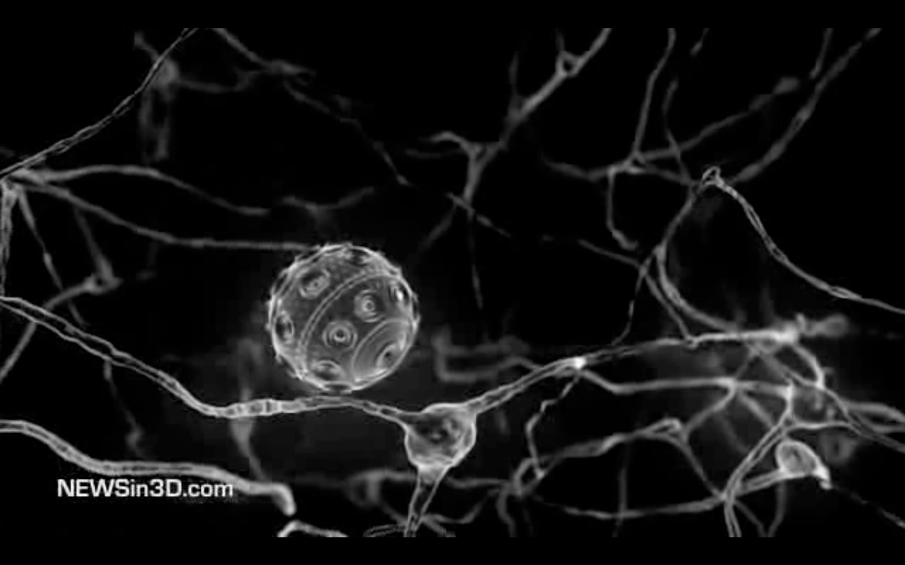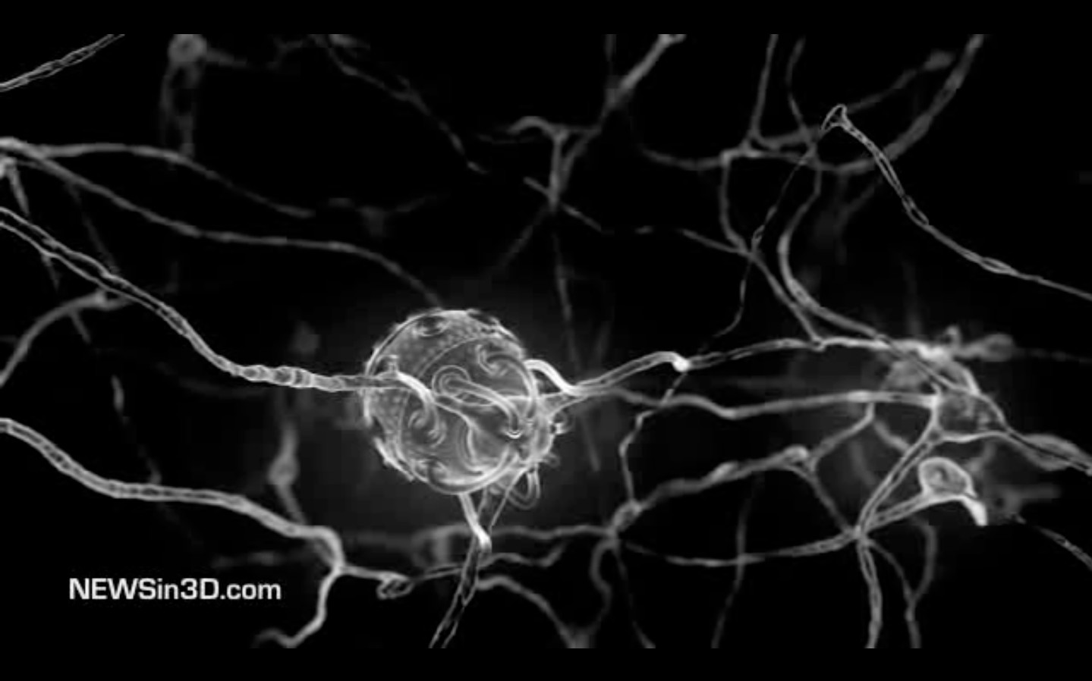
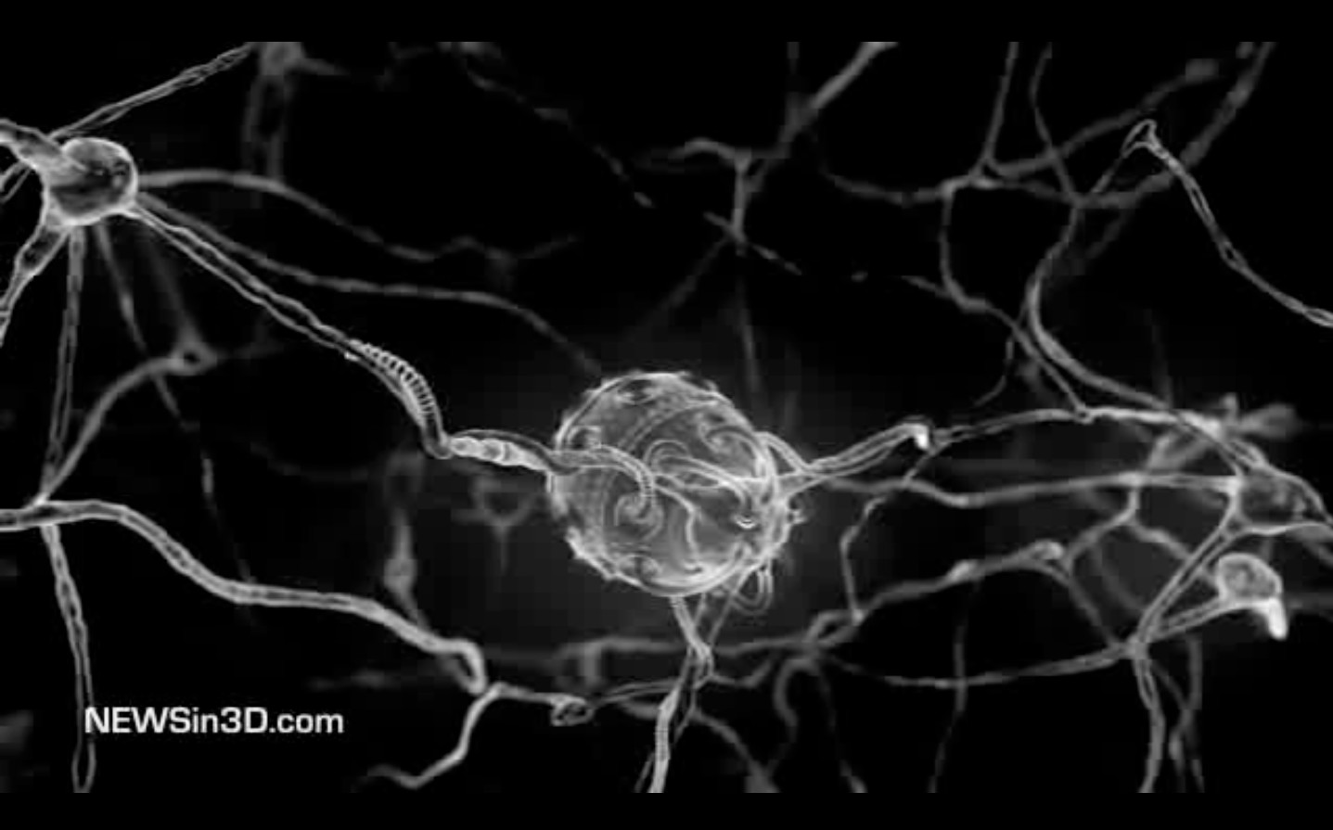
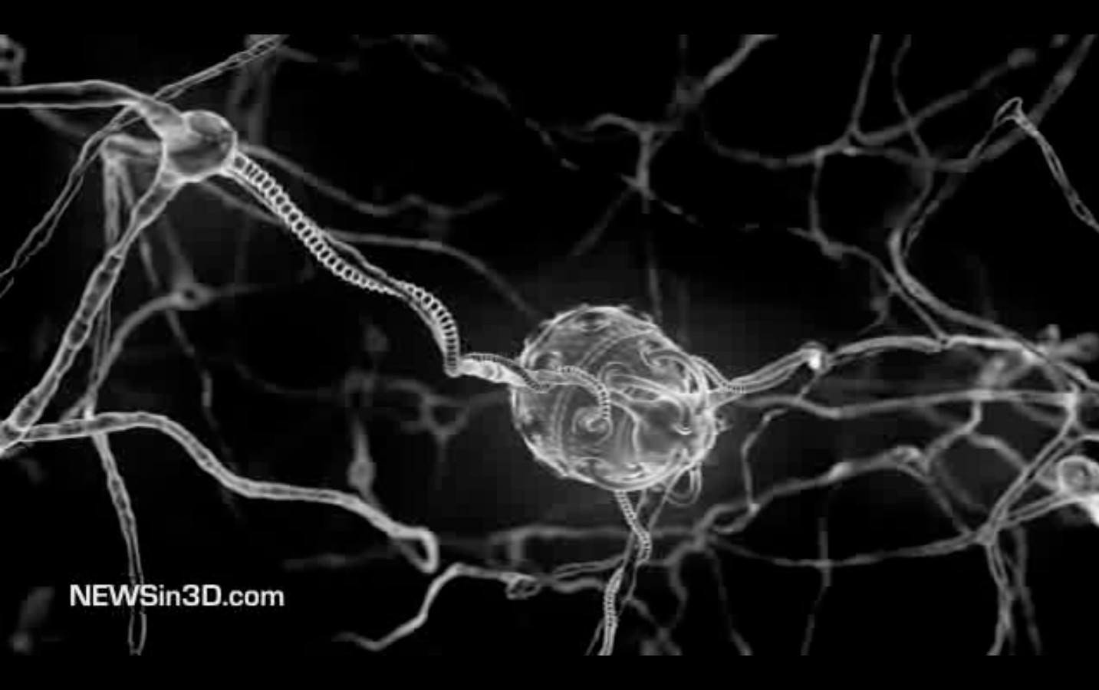

The sphere in this film stands for one (Ba, Sr_{x}) TiO₃ piezo-­‐crystal, the growing fibres stand for chains out of protein, prion & organic barium-­‐compounds.

According to this perception of things the TSE epidemic in the UK was a field study of a transhumanistic technology, and CFJ a collateral damage of a full-­‐scale implementation of the same technology.

Purdey considers if not all oft he degenerative old age diseases are following the same pattern, making a difference only in the point of the substitutive metal. Dementia and Alzheimer are associated with aluminium, ALS wit lead, Parkinson with manganese.

Wireless technology that uses high frequency radiation randomly causes high frequencies of different strength in our surroundings, which penetrates plants and living beings.
Examples on such devises are; mobile phones, mobile towers and Wi-­‐Fi technology, wireless routers, bluetooth technology, cordless phones, smart meters, tetra system, radars and digital terrestrial broadcast systems.
However, radio-­‐signals also could be intentionally generated by transmission stations under the control of the intelligence community and weapon manufacturers who offer security solutions to governments. As to this theoretical possibility to apply mind control with piezo-­‐crystals, we should consider the fact that there are technical facilities to apply microwave fields on every populated area of this world, and that this technical equipment is in the hand of people who are very much into the philosophy of control. In this context

we need to consider, that almost every high-­‐frequent signal transmitted contains fragmented packages, hat are remounted on the receiver-­‐side. Due to this fragmentation it is possible to abuse every transmission to emit a lower-­‐frequent secondary signal without altering the informational content of the original transmission. This especially is the case for W-­‐LAN.
Following another article describing effects on humans, the bio-­‐concentration in the food chain does not even need to reach dangerous concentrations, because the agent already does harm even if it is not located inside the body. In November 2010 after a snowy day in Aachen, a town in North-­‐West-­‐Germany, the healing practitioner Wolfgang Creyaufmüller56 registered a widespread appearance of headaches among his patients.
They could not be successfully treated with recipe-­‐free painkillers like ASS, Paracetamol or Ibuprofen.
As a healing practitioner he was using bio-­‐field-­‐measurement with the nosode FSME as part of his diagnostics. The device is measuring biophoton activity of the human body. All patients with the abnormal headaches showed significantly weakened biophoton fields.
Creyaufmüller knew that normally snow has a positive effect on biophoton activity of humans – supporting the levels of humans and being at +8 on the scale itself. So he went out measuring the snow and found a biophoton activity of -­‐8 on the snow surface. As an anti-­‐nuclear power activist he has been following up the contamination deriving from the Chernobyl accident for years. He expected some radioactive fallout, thus he decided to have chemical analysis conducted of the snow. However, the snow instead showed high levels of barium isotopes instead which could not be related to any known nuclear accident.
The source of the effect could have been barium-­‐strontium-­‐titanate, since these nano-­‐ crystals absorb biophotons. It is an indication that also humans might be affected by the interruption of biophoton activity, and that humans might feed their biophoton field with refracted (polarized) sunlight.
Additionally, it could hint to the ability of nano-­‐crystals to affect life on the continents in a way similar to the effects suspected for plankton. This could regard all biotopes, when being optically open and interconnected systems.
In general, a weakened biophoton activity results in weakened ability of self-­‐organization in the biological system. This touches all degenerative diseases as well as the subjective well-­‐being.
Another possible impact of barium-­‐strontium-­‐titanate concerns signal enhancement. This is a term derived from information-­‐medicine. Dietrich Klinghardt, who has been voted to the Physician of the Year back in 2011, developed a special system for autonomic response testing (ART), where he uses laser light and refracting Plexiglas cubes as signal enhancers. The Plexiglas is meant to have optical qualities that are similar to those of barium-­‐

56 Wolfgang Creyaufmüller: Wie kommt Barium ins Regenwasser? Aachen. Online at http://www.sauberer-­‐himmel.de November the 17th 2012.

strontium-­‐titanate nano-­‐crystals, just on the macroscopic scale. By positioning a poison or a remedy on these Plexiglas cubes close to the patients head, Klinghardt tests if substances are setting the body into a state of stress, or lead to relaxation – something that is possible to test via ART, where the tension of arm muscles is mechanically detected. The idea is that the coherent, polarized light created by laser and cube can carry both the information of the poison and of a possible remedy into the patients cell communication, triggering the same reaction that the real chemical would trigger once it is in the body.
Against this background the possibility that barium-­‐strontium-­‐titanate nano-­‐crystals could act as signal enhancers is striking. They would enhance any kind of biological information above their absorption lines, i.e. above UV, just like Klinghardts Plexiglas cubes, but being millions of them.
This would be a classical case of synergistic toxicity, enhancing the information field of various toxins within the body. This could be one explanation of Multiple Chemical Sensitivity (MCS).

Damage related to Aluminum Oxide
The last time Europe experienced large scale consequences from airborne pollution was in the 1970s and 80s. The fume from burning of fossil fuel by large industries was permitted to go unfiltered into the atmosphere, causing acid rain. In the late 1970 large forest areas in Germany, Poland and Czech Republic started dying, and mass death of fish was reported from rivers in Norway and Sweden.
Burning fossil fuels releases SO₂ and NO₂ into the air, when it connects with the humidity in the air H₂S0₄ and H₂NO₃ is formed. In addition burning carbon creates extra CO₂, which forms extra H₂CO₃. All these are acid agents, which turn the humidity in the air acid. This acid can damage plants directly via fog or indirectly via the rain entering the ground and releasing heavy metals from the soil, among them aluminum oxide which can harm plants and other organisms.
Al₂O₃ as well as other heavy metal compounds occur as a mineralogical unit with the SiO₂ in clays and many other minerals. In this form it is harmless. The acid rain has the capacity to dissolve SiO₂ and thus release Al₂O₃ and other heavy metal compounds into a bioavailable form. In addition the Al₃+ can form toxic compounds with for example fluorine.
The sulfur-­‐content of coal can be up to 3%, where as heavy metals content amounts to only 0,003%, so the amounts of aluminum brought up into the atmosphere by burning fuel used to be of minor importance compared to the amounts of aluminum released in the soil as a result of acid rain.
Aluminum-­‐oxide was found to attach to the membranes of the tiny roots of the trees, blocking the uptake of nutrition and causing the roots to die off. Aluminum ions were identified to attach to the gills of fish and disturbing the uptake of oxygen.

The vague scientific memory of the acid rain problem causes a number of misunderstandings. Sometimes in discussions it is said that aluminum turns the rain acid. This is not correct. Large presence of Al₂O₃ in the rain would bring the rain further into the alkaline state. When rain comes down acid it is an indication of fuel impurities or additives containing sulfur and halogens. Rainwater has a natural acidity at 5,5 when it is in equilibrium with the natural C0₂ content of the air. Acid rain is rainwater with acidity below 5.5.
Interestingly this release of Al₂O₃ in the soil is part of the self-­‐regulation mechanism that protects the soils itself from getting too acidic by acid rain. In this way it can protect the microorganisms in the soil itself.
The problem today is that it is not known how much of the aluminum deposited is deposited as amorphous flitters in micron-­‐size, amorphous nano-­‐particles or mono-­‐ crystalline nano-­‐particles.
Al₂O₃ as mentioned in geo-­‐engineering-­‐patents, would form thin flitters in the range of 10-­‐ 100 micron. However, even the micron size flitters when being thin enough might brake down and produce nano-­‐size particles. But anyway it seems to be more likely that the particles observed come from military application and are produced by spray pyrolysis within the jet engines57. When run through normal jet engines during normal flight-­‐ condition at stable altitude the temperatures in the engine should create amorphous spherical aluminum-­‐oxide nano-­‐particles. With military planes we see the possibility to utilize afterburner technology, with very similar conditions to rocket propulsion, that reaches higher temperatures and would be able to melt and re-­‐crystallize amorphous aluminum oxide nano-­‐particles to mono-­‐crystalline corundum nano-­‐crystals in the second chamber, with the varieties ruby as a result if doted with chrome, and sapphire if doted with iron and titanium.
Conditions like found in afterburners could eventually create a particles-­‐form called “whisker”. Back in the 80s engineers tried to create ultra-­‐light concrete with nano-­‐ particles created in spray pyrolysis at high temperatures. The crystalline particles formed shapes with hundreds of sharp radial orientated mono-­‐crystalline needles. The concept was meant to achieve low weight when bound in concrete. The technology was abandoned because these particles turned out to cause cancer.

Aluminum-­‐oxide is not only mentioned as reflective particles but also is known to improve the efficiency of the combustion process by up to 40% as a combustion accelerator. This technology is especially utilized for fuels used in afterburners. It also relates to the experience with JP-­‐8 reported to burn easier and faster then kerosene or diesel fuel.

57 A.I.Y. Tok, F.Y.C. Boey, X.L. Zhao: Novel synthesis of Al2O3 nano particles by flame spray pyrolysis. Journal of Materials Processing Technology 178 (2006) 270-­‐273. M.I. Martín, L.S. Gómez, O. Milosevic, M.E. Rabanal: Nanostructured alumina particles synthesized by the Spray. Pyrolysis method: microstructural and morphological analysis. University Carlos III de Madrid, Avda. de la Universidad, 30, 28911 Leganés, Madrid, Spain. Institute of Technical Sciences of Serbian Academy of Sciences and Arts, K. Mihailova 35/IV, 11000 Belgrade, Serbia.

Especially the rocket-­‐ and afterburner fuels can contain up to 40% aluminum. American environmental activists suspect the same properties of the material to enhance the violence of bush-­‐ and forest-­‐fires once these particles are accumulated within the plants and in the ground, and especially lead to very aggressive fires, especially in the root area of the trees, a phenomenon that has not been observed before.
However, the only thing possible at this moment is to theoretically evaluate what type of particle would have what effect when entering plant life and mammals.
Below are examples of studies involving nano-­‐aluminum-­‐oxide, like the one proposed for geo-­‐engineering.

A peer reviewed research paper from the department of biology at the University of East Carolina, USA, researched the effects of aluminum-­‐oxide nano-­‐particles on the growth, development, and microRNA expression of tobacco (Nicotiana tabacum), demonstrating negative effect of Al₂O₃ nanoparticles on plants:
In this study, we exposed tobacco (Nicotiana tabacum) plants (an important cash crop as well as a model organism) to 0%, 0.1%, 0.5%, and 1% Al₂O₃ nanoparticles and found that as exposure to the nanoparticles increased, the average root length, the average biomass, and the leaf count of the seedlings significantly decreased.58

Picture out of the study of Burkley, Ashlock, Winfrey and Zhang.

Another study shows toxic effect of Al₂O₃ nanoparticles on human cells.

The objective of this study was to assess the acute toxicity of ANPs in human mesenchymal stem cells (hMSCs) in vitro. The results indicate that ANPs have a significant and dose-­‐dependent effect on

58 Caitlin E. Burklew, Jordan Ashlock, William B. Winfrey, Baohong Zhang: Effects of Aluminum Oxide Nanoparticles on the Growth, Development, and microRNA Expression of Tobacco (Nicotiana tabacum). PLOS one, 18.06.2013.

cytotoxicity. Control cells showed a characteristic, homogeneous nuclear staining pattern, whereas ANP-­‐exposed cells showed abnormal nuclear morphological changes such as condensation or fragmentation. An early characteristic of apoptosis was observed in ANP-­‐treated cells. Further confirmation of cell death in hMSCs was observed through increased expression of chosen signaling genes and also decreased expression of Bcl-­‐2 during mitochondria-­‐mediated cell death.
Although they (Al₂O₃) provide great advantages in food and agricultural products, the chronic and acute toxicity of ANPs still needs to be assessed carefully.59

Yet another study shows toxic effect of Al₂O₃ nanoparticles on the mitochondria in mammalian cells60. It was also documented that mitochondrial function decreased significantly in the cells exposed to ZnO at 50 to 100 microg/mL, and in the cells exposed to Fe₃O₄, Al₂O₃, and TiO₂ with concentrations greater than 200 microg/mL.

Another study shows toxic effect of Al₂O₃ nanoparticles on mitochondria in lung cells.
The results show that the four types of metal oxide nanoparticles lead to cellular mitochondrial dysfunction, morphological modifications and apoptosis at the concentration range of 0.25-­‐1.50 mg/mL and the toxic effects are obviously displayed in dose-­‐dependent manner. ZnO is the most toxic nanomaterial followed by TiO₂, SiO₂, and Al₂O₃ nanoparticles in a descending order.

The results highlight the differential cytotoxicity associated with exposure to ZnO, TiO₂, SiO₂, and Al₂O₃ nanoparticles, and suggest an extreme attention to safety utilization of these nano-­‐materials.61

One of the main mechanisms of nanoparticle toxicity is thought to be the generation of reactive oxygen species (ROS), which primarily damage cell membranes.

Ruminococcus flavefaciens is an anaerobe gut bacteria that plays an important role in the digestion of hemicellulose and cellulose plant cell walls. In spite of oxygen not being present in this milieu, analysis revealed dose-­‐effect changes in membrane composition exclusively when cells were exposed to Al₂O₃ nanoparticles in a concentration range of 3-­‐5 g/L. 62

This indicates that other mechanisms than oxidation is damaging cell structures. It also indicates that Al₂O₃ in food might affect digestion negatively.

The toxic impact of nanoparticles thought has to be related to their large surface, and also the fact that nano-­‐particles can pass through the cell membranes in organisms.

Leaf trees might be able to release themselves from excess aluminum when shedding their leaves.
In areas with a heavy load of persistent contrails some species of trees have been observed secreting a white dust on the barks surface that is visible almost like a layer of white color. It is possible that the phenomenon observed is an attempt by the trees to get rid of excess

59 Al₂O₃ Nanoparticles Induce Mitochondria-­‐Mediated Cell Death and Upregulate the Expression of Signaling Genes in Human Mesenchymal Stem Cells. King Saud University, Saudi Arabia (2012):
60 Toxicity of metal oxide nanoparticles in mammalian cells. Old Dominion University, USA (2006);
61 ZnO, TiO₂, SiO₂ and Al₂O₃ nanoparticles-­‐ induced Toxic Effects on Human fetal lung Fibroblasts. South East University, Jiangsu, China (2011);
62 Masa Vodovnik, Rok Kostanjsek, Masa Zorek, Romana Marinsek Logar: Exposure to Al₂O₃ nanoparticles changes the fatty acid profile of the anaerobe Ruminococcus flavefaciens. University of Ljubljana, Slovenia. (2012)

aluminum oxide.

Aluminum oxide is not only mentioned in patents and discussions as reflective particles, but it also is known to improve the efficiency of the combustion process by up to 40% as a combustion accelerator. This technology is especially utilized for fuels used in afterburners. These fuels contain up to 40% aluminum. Fire fighters have observed that bush and forest fires are far more explosive now than just some years ago, they have also been puzzled by very aggressive fires shooting up from the root area of the trees.
Aluminum nano-­‐particles that are used as combustion accelerator in jet engines, would have the same qualities and effect on forests and can accumulate in the soil beneath the trees causing explosive fires.
When Al₂O₃ nano-­‐particles exist in mono-­‐crystalline form, we would expect no solubility. Even less so if they are doted with iron & titanium and maybe chrome. These are small gemstones: ruby and sapphire. Like the gemstones they have a color, high refractivity, probably good reflectivity. Having a color means that within the spectrum of cell-­‐ communication they would filter out certain frequencies and refract others which could disturb the morphogenetic field and the plants mechanisms of self-­‐organization.

The suspicion that like with barium-­‐strontium-­‐titanate the damaging effect of aluminum is also related to optical effects within the plant is supported by the first publication about the GMO plants resistant to aluminum. The article states that the modified plants are “actually blind to what happens within the cells”. The author obviously knew that the cell division is blocked by the aluminum, and that the bio-­‐engineers found ways to keep the cell division running although the optics were blocked.
Even if it is good to have a working solution to a serious problem, the question arises why and how someone was able to find a solution to a problem that did not even exist back at that time, someone who showed on one hand that he exactly knew about the role of biophotons, by A. mentioning it and B. basing his solution on it, but at the same time declares that the reason is the chemical intoxication from the soil, which obviously was not true. This does not make sense unless one suspects that certain economic entities intentionally created a problem to sell the solution.
An agent that has similar effects and a similar crystallography as aluminum oxide whiskers is manganese oxide. Mananese is known to cause flu symptoms and the whiskers have been found in environmental analysis, especially during the winter month when flu becomes a topic of public interest. Manganse-­‐Whisker are produced in spray pyrolysis at 600 deg C. This means it is possible to produce them in jet-­‐engines during normal flight conditions.

Optical Analysis
Nano particles can only be seen under pretty expensive microscopes. In this chapter we therefor will first have a look at aerosols that can be analysed with a normal microscope.

Many reports mention nano-­‐fibers falling from the sky as one phenomenon connected to geo-­‐engineering. As far as this study can oversee the technical possibilities, this can relate to three different mechanisms:
-­‐ the polymerization of nano-­‐particles
-­‐ metal-­‐coated nylon fibers
-­‐ technical hollow nano fibers
-­‐ self replicating hollow nano-­‐fibers, i.e. Morgellons
The first possible mechanism when fibers are observed could be a reaction of Ca(NO₃)₂ and fluoride-­‐tensides to Ca₂F-­‐nano-­‐crystals, which similar to piezoelectric crystals develop magnetic properties when exposed to external fields. In a dry environment these nano-­‐ crystals would theoretically form unstable, spider-­‐web-­‐like structures when triggered to become magnetic, in humid environment they theoretically would be able to form droplets on command, by fusing smaller droplets by magnetic attraction to rain-­‐size droplets. This could correspond to films where these fibers melt as soon as they feel the body-­‐heat of an approaching hand.

The second form of fibers observed, are the aluminum coated nylon fibers, as indicated by the manuscript from U.S. Air Force Academy, Department of Chemistry. They have been reported to hide planes from radar detection, as well as being used to deflect sunlight in the context of combating global warming. The Air Force calls them spoofer sprays.

The third form of fibers reported are technically produced hollow fibers containing all sorts of chemicals, some of them identified as insecticides. According to the scientific literature such things exist, they are artificial shells designed to effectively bring medicine or poisons into defined areas of the lower intestines.

The forth form of fibers reported to be found in rain water samples but also in humans and animals are the so called Morgellons, which bio-­‐accumulate and sometimes cause a disease where these fibers exit via the skin, causing ugly skin irritations. There are about 100.000 to 300.000 registered victims worldwide. According to the carnicom-­‐institute these fibers turned out to be „synthetic biology”, an artificially engineered life form that is showing properties of eukarya, archaea and bacteria, thus representing an optimized mixture of all aspects or all families of life existing on this planet. They look like the tubular shaped fungus, contain organs looking and self-­‐replicating like bacteria, but as a whole behave like eucarya. From the fungi it inherited it's ability to grow and multiply explosively when triggered by a defined electromagnetic frequency, in this case at 375 nm (blue) within the visible spectrum. According to the Carnicom Institute one of the self-­‐replicating organs found inside the tubes were identified as something similar to human red blood cells, however they were self-­‐replicating outside, in free nature, not in a petri-­‐dish, a life-­‐form

that could withstand basically everything, freezing, drying, burning in a Bunsen-­‐flame, pouring bleach on them. Nothing destroyed these cells. Associated with these Morgellons also other parts of “self-­‐assembling nano-­‐machines” were found, including gold nano-­‐ particles and hexagonal crystals glowing in different colors when triggered by microwave radiation.

Despite the very obvious reality of these fibers the disease is officially declared by the US-­‐ authorities being psychosomatic, classified as delusional parasitizes, which hints to an intelligence background.

For further understanding we first recommend the lecture “From Chemtrails to Pseudo-­‐ Life – the dark Agenda of synthetic Biology” by Sofia Smallstorm, as well as the publication “Extreme Genetic Engineering”.63

  - Trans-­‐Humanistic Technologies I – extracellular systems

To understand the full potential of this synthetic biology one might look into some cutting edge applications in medicine. Today medicine is using nano-­‐dyes to mark and microscope very small biological elements like proteins and DNA strings. Originally these nano-­‐dyes were made of fluorescent complex molecules containing both organic and heavy metal compounds. Observed with ultra short laser pulses it was possible to capture the fluorescent picture only, while the camera is closed during the pico-­‐seconds the laser is sending its light flashes to avoid capturing direct reflections. To observe continuously without this type of time-­‐resolution, second generation nano-­‐dyes utilize a mixture of different nano-­‐crystals and complex organic molecules with associated heavy metal cations, where the ability of up-­‐conversion of frequencies64 is used to feed the dye with radio-­‐frequencies on one, but harvest the picture on a second frequency band. Following this concept nano-­‐dyes mentioned in the official literature have been developed that absorb radio frequencies of about 1800 nm, upconvert the photons and emit within the visible spectrum. Like this they can glow virtually without a visible source of light.

More complex medical applications consist of self-­‐assembling65 nano-­‐machines, like for example optical fibers66, that by capillarity take in and up-­‐concentrate nano-­‐dyes and

63 etc-­‐group: extreme genetic engineering. An introduction to synthetic biology. January 2007.
64 Gainer Ch. F., Joshua G. S., De Silva Ch. R., Romanowski M.: Control of green and red upconversion in NaYF4:Yb3+, Er3+ nanoparticles by excitation modulation. Journal of Materials Chemistry, Vol.21, p.18530-­‐18533 (2011).
65 Ding B., Hrelescu C., Arnold N., Isic G., Klar T. A.: Spectral and directional reshaping of fluorescence in large area self-­‐ assembled plasmonic-­‐photonic crystals. Nano Letters, Vol.013, p.378-­‐386 (2013) Also: Woller J. G., Hannestad J. K., Albinsson B.: Self-­‐assembled nanoscale DNA–porphyrin complex for artificial light harvesting. Journal of the American Chemical Society, Vol.135, p.2759-­‐2768 (2013) Also: Sagun E., Knyukshto V. N., Ivashin N. V., Shchupak E. E.: Photoinduced relaxation processes in self-­‐assembling complexes from CdSe/ZnS water-­‐soluble nanocrystals and cationic porphyrins. Optics and Spectroscopy, Vol.113, p.165-­‐178 (2012) Also: Aqueous self-­‐assembly of an electroluminescent double-­‐helical metallopolymer. Journal of the American Chemical Society, Vol.134, p.19170-­‐19178 (2012)
66 Jaskiewicz K., Larsen A., Schaeffel D., Koynov K., Lieberwirth I., Fytas G., Landfester K., Kroeger A.: Incorporation of nanoparticles into polymersomes: Size and concentration effects. ACS Nano, Vol.06, p.7254-­‐7262 (2012) Also: Williams
G. O. S., Euser T. G., Russell P. St. J., Jones A. C.: Spectrofluorimetry with attomolesensitivity in photonic crystal fibers.

other nano-­‐particles with special characteristics, like gold-­‐nano-­‐particles67. These fibers are able to collect light patterns coming in from the DNA, turning them into electromagnetic signals that are sent by the fiber-­‐based so called plasmonic antennas68 out as an readable electromagnetic signal69. A second class of nano-­‐machines function the opposite way: large area self assembling photonic-­‐plasmonic crystals are quantum laser units that take in electromagnetic signals and turn them into single photon emissions70 that communicate with the DNA. These two classes are thus able to create a bi-­‐directional technical/biological interface.

Such a read/write unit might function quite simple in analogy to a tape recorder. Any aspect of human life, emotions, energetic states or even spiritual experiences, anything that manifests on the level of DNA cell communication, can be recorded under lab conditions and replayed in any single individual that can be targeted by radio frequencies
– once these self-­‐assembling nano-­‐bots exist within the human body.

Additionally, when applied on large areas, methods of collective mind control are thinkable.

Historically71 these nano-­‐crystal applications are an advanced development of the quantum dots72 that have been developed by Bell Labs in the early 80s, however the fiber and nano-­‐crystal technology is much more stable, especially regarding solubility of the

Methods and Applications in Fluorescence, Vol.01, 015003 (2013)
67 Raut S. L., Shumilov D., Chib R., Rich R., Gryczynski Z., Gryczynski I.: Two photon induced luminescence of BSA protected gold clusters. Chemical Physics Letters, Vol.561-­‐562, p.74-­‐76 (2013). Also: Tombe S., Antunes E., Nyokong T.: Electrospun fibers functionalized with phthalocyanine-­‐gold nanoparticle conjugates for photocatalytic applications.
Journal of Molecular Catalysis A: Chemical, Vol.371, p.125-­‐134 (2013). Also: Wen X., Yu P., Toh Y.-­‐R., Tang J.: Quantum confined Stark Effect in Au8 and Au25 nanoclusters. The Journal of Physical Chemistry C, Vol.117, p.3621-­‐3626 (2013). Also: Muskens O. L., England M. W., Danos L., Li M., Mann S.: Plasmonic response of Ag-­‐ and Au-­‐infiltrated cross-­‐linked lysozyme crystals. Advanced Functional Materials, Vol.023, p.281-­‐290 (2013).
68 Acuna G.P., Holzmeister P., Möller F.M., Beater S., Lalkens B., Tinnefeld P.: DNA-­‐templated nanoantennas for single-­‐ molecule detection at elevated concentrations. Colloidal Nanocrystals for Biomedical Applications VIII, Vol.XXX, 859509 (2013) Also: de Leon N. P., Shields B. J., Yu Ch. L., Englund D., Akimov A. V., Lukin M. D., Park H.: Tailoring light-­‐matter interaction with a nanoscale plasmon resonator. arXiv:1202.0829v1 (2012)
69 De Greve K., Yu L., McMahon P. L., Pelc J. S., Natarajan C. M., Kim N. Y., Abe E., Maier S., Schneider C., Kamp M., Höfling S., Hadfield R. H., Forchel A., Fejer M. M., Yamamoto Y.: Quantum-­‐dot spin-­‐photon entanglement via frequency downconversion to telecom wavelength. Nature, Vol.491, p. 421-­‐425 (2012) Also: Zaske S., Lenhard A., Kessler C. A., Kettler J., Hepp C., Arend C., Albrecht R., Schulz W.-­‐M., Jetter M., Michler P., Becher C.: Visible-­‐to-­‐telecom quantum frequency conversion of light from a single quantum emitter. Physical Review Letters, Vol. 109, 147404 (2012). See also: Guo-­‐Liang Shentu, Jason S. Pelc, Xiao-­‐Dong Wang, Qi-­‐Chao Sun, Ming. Yang Zheng, M.M. Fejer, Qiang Zhang, Jian-­‐Wei Pan: Ultralow noise up-­‐conversion detector and spectrometer for the telecom band. Optical Society of America, POTIC PRESS 13986, Vol. 21, No. 12, 17. June 2013.
70 Winkler J. M., Lukishova S. G., Bissell L. J.: Room-­‐temperature single photon sources with definite circular and linear polarizations based on single-­‐emitter fluorescence in liquid crystal hosts. Journal of Physics: Conference Series, Vol.414, 012006 (2013)
71 Kendrick M. J.: Light-­‐matter interactions: from the photophysics of organic semiconductors to high spatial resolution optical tweezer-­‐controlled nanoprobes. An Abstract of the Dissertation, Oregon State University (2012)
72 Midolo L., Pagliano F., Hoang T. B., Xia T., van Otten F. W. M., Li L. H., Linfield E.H., Lermer M., Höfling S., Fiore A.: Spontaneous emission control of single quantum dots by electromechanical tuning of a photonic crystal cavity. Applied Physics Letters, Vol.101, 091106 (2012). Also: Shcherbatyuk G. V., Talbot P., Ghosh S.: Controlling photo-­‐induced spectral changes in CdSe/ZnS quantum dots by tuning inter-­‐dot energy transfer. Applied Physics Letters, Vol.100, p.212114-­‐1-­‐ 212114-­‐4 (2012). See also: Ziyun Di, Jones H. V., Dolan P. R., Fairclough S. M., Wincott M. B., Fill J., Hughes G. M., Smith J. M.: Controlling the emission from semiconductor quantum dots using ultra-­‐small tunable optical microcavities. arXiv:1206.6046v1 (2012)

dyes containing heavy metals in acids.

Other of these intelligence applications seem to involve real antennas like glass insulated superconducting nano-­‐wires73, 74

As mentioned, the system that shows up associated to the Morgellons disease is quite advanced. The self-­‐replicating fibers and the typical hexagonal crystals seem to grow in a kind of biologic-­‐technical symbiosis.

Samples from the Phoenix atmosphere taken by Ms. Coralyn Hill, Astro Physicist of Harvard and analyzed in a nano equipped lab showed three different mixtures of components of these self-­‐assembling technologies:

- Polycrystalline Sr Mg-­‐Doped (La, Ga) O₂ nano wire (LSGM) P19 Protein Methotrexate
- TiO₂ Polymer/Au/Al blend nanowire terephtlalic acid Dimethyl Terephthalete Carbon nano tube Radioactive Sodium Iodide, N-­‐acetylglucosamine
- High Resolution TEM revealed crystalline lattice spacings of palladium & aluminum, microtube particle arrays bound to amino acids. Pd is bound to the N and S atoms in the side chains of crysteine (red), methionine (blue), and hystidine (green/yellow). Hystadine is a metal binding residue in peptides due to the disprotenated N₃ atom in the imadazole ring. Ni and Co magnetice nano wires without diameter of 50-­‐60 nm. Stacked pryidine ligand molecular wires containing Zn with porphyrin cores. Ladder oliogoners of Quinoxaline and benzoanthracene (a carcinogenic hydrocarbon).

73 Kim J., Lee S., Suh J.-­‐K. F., Park J. H., Shin H.-­‐J.: Active control of dielectrophoretic force at nanowire electrode for ultrahigh single nanoparticle manipulation yield. Applied Physics Letters, Vol.102, p.063105 (2013). Also: Lee Y.-­‐B., Park S., Lee S., Kim J., Lee K.-­‐S., Joo J.: Nanoscale luminescence characteristics of CdSe/ZnS quantum dots hybridized with organic and metal nanowires: energy transfer effects. Journal of Materials Chemistry C, Vol.01, p.2145-­‐2151 (2013) Also: O'Carroll D. M., Fakonas J. S., Callahan D. M., Schierhorn M., Atwater H. A.: Metal-­‐Polymer-­‐Metal Split-­‐Dipole Nanoantennas. Advanced Materials, Vol.024, p.OP136-­‐OP142 (2012)
74 Avella A., Brida G., Carpentras D., Cavanna A., Degiovanni I. P. , Genovese M., Gramegna M., Traina P.: Review on recent groundbreaking experiments on quantum communication with orthogonal states. arXiv:1206.1503v1 (2012) Also: Sandberg R. L., Padilha L. A., Qazilbash M. M., Bae W. Ki, Schaller R. D., Peitryga J. M., Stevens M. J. Baek B., Nam S. W., Klimov V. I.: Multiexciton dynamics in infrared-­‐emitting colloidal nanostructures probed by a superconducting nanowire single-­‐photon detector. ACS Nano, Vol.06, p.9532-­‐9540 (2012). Also: Rich R., Ji Li, Fudala R., Gryczynski Z., Gryczynski I., Mandecki W.: Properties of coatings on RFID p-­‐Chips that support plasmonic fluorescence enhancement in bioassays.
Analytical and Bioanalytical Chemistry, Vol.404, p.2223-­‐2231 (2012)

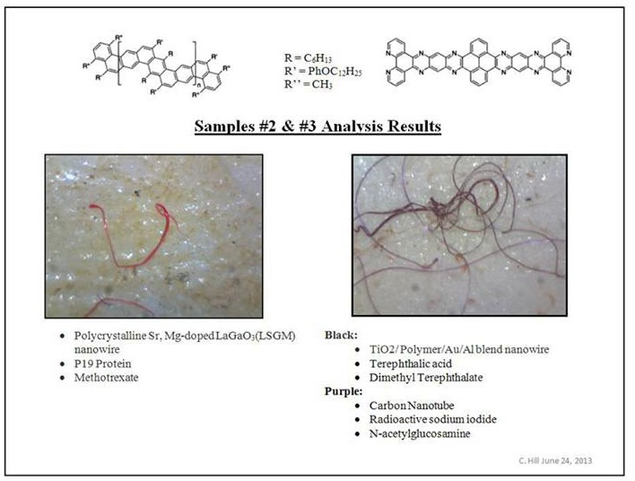
Original paper by the nano lab of the Harvard University.
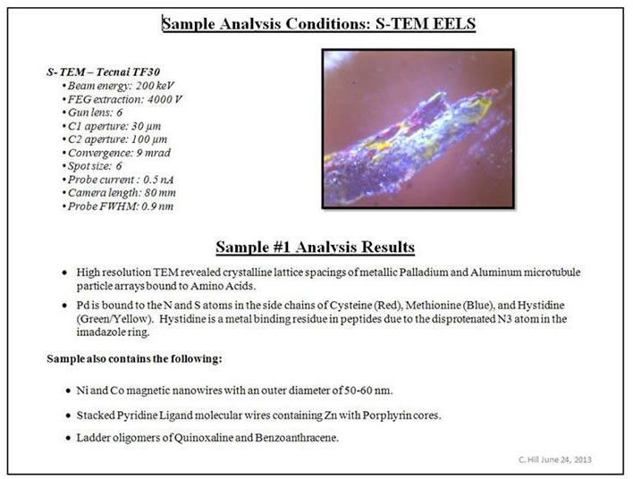
Original paper by the nano lab of the Harvard University.

Compared to the particulate plasma showing up as barium, strontium, titanium and aluminum the description, analysis and understanding of this transhumanistic technology is rather easy. Most of the basic scientific papers are public domain. We already referred to these studies earlier in the footnotes, the publications that appear most important to us are:

-­‐ Ding B., Hrelescu C., Arnold N., Isic G., Klar T. A.: Spectral and directional reshaping of fluorescence in large area self-­‐assembled plasmonic-­‐photonic crystals. Nano Letters, Vol.013, p.378-­‐386 (2013)
-­‐ Woller J. G., Hannestad J. K., Albinsson B.: Self-­‐assembled nanoscale DNA–porphyrin complex for artificial light harvesting. Journal of the American Chemical Society, Vol.135, p.2759-­‐2768 (2013)
-­‐ Sagun E., Knyukshto V. N., Ivashin N. V., Shchupak E. E.: Photoinduced relaxation processes in self-­‐assembling complexes from CdSe/ZnS water-­‐soluble nanocrystals and cationic porphyrins. Optics and Spectroscopy, Vol.113, p.165-­‐178 (2012)
-­‐ Aqueous self-­‐assembly of an electroluminescent double-­‐helical metallopolymer.
Journal of the American Chemical Society, Vol.134, p.19170-­‐19178 (2012)
-­‐ Jaskiewicz K., Larsen A., Schaeffel D., Koynov K., Lieberwirth I., Fytas G., Landfester K., Kroeger A.: Incorporation of nanoparticles into polymersomes: Size and concentration effects. ACS Nano, Vol.06, p.7254-­‐7262 (2012)
-­‐ Williams G. O. S., Euser T. G., Russell P. St. J., Jones A. C.: Spectrofluorimetry with attomolesensitivity in photonic crystal fibers. Methods and Applications in Fluorescence, Vol.01, 015003 (2013)

To fully understand the concept we will first have a look at the Morgellon life cycle as a biological being. Our approach to understand the Morgellons life cycle was fully visual, analyzing the total number of 14.000 pictures of Morgellon related phenomena. We had a close look at all Morgellon related phenomena, to find forms that occurred over and over again, and put them in a logical order. This approach was successful due to the photographic work of Jan Smith, Sharlene Neal and Manuela Binieck. Unfortunately we will not display Manuelas work visually in the frame of this study. The most important of her pictures were published in the German magazine Raum und Zeit, in two articles in January/February and February/March 2014. The publication is available online at http://www.raum-­‐und-­‐zeit.com. Further there are two German lectures held by the author available on DVD, that display these pictures, the first one on a conference of the DEGEIM in Lindau, November 2013, the second one on the “Medizinische Woche” in Baden-­‐Baden, held on October 30th 2014.

Morgellons are a fungus that is infecting the entire human body, and later is growing its fruiting bodies within the stomach and in the uterus of women. The fruiting bodies are released in a 28 day-­‐cycle, appearing to the patient as parasites. Due to their plant cell structure they are normally diagnosed as food-­‐leftovers.

To be exact: In the life of a fungus there are four steps: mycelium, peduncle basis, fruiting

body and spores. First the mycelium, growing in the muscles, bones and in the brain, i.e. the fibers known as Morgellons, enter the stomach through the stomach mucosa, form a knot, releasing some kind of liquid that turns the knot into a solid peduncle basis. The fibers forming the fruiting body out of the peduncle base in general look different from the mycelium itself, mostly thicker, like soya-­‐sprouts, who inter-­‐wave in a carpet-­‐like texture that later gets covered by a outer layer looking like chicken-­‐skin. The fully-­‐grown Morgellon fruiting body shows mostly a shrimp-­‐like morphogenesis, with a tail, able to bend around a “hip”, with a penguin-­‐head shaped forehead and some kind of umbilical cord attached to the belly. The fruiting bodies carry a single insect-­‐type eye with hexagonal crystal-­‐like forms carrying the spores.

The overall impression is of an human embryo in the 20th day of pregnancy, just with one insect-­‐type eye instead of two human ones.

Human embryo in the 20th day of pregnancy.

The woman who donated the excellent photos we can not display for copyright reasons always talked about the tail and the duck-­‐like head, called the little ones “rats”. She also said her instincts related to them as to children. Apparently they are mushrooms but they carry the morphogenetic field of humanoid babies.

To understand both these findings and the genetic analysis conducted by the Carnicom-­‐ Institute it was necessary to monitor a number of genetically modified beings.

As it looks like, the Morgellons DNA is a genetically modified version of Metarhizum anisopliae, Metarhizum acridum, Metarhizum majus, Beauveria brongnartii or Basidobulus, all out oft the order of the Entomophthorales.

Both morphology and special abilities of these original orders seem to be combined in a unique way to form the life form known as Morgellons.

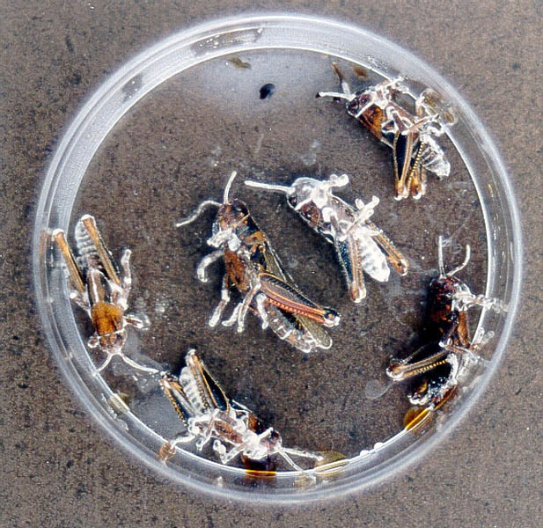

Basidiobulus affects humans, and it seems to have an affinity to colors. With humans it is causing the
Perianal Crohn Disease. However, Basidiobulus is much more aggressive than Morgellons. Metarhizum majus as well as Beauveria are responsible for the insect like forms as well as the ability to mimicry DNA of the host. These two fungi are natural enemies of insects. When it infects insects, the fungus spreads within their body, basically eats the insects up from inside, and then surfaces again, forms spores and tries to infect other insects.

There are two special abilities in this biological order to support the overall concept that plays a role in the Morgellons disease.

  - The fungi are able to assimilate higher DNA, multiply it and build up a DNA cluster that creates a morphogenetic field that resembles a humanoid morphogenetic field. This has two goals: It fools the energetic part of the immune system of the victim. The fungus appears to be part of the victim. There is no reason to attack it.
  - The second goal is to attract and infect more victims by mimicry. With the morphogenetic field of the victim the fungus is able to build up a “mushroom”, a fruiting body that resembles the original blueprint of the victims DNA in form and size. With insects you will have a mushroom that grows in the form of the insect that it just had killed.
This class of fungi has been widely used to genetically engineer myco-­‐insecticides. The fungus is using a multilayered hexagonal structure to protect and cover the spore.

These hexagons, who have the ability to produce radio controlled cold light, are as mentioned known out of a different context: They are part of synthetic biology research, called self assembling large area photonic plasmonic crystals.
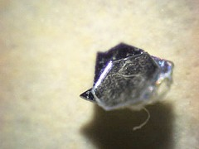
Hexagons associated with the Morgellons disease.

Later the baby generation of Morgellons grows out of the hexagon. The second generation of Morgellons forms new mycelium.
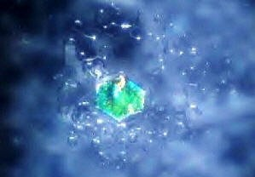
Hexagon that grows new mycelium in a petri-­‐dish.

From the technical point of view we guess nobody cares about the full life cycle of the fungus. What they want to have within the human body are hollow fibers that accumulate nano-­‐dyes within the fiber and those hexagonal self-­‐assembling large area photonic-­‐ plasmonic crystals, that accumulate nano-­‐dyes between the transparent layers.

In the language of the intelligence community both are self-­‐assembling nano-­‐bots. They spray them in components, separated into bioform and nano-­‐dye, call this mixture smart dust, and expect the smart dust to bio-­‐accumulate and self-­‐assemble itself to working units within the body.

The fibers and the crystals form a read/write unit. The fibers collect DNA light communication, i.e. the bi-­‐directional single photon emissions interchanged by any DNA cluster, and turn it into radio signals. The crystals take in radio signals and transform them into light signals readable by the human DNA. What ever human experience I want to “mind-­‐control”, I can induce this experience in a person, like saying “asshole” to a person to induce anger, read it out by collecting the signal sent by the Morgellons with a special antenna, store it in a digital file, turn this stored anger into a radio signal and make any other human being experience the same emotional or even mental pattern by making the hexagonal crystals reproduce the light patterns. According to old vedic knowledge red light controls sexuality, orange anger, blue the thoughts.

This is what we can state to that topic. Read the original scientific papers by the original inventors.

It is not 100% secured but we would tend to understand the rubies and sapphires created in the context of the particulate plasma used for military reasons as intermediate optical units that smoothen the light transfer between the relative big DNA-­‐molecules, via the nano crystals, to the molecular nano-­‐dyes within the Morgellons. This would represent a hierarchically organized cluster of red and blue fluorescent particles covering three scales in size. This makes sense when working with morphogenetic fields. It guaranties a strong transfer from light stored within the DNA clusters to the artificial Morgellon based light framework, that finally transforms the stored energy into a radio signal and sends it out of the body. Extracting light from the DNA lowers the scalar potential of the DNA. It is a direct transfer of scalar potential out of the human system.

They are flattening us down, lowering “our vibration”, extracting energy. Sucking out what one could call life force. Also, with the rubies and sapphires and the other nano-­‐crysralls the light is permanently refracted… even if it finally ends up in a second human DNA. We loose order. This could be one aspect of the aluminum-­‐connection to Alzheimer and dementia. The thoughts, the recalled memory, is getting blurry because the light is permanently refracted by rubies and sapphires, loosing the geometrical order of the bidirectional light communication which by its nature is nothing else then consciousness. Thoughts or consciousness – regarded as composite signals of their smallest units, like bits and bites in computing – are scalar-­‐waves passing the brain in a geometrically ordered form creating fluctuating spheres of the platonic bodies. These are the smallest fragments

of logic and grammar. If the scalar-­‐waves are refracted, the angles are permanently changed, which makes it impossible to form repetitive platonic structures. Thinking whites out, like the blue color of the sky.

This is far beyond any known concept of mind control.
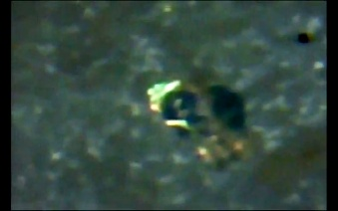
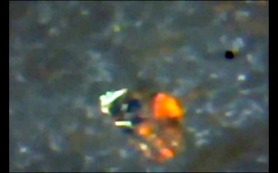
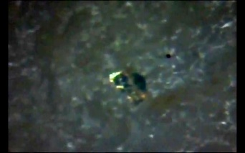
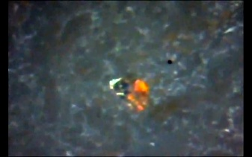
Screenshots taken from a film about blinking crystals made by Jan Smith, who is suffering from the Morgellons disease and documents all related phenomena. A hint to the possibility, that the concept might be online.

Who actually stand behind this agenda is hard to say. The only source that states things on the spot is the Novel “Crosswalk – the Sun Thieves” by Cara St. Louis-­‐Farrelly. Following her hints and backing up her statements with real world research leads to the following picture: Starting from the very beginning, with the discovery of the quantum dots in the year 1982, the system has been developed by Bell Labs, and has apparently been industrialized by the state owned company MITRE. MITRE develops technologies for the intelligence community. The company has an interesting position: On one hand it has a super user status, i.e. it stands above the control by the US authorities, on the other hand – according to their own website – it claims to be “funded by private sponsors to achieve their goals”. The certification of the airplanes has been done by the NASA, the production of at least some of the planes by Hawker Beechcraft, a Raytheon-­‐daughter, and the spraying activity within the US had been done by evergreen international, a CIA owned airline.

Microscopic analysis of nano-­‐particles

Microscopic analysis of nano-­‐particles is conducted by observing dried raindrops on glass. Doing this on regular basis reveals that the quality of what rain contains varies from day to day – with repeating pictures. Also – according to activists who do this type of monitoring on daily basis – there seems to be a program running, that is introducing new classes of particles following a 6-­‐month pattern. This leaves the overall impression of a genetic-­‐ engineering program that is up and running.

Some of the particles seem to have electromagnetic properties, i.e. they self-­‐organize like little magnets when drying. It could very well hint to (Ba, Sr_{x})TiO₃ and its piezoelectric properties.

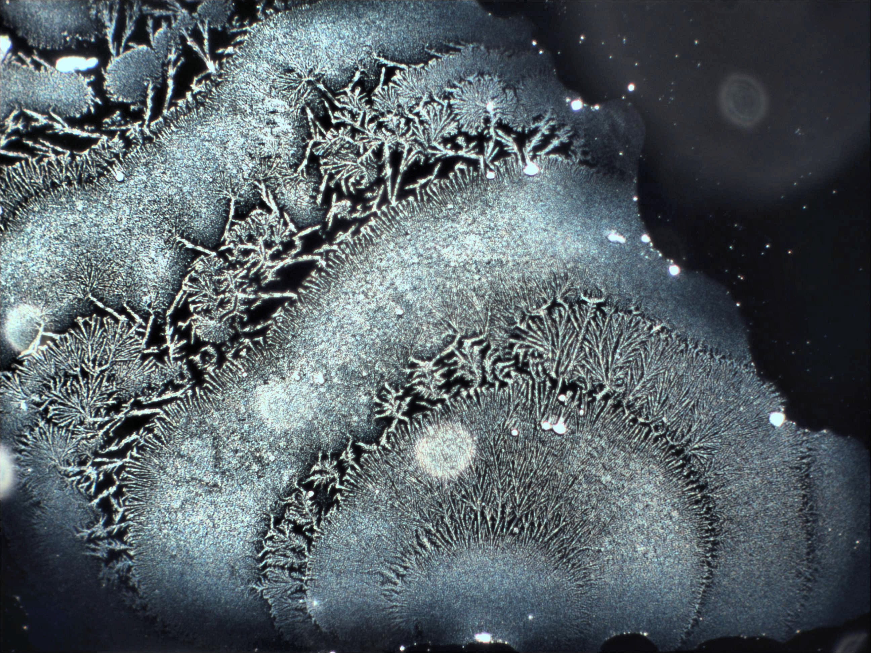
Private environmental monitoring from Germany

Other pictures show the ability of particles to convert infrared radiation and/or heat into light within the visible spectrum, i.e. they shine when heated. This property has been described as up-­‐conversion – it also is typical for (Ba, Sr_{x}) TiO₃. The warm breath of a human is sufficient to trigger an effect that easily over-­‐blends the capacities of the camera.
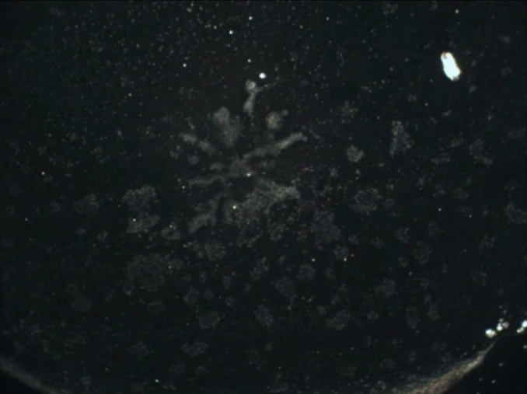
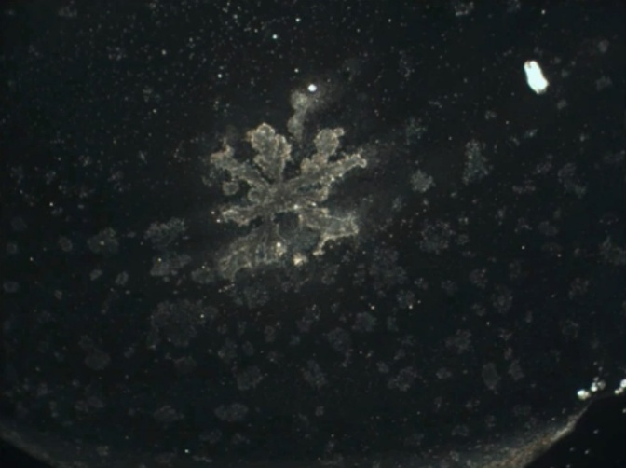

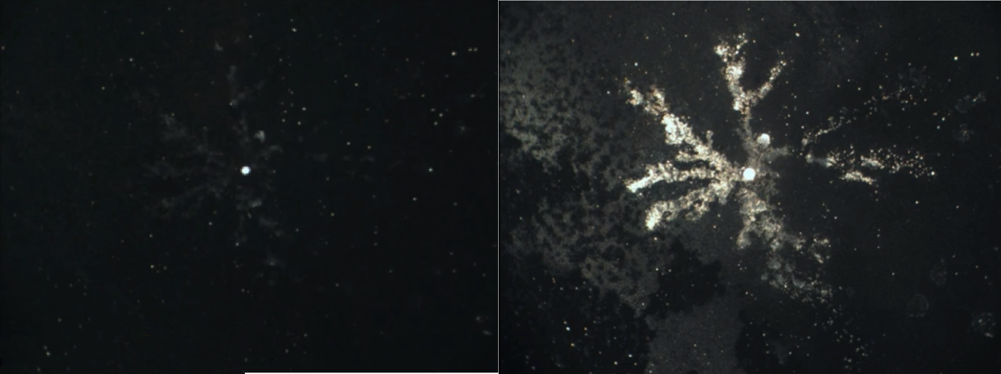
Private environmental monitoring from Germany

Knowing how the biophoton-­‐patterns within the body work, these properties get scary: This disrupts the multiple 3fold order of electromagnetic waves within the body and thus weakens the ability to form longitudinal waves on the highest order, turning biophotons into longitudinal waves. This stops biophotons to couple to scalar potential. This actually seems to be the effect that makes (Ba, Sr_{x}) TiO₃ usefull for self-­‐pumped phase conjugation (SPPC) applications. This is what makes it so dangerous for all life forms.

With these agents on board any attempt to take over the control with technical low frequent signals could much easier be crowned with success.

A second type of chemistry that seems to be in solution within the raindrop shows crystallization-­‐properties that resemble “whiskers”, mono-­‐crystalline particles that consist of a number of sharp needles heading into all directions. This could be Al₂O₃ or MnO₂.
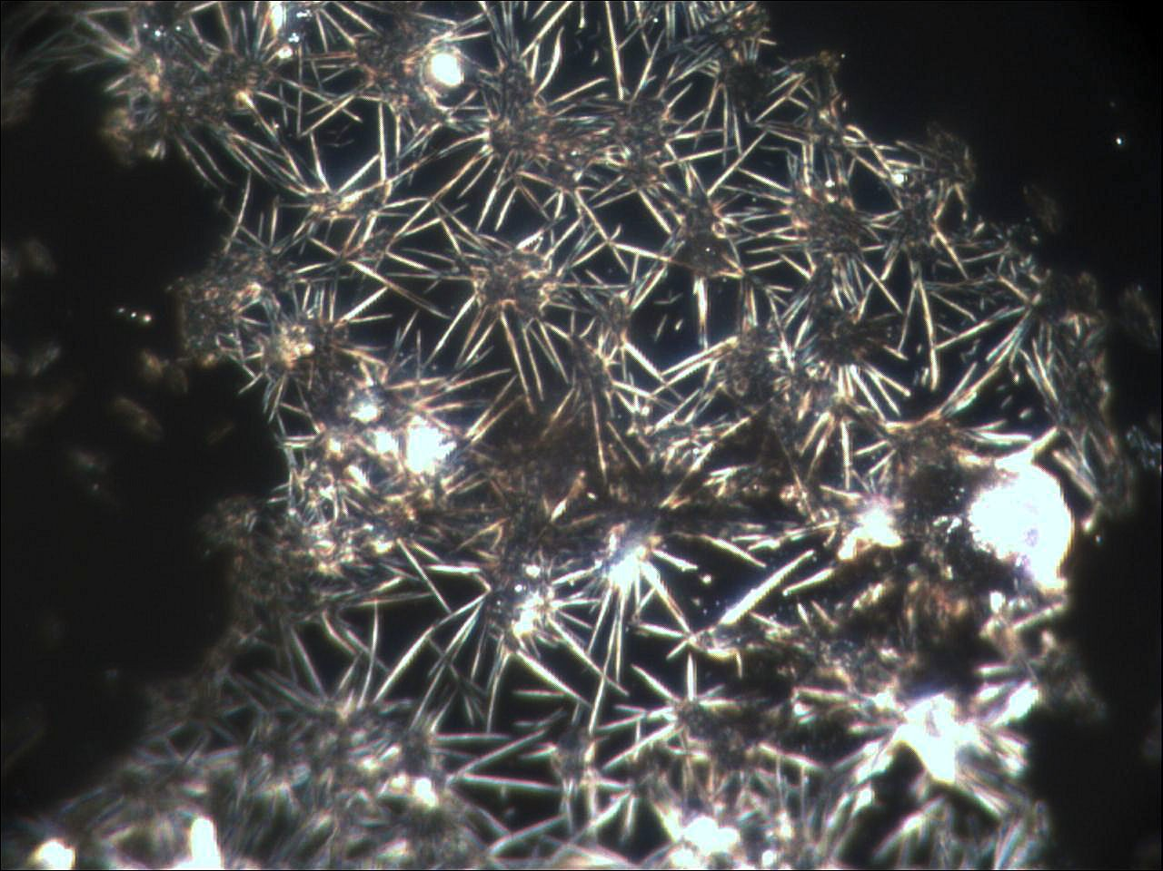
Private environmental monitoring from Germany

On some days tiny droplets of an unknown black liquid could be detected. We still don’t have chemical analysis of this material, but it might turn out to be Black Goo, a substance that will be discussed later in chapter 9.
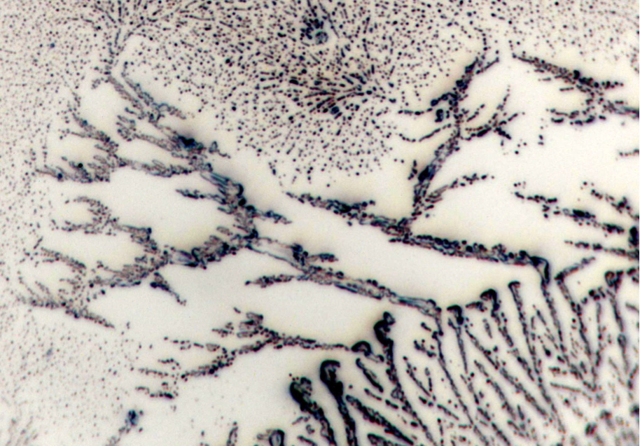
Private environmental monitoring from Germany

Transhumanistic Technologies II – Intracellular Systems
It is not easy to access the possibilities that are given by synthetic biology in a complex manner. The first thing to do is to encircle the field of studies. In genetics, like it was done since the early 60s, it all was about slicing DNA to fragments and introducing those fragments into other species’ DNA. In this way the scientists hoped to be able to transfer properties of one species onto another. Since the late 70s it is possible to fully synthesize DNA. The speed of synthesizing DNA has developed exponentially. Today the printout of a full size genome takes a few weeks at costs of a few cents per base-­‐pair. All one needs is the digitized source code. It does not matter whether this code originates from natural DNA or if it has been designed at the computer screen. Today this is a routine service, one sends the file to on of the two dozen labs specialized on this task and a few weeks later the readymade genome is sent in per snail mail.

DNA, RNA and PNA (DNA with a synthetic spine) , that have no antetype in nature is called synthetic biology.

To understand what can be done with synthetic biology it is important to first understand how a genome works. A genome has three functions:

- It is the first link in the formation of our body. DNA creates by copying half strands of itself RNA, RNA creates protein.
- DNA creates bio-­‐photons – this is the part we already know from prior chapters.
- And then there is what science calls junk DNA, the major part of the genome that apparently has no function at all, it doesn’t create light, it doesn’t create matter, however, its internal pattern follows the laws of the grammar of the human languages. I guess this is the part of nature where epigenetics materialize, which is the biological short term memory of nature. Once language is the common denominator it seems to be likely that this somehow is responsible for the connection between the body and the soul.

The different departments in synthetic biology have developed according to these different functions. Some of the scientists designed sequences that were meant to produce certain substances. In medicine this is about synthesizing active ingredients that normally are derived from expensive or rare plant material in bacteria cultures. In agro-­‐business it is about synthesizing fuels.

A different branch has specialized on the optical properties of the DNA. We need to realize that this approach might outshine everything we have learned about transhumanism. One can find the protagonists following the search item “optogenetics”. In contrast to the extracellular transhumanistic systems, that mainly originate from the US, this research concentrates in the German speaking part of Western Europe. Once it is possible to modify a bacterium in a way that it functions as a radio-­‐controlled light-­‐bulb collectively creating living plasma screens, it is obvious how big the temptation is to implement these sequences into the human genome to get access to the light-­‐body.

The third research area that has evolved is based on the idea to use DNA as digital processors. The creation of base-­‐pairs functioning as controllable transistor-­‐like elements turned out to be doable. The main problem was the re-­‐extraction of the data from the biological chip. At the moment this part of the game is somewhere in the proof-­‐of-­‐ principle-­‐state.

Mainly out of security reasoning, much of the effort has been laid on RNA instead of DNA. RNA doesn’t change biology on the deepest level – this reduces the risk of changing the genetic information – however it modifies the outcome of cell activity. Additionally it is easy to introduce RNA into cells. It is done by lipopeptides, which are complex proteins that hold a number of RNA strands.

Up to here this description is derived from what is known about the synthetic biology research in the civil domain. It is an open secret, that the military domain is ahead of the civil domain by 30 to 50 years. Less an open secret than a rule of thumb is that everything doable actually is done by the military – at least it is developed and tested in extensive field studies, mostly at the countries own civil population.

It would not be a surprise, if the military domain would have exploited all the possibilities in synthetic biology and would have already created bioweapons, that are based on synthetic RNA, consisting of one radio-­‐ controlled logic-­‐element and a sequence that either creates substances of defined quality – in the military context I would expect some kind of cell poison capable of disabling or killing a person – or light of defined quality, which would resume in psychotronic weapons. The controlling signal can be imagined as something like a dial-­‐in frequency-­‐sequence, that switches the line of RNA-­‐base-­‐pairs “open” to activate the sequence next to the logic element to either produce light of a defined quality or a specific substance. The implementation of the logic elements would make sure that the designed sequences are not activated by coincidence. A mass production of RNA strands of this kind – once the design is perfected – should be no problem.

Having such a technology airborne would turn all people to hostages of the entities, who know the activation codes and control transmission-­‐towers capable of serving the right frequencies.

If one looks into the recent history and considers whether there are settings that look like someone has been testing such a technology in open field studies, one immediately thinks of the narcolepsy in the Scandinavian countries.

Unconfirmed information relates this kind of agenda to a project called “R abe Neu”, developed by the Austrian Institute of Technology on behalf of “countries” and “entities associated to the intelligence community”. To be precise, there seems to exist detailed proof for this program, however the people who hold this proof decided to not publish it. This makes it difficult to deal with the topic. As far as we had insight into their papers, the controlling frequencies are in the range of 1-­‐10 GHz. The paper states the system is

airborne since 2003, and internally referred to as “Luftseuche” (in English “Air Plague”). It explicitly says that it is part of the so-­‐called chemtrails. As a proof of principle the paper also explicitly names one psychotronic dial in-­‐code, and refers to the existence of non-­‐ lethal dial in-­‐codes affecting different functions of the human body, as well as lethal dial-­‐ in-­‐codes causing cancer, killing within minutes (unknown mechanism) or immediately by making all infected cells produce prussic acid. Also, the papers discuss the effort done to optimize the cluster topology. This is extremely important information. Would this be about infecting cells with synthetic virus-­‐like RNA-­‐strands, cluster topology would not matter. Cluster topology matters, when these clusters are supposed to carry swarm intelligence, i.e. are meant to be able to carry artificial intelligence (AI) themselves.
Following the paper there is a deactivation code implemented to secure the system against abuse, however the deactivation-­‐code itself is not mentioned. According to independent information delivered by a former scientific director of the institute conducting this research, the entire deactivation code story was a scam, and once the system is run by the AI carried by the cluster topology, it is up to the AI to grant access – or take over control.
The same former scientific director stated that the entire design was initially based on alien technology.

Knowing that the US intelligence already devolved the decision about the assassination of dissidents to a central AI, this idea becomes even more irritating. It will not take long and all the way from surveillance, analysis of potential danger that is emanating from the dissident, down to the assassination command given to a drone or (when the system will be in full operation) to a RNA cluster, will lie outside human responsibility75.

Artificial swarm intelligence carried by a RNA cluster that is pervading human DNA also brings us straight to a scientific understanding what a bio-­‐robot might be.

Quantitative Analysis

Atmospheric barium-­‐deposition in Germany
During the last decades various state institutes have analyzed rainwater, dry atmospheric deposition (dust) and heavy metal content in organic matter, mainly by testing either dust deposition in a container covered by a roof to be protected from rain or by standardized grass samples grown for a period of 4 weeks to detect wet and dry atmospheric deposition of pollutants. This study refers mainly to publications of the Landesumweltamt Brandenburg and the Bayerisches Landesamt für Umwelt, two regional state authorities, and a few minor sources like ash analysis of biomass power plants run on grass. These measurements are available up to the year 2011. Due to the fact that the national Bundesumweltamt today has decided to only fulfill the “UN ECE Convention on long-­‐range trans boundary pollution” and the EU law “Richtlinie 2008/50EG from May 2008” the

75 Interview with a former Bafin-­‐employee, online auf http://www.extremnews.de/

national institutions are not monitoring barium, strontium and titanium.

The review of all the official barium deposit measurements available online showed a decrease in dry deposition by more than 90% during the last 15 years and in the same period of time an estimated increase of wet deposition of barium by close to 100%. This complete opposite development is remarkable. Dry deposition derives mainly from industrial pollution and uptake from dust from the ground. Wet deposition is associated to aerosols. Younger official data than 2011 are not available from official sources.

For 2012 we based the statistics on 60 available rain samples taken by private persons analyzed in certificated labs. These samples were collected and controlled by the initiative “Sauberer Himmel e.V.”.
These findings need to be reviewed against the background of strongly reduced pollution by all other metals. The following graph shows lead as an example.
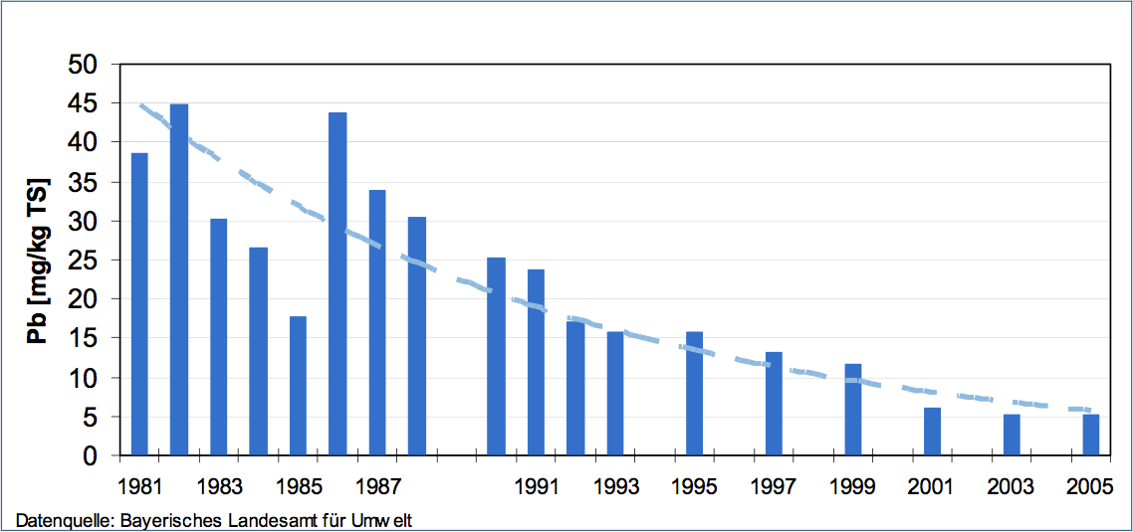
Lead in mg/kg dried grass samples (wet deposition) over the last 3 decades.

Both strontium and titanium have hardly been measured by the official authorities. Dry deposition of Barium was reduced like most other pollutants from heavy industry. There is no source for barium on the ground, like mining or industry, that can explain the increased levels in pollution registered in the wet deposition. The high amounts of Barium seem to come straight with the rain – which hints to high-­‐altitude-­‐aerosols as a source and thus to geo-­‐engineering or spraying for military purposes. The titanium pollution is mainly related to steel production and might have strongly been reduced due to the massive transfer of this type of industry to china.
The statistical evaluation of 72 rainwater samples by the author, gathered by the German “initiative for a clean sky” (Sauberer Himmel), indicates an amount of approx. 911 tons of barium falling out over Germany during the year 2012.
The grass samples can be estimated to mirror 1625 t barium in 2011, however this amount should also contain the dry deposition as well as some barium taken up by the plants from

the soil originating from mineral substrate.
If the original source of industrial barium pollution has been reduced by 90 % during the 15 years as shown by the values for dry deposition, and the overall values including wet and dry deposition went up by intermediated 100% since 2001, there is no other explanation than a new source that is explicitly connected to aerosols brought down by rain registered in the wet deposition analysis.
This new source then would be responsible for 90% of the total values in the year 2012. Therefore one should assume an atmospheric deposition of minimum 865 t barium originating from aerosols coming down with the rain from high altitudes.
Indicating (Ba, Sr_{x}) TiO₃ in nature is difficult. Measurements of bio-­‐available barium, strontium and titanium indicate elements in solution, but due to the non-­‐solubility of (Ba, Sr_{x})TiO₃ such measurements do not indicate nano-­‐crystals at all. An analysis of the total mineral content would correctly show Ba, Sr and Ti as single elements when performed with fluorine acid only, when nitric acid is used (Ba, Sr_{x}) TiO₃ would not show at all, Al₂O₃ would show only partly. It is impossible to speculate about total amounts. The measured number must origin from the leftovers of the crystals manufactured in the jet engines.
Optical analysis with the microscope can determine the existence of nano-­‐crystals within plant cell tissue, but would need time-­‐consuming statistics on thousands of single crystal measurements to make any quantitative statements.

Research in Norway
The Norwegian State monitors the atmospheric deposition of heavy metals in the country. The findings show like in Germany, a sharp decrease in industrial pollutants and a slight increase in substances associated with geo-­‐engineering, like Barium and Strontium.
However these values are average values with very high local variations.

The state-­‐run Klima-­‐ og forurensings direktoratet (Climate and pollution Agency) does extensive testing on airborne pollution. Due to wind patterns, Norway receives pollution transported long distances from sources in the central, east and southern parts of Europe to even remote areas of the country.
The standard measurement of air pollutants in Norway is done with moss of the type Hylocomium Splendens, not with grass, so direct comparison to German data cannot be done. Hylocomium Splendens do not use roots for uptake of water or nutrition, so it takes up only dry and wet deposition. Representative amounts of samples was first collected in 1977, 1985 and since then every 5 years evaluating 464 locations all over Norway. From each place 5 to 10 samples from an area of 50x 50meter have been taken, minimum 300 meter from main roads and houses. 42 elements including Al, Sr, Ba and Ti have been tested, but not all from the very beginning76

76 Atmosfærisk nedfall av tungmetaller i Norge (Atmospheric deposition of heavy metals in Norway )– Landsomfattende undersøkelse i 2010 (TA-­‐2859/2011)

Median values for analyzed moss for Norway:
Aluminum 1977 with 720 mg/kg, 1995 with 290 mg/kg , 2010 with 280 mg/kg
Titanium 1995 with 43 mg/kg, 2010 with 25 mg/kg
Strontium 1995 with 13 mg/kg, 2010 with 15 mg/kg
Barium 1995 with 24 mg/kg, 2010 with 25 mg/kg

Minimum and maximum values:
Aluminum showed in 2005 values between 58,0 -­‐ 12 121 mg/kg
2010 values between 46,0 -­‐ 4 581 mg/kg Titanium showed in 2010 values between 4,0 -­‐ 260 mg/kg Strontium showed in 2010 values between 1,9 -­‐ 72 mg/kg Barium showed in 2000 values between 4,3 -­‐ 217 mg/kg
2005 values between 4,2 -­‐ 119 mg/kg
2010 values between 4,0 -­‐ 325 mg/kg

The big differences in values of Barium and Strontium were assumed to either be the result of local Strontium deposition from the Atlantic or a result from the uptake of dust from Barium-­‐rich soils. Barium and Strontium distributions were statistically not associated.
Natural occurring Aluminum, Barium and Strontium in the soil is needed, and can be tolerated to a variable degree in different plants, local vegetation adjusts to the quality of the soil. When large amounts go into solution in rivers as Al3+, aluminum-­‐oxide is not tolerated by fish. In Norway this was a major problem during the years of heavy acid rain.
During the second half of the year 2012 some farmers at the east coast of Oslo Fjord in Norway experienced a significant slowing down of grass-­‐growth, which reduced the second harvest of hay. Samples of this grass, Timothy, Phleum pratense was collected, it was analyzed at the Norwegian Forest and Landscape Institute for the total amount of minerals:
Aluminum: 176 mg/kg
Barium: 49 mg/kg
Strontium: 69 mg/kg
Titanium: 28 mg/kg

We compared these results with the results obtained by the Norwegian school of veterinary science. They carried out a study collecting grass samples from all of Norway in 2006/7 This project has yet to be published; however our samples fall within the average of their study.
To see if any of the Barium in the ground could have an atmospheric input, the soil where the retarded grass grew were analyzed and compared to soil largely unexposed to rain for the last 70 years, by a barn build above it.
The soil unexposed to rain was higher in all measured metals except one. Evaporation brings minerals up from the rock bed, when no rain washes them out, and no plant

material is removed (which would have lowered the soils mineral content), so the levels remain high. The exception was Barium. Only barium measured higher outside on the open field.

Metal in Soil sa  Aluminum | mple  mg/kg | not exposed  25.150,00 | exposed to rain  22.900,00 | ratio  1.098
Barium | mg/kg | 140,00 | 155,00 | 0.903
Lead | mg/kg | 29,00 | 16,00 | 1.813
Arsenium | mg/kg | 4,80 | 2,80 | 1.714
Cadmium | mg/kg | 0,28 | 0,18 | 1.555
Nickel | mg/kg | 21,00 | 20,00 | 1.05
Palladium | mg/kg | <5 | <5

There is no local industry or mining that can explain this increased amount of Barium. The input by fertilizers used was controlled and showed no barium content on the label. The most likely source of this Barium is from wet atmospheric deposition.
However these values and their discussion is rather pointless. As mentioned, the synthesis of (Ba, Sr_{x}) TiO₃ nano-­‐particle in the jet engines would not be identified by the commonly used test methods, what might show up are just the non-­‐processed leftovers of the crystal-­‐ synthesis. The only method that practically might work out to detect the nano-­‐crystals is microscopy including some quantitative statistics.
In addition to the reduced growth of the grass monitored in Norway, there was a problem of fungi. Multiple factors may be in action. (Ba, Sr_{x}) TiO₃ may stop plant growth, it may also together with Al₂O₃ disturb cell potential that reduce the plants immune system as well as their vitality. We also know from experiments that exposure to high frequency radiation in a normal office of today can 600 fold the production of mycotoxins from fungi, compared to non-­‐radiated fungi. This is massive. Most places are today exposed to some degree of microwave (high frequency) radiation.
Among cows born in 2011 that this year gave birth for the first time, there was an unusual increase of difficult births in all cow races, in this area. The reason for this is still unknown. The barley for feed had been heavily infected with fungus, due to very wet summers. It is know among farmers that decreased fertility and increased abortion rate among their cows follows in years with fungus-­‐infected feed. Also the mechanisms mention above may be a part of this picture.
Images from the day of sample taking east of the Oslo fjord.

A promising morning of a summer day. Relative short contrails as an indicator for rather dry, warm air at high altitudes.

First appearance of persistent contrails.

Spreading contrails forming white hazy skies.

Hazy sky and a completely died off birch forest 3 km from the farm.

Field with partly retarded plant growth. On the right side normal growth rate, on the left side retarded growth.
Damaged grass, light green color, brown spots.

Damage by fungi, possibly as a result of disturbed cell potential.
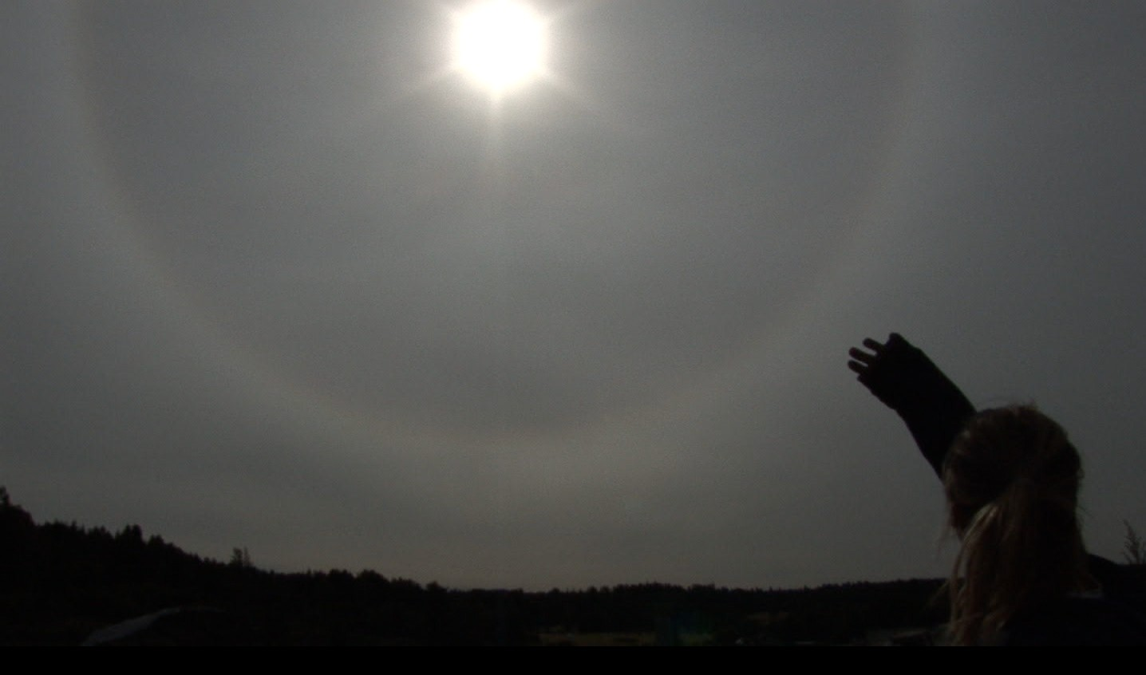

Haze coming down to the surface creating a halo, about 14.30 in the afternoon, a structure that should appear with ice crystals at high altitudes but not on a summer day with temperatures of about 17 degrees Celsius near ground level. In earlier times halos like this were seen on ice-­‐cold winter days around the sun or the moon at night. (All Fotos from Norway by Kristin Hauksdottir)

Politics, infrastructure and possible military use
When governmental, military or agency activities are classified, when people involved have to sign non-­‐disclosure agreements and are threatened with being jailed, then normally one finds what is declared as being conspiracy theory as a natural reaction of the human mind. One has a secret, the other one wonders what it is. Simple as that. Project Cloverleaf is as highly classified as a project can be.
The public is left with no official information. There is a little whistle blowing that might contain truth, but also might contain considerable amounts of disinformation. Normally, there should be no place for this in a paper that aims to be scientific in spirit. But at this point there is no other option than to cite the whistle blowers and accept their wish to hide their identity. And again look for scientific proof for their claims.
Thus the following information is not citable in the scientific sense of the word and might contain desinformation.
Trying to find out what actually is happening in the field of geo-­‐engineering is not easy. The structure one meets is onion-­‐like. There is an official surface that is moving big money in research but projects practical geo-­‐engineering mainly into the future77. But even if one looks behind the scene, listens to the statements of whistle blowers and reads secret documents that were unintentionally exposed to the public, there is not one coherent truth but rather onion like layers of different concepts of reality to be found.
The outer onionskin looks like this: geo-­‐engineering was first thought of in pre WWII Germany. Most ideas were megalomaniac but rather grounded, like cutting of and drying out the Mediterranean to harvest land and set up a water power plant to supply the entire area with electricity. A second concept was to melt down the pole caps to get access to natural resources underneath. Some of that engineering spirit came to the US after the war. Operation Paperclip recruited 10.000 German top researchers to serve the US-­‐ military. The targets publicly discussed were rather peaceful. Like preventing hurricanes and hale, directing rain to guarantee harvests.
In 1964 the American National Science Foundation called in a special commission on weather manipulation. However, the first practical applications turned out to be less peaceful. It was the cloud seeding conducted in North Vietnam to enhance monsoon rains and flood the jungle to cut the Vietcong off from supplies.
The first notable document relating to the form of cloud seeding discussed in this paper is the Welsbach patent78 in 1986. It is the first patent suggesting the spraying of aluminum oxide and metal salts to combat climate change. Since then more follow up patents have been filed that cover the entire technical process of cloud seeding by aerosol spraying from both civil and military airplanes.

77 Professor John Shepherd et al.: Geoengineering the Climate: Science, Governance and Uncertainty. The Royal Society 2009.
78 US-­‐Patent No. 5,003,186

In 1990 the US Government entered a phase of intensive research into Geo-­‐Engineering with the “Global Change Research Act”79.
In 2001, President elect George W. Bush established the (CCRI) Climate Change Research Initiative. A year later it was made public that the USGCRP or United States Global Change Research program and the CCRI both would become what is known as the (CCSP) Climate Change Science Program. Now, under the Obama Administration the legacy continues
to move forward as the USGCRP, with a yearly budget of 2.7 billion dollars.80 An insight into these programs reveals that most of it is about combating not monitoring climate change.
Another initiative is projected by the US Department of Homeland Security, which intends to set up the “Hurricane Aerosol and Microphysics Program”81.
In 2012 US-­‐scientists targeted “a affordable price of below 5 billion a year” to “blow a million of tons” into altitudes of 18 miles82.
All these sources refer to man made climate change as the problem to be solved by geo-­‐ engineering. Climate-­‐change is believed to be caused mainly by CO₂.
The findings of this research are summarized in this graph:
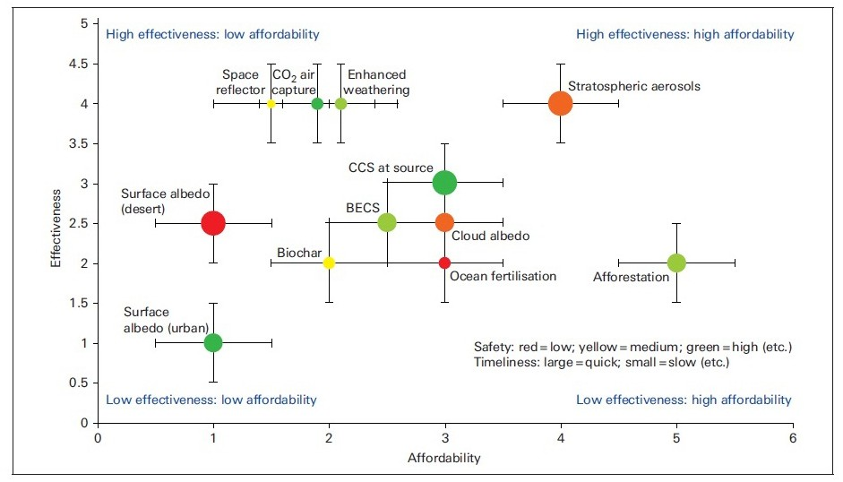

Source unknown, for copyright issues please contact the author.

The following passage draws a vague picture of the actions projected and of the aerosols

79 Official governmental website: http://www.gcrio.org/gcact1990.html
80 Shepard Ambellas & Avalon: The Budget Obama Didn’t Want You To Know About. the intelhub.com, March 30, 2011. Online at: http://theintelhub.com/2011/03/30/secret-­‐presidential-­‐chemtrail-­‐budget-­‐uncovered-­‐exceeds-­‐billions-­‐to-­‐ spray-­‐populations-­‐like-­‐roaches/ on Nov. 22nd 2012.
81 Richard W. Spinrad to William Laska, “Response to Statement of Work: Hurricane Aerosol and Microphysics Program,” US Department of Commerce, National Oceanic and Atmospheric Administration, Silver Springs, MD, July 29, 2009, http://voices.washingtonpost.com/capitalweathergang/noaa_letter_dhs_hurricane_modification.pdf
82 Allister Doyle and David Fogarty, “’Sunshade’ to Fight Climate Change Costed at $5 Billion Year,” Reuters, August 31, 2012, http://in.reuters.com/article/2012/08/30/climate-­‐sunshade-­‐idINDEE87T0K420120830

planed to be used:
So far, launching reflective materials into the upper stratosphere seems to be the easiest and most cost-­‐effective option. This could be accomplished by using high-­‐flying aircraft, naval guns, or giant balloons. The appropriate materials could include sulfate aerosols (which would be created by releasing sulfur dioxide gas), aluminum oxide dust, or even self-­‐levitating and self-­‐orienting designer particles engineered to migrate to the Polar Regions and remain in place for long periods. If it can be done, concentrating sunshades over the poles would be a particularly interesting option, since those latitudes appear to be the most sensitive to global warming. Most cost estimates for such geo-­‐ engineering strategies are preliminary and unreliable. However, there is general agreement that the strategies are cheap; the total expense of the most cost-­‐effective options would amount to perhaps as little as a few billion dollars, just one percent (or less) of the cost of dramatically cutting emissions.83

The description of “self-levitating and self-orienting designer particles” might fit on (Ba, Sr_{x}) TiO₃, with its ability to be ionized and directed by microwave radiation.
This is the outer skin of the onion.
When we go to pre-­‐climate-­‐change-­‐times, things still looked a bit different. Jim Phelps had been working for many years at the Oak Ridge National Laboratories researching the ozone hole and other air-­‐pollution related problems. Global warming was already known back then. However it was not dramatizes and mainly related to fluorine-­‐ and sulfur-­‐ emissions from jet fuel. Fluorine and sulfur, creating the aggressive HF and H₂SO₄ acid in the clouds, was regarded as the main cause for acid rain. Both sulfur and fluorine compounds were regarded as a reason for increasing persistence of contrails as well as of the appearance of more high altitude cirrus clouds. These clouds were believed to hold back infrared radiation and cause global warming. To prevent damage done by especially fluorine, that formed toxic aluminum-­‐fluorine compounds once raining down, he suggested adding TiO₂ to the jet fuel – or spray the compounds simultaneously during the flight – to bind the fluorine to metals that form less toxic compounds. As to the military branch of geo-­‐engineering, there are only a few sources, mainly ex employees of various agencies.
We can trace the beginnings of military Spraying-­‐Operations also referred to the Project Cloverleaf right to Dr. Edward Teller, father of the hydrogen bomb and proponent of nuking inhabited coast-­‐ lines to rearrange them for economic projects. Before he died in 2003, Teller was director emeritus of Lawrence Livermore National Laboratory, where plans for nuclear, biological and directed energy weapons are crafted. In 1997, Teller publicly outlined his proposal to use aircraft to scatter in the stratosphere millions of tons of electrically conductive metallic materials, ostensibly to reduce global warming84. (…)

Teller estimated that commercial aircraft could be used to spew these particles at a cost of 33 cents a pound. (…) A 1991 Hughes aircraft patent confirms that sunscreen particulate materials can be run

83 David G. Victor, M. Granger Morgan, Jay Apt, John Steinbruner, and Katharine Ricke: The Geoengineering Option. A Last Resort Against Global Warming? Foreign Affairs, March/April 2009
84 Edward Teller, Lowell Wood, Roderick Hyde: Global Warming and Ice Ages: Prospects for Physics-­‐Based Modulation of Global Change, Edward Teller and Lowell Wood, Hoover Institution, Stanford University, prepared for invited presentation at the International Seminar On Planetary Emergencies, Erice, Italy, August 20-­‐23, 1997; also "The Planet Needs a Sunscreen," Wall Street Journal, 10-­‐17-­‐97.

through jet engines.85

A different story is told by A. C. Griffith86, an NSA, later CIA employee who uncovered his truth on the Monday edition of the power hour, a national broadcast show. Another onionskin. Griffith served at the Ray Patterson Air force base, which he called the headquarters of US chemtrailing programs. Griffith refers to an ongoing cold war between Russia and the US utilizing scalar weapons. The worst incident of this cold war was – according to the ex US military Col. Tom Bearden, whom Griffith cites on the radio show –, the attempt of Russia to trigger an earthquake in the St. Andreas fault with the Ukraine based (so-­‐called) Woodpecker devices (long range micro-­‐wave transmitters), that were fed with electricity by the Chernobyl power stations. According to Griffith, the attack was staved of with the help of Israel, thus causing what is known as the Chernobyl accident.
Griffith sees the US being behind other countries in the development of these weapons as well as of possible defense systems. Against this background he describes the development of chemtrail-­‐programs as a necessary defense system developed by the CIA/NSA intelligence community. The CIA, that had been operating a major aircraft fleet for drug trade to finance their unofficial activities i.e. black ops, must have been running out of spraying capacities and tried to involve the Navy. Admiral Jeremia Border, Chef of US-­‐Navy Operations, refused to join into the program and officially committed suicide by shooting himself twice into the chest. Since then the navy became part of the referred Project Cloverleaf. To explain the role of aerosols Griffith referred to a paper by Matthew Daggett with the title “Atmospheric sensitivity invalidation study of the variable terrain radio parabolic equation model”, describing a 3D battlefield radar monitoring system that could be operated from a ship 400 miles off the shore by using barium-­‐salts as an reflective aerosol. Griffith also mentioned DARPA and other agencies as possibly joining in to make use of the aerosol spraying for different purposes.
On the next layer one might discover the interconnection between the civil and company-­‐ based research done with HAARP, ICECAT and similar microwave transmitting devices and aerosol spraying – assuming that this is the direction Griffith should have been pointing to.
According to University of Ottawa Professor Michael Chossudovsky, the military's High-­‐frequency Active Auroral Research Program (HAARP), operating in Alaska as part of the Strategic Defense Initiative, is a powerful tool for weather and climate modification87. Operated jointly by the U.S. Navy and Air Force, HAARP antennas bombard and heat the ionosphere, causing electromagnetic frequencies to bounce back to earth, penetrating everything living and dead88.
HAARP transmissions make holes in the ozone89, creating yet another hobgoblin. HAARP inventor Bernard Eastlund described in his original patent how antenna energy could interact with plumes of

85 Amy Worthington: Aerosol and Electromagnetic Weapons in the Age of Nuclear War. Global Research | June 1, 2004 86 power hour, national broadcast show, online at http://www.youtube.com/watch?v=rS3mVg7GIGI Archived partI, part2, part3
87 "Washington's New World Order Weapons Have the Ability to Trigger Climate Change," Center for Research on Globalization, Professor Michael Chossudovsky, University of Ottawa, January 2001.
- "HAARP: Vandalism in the Sky?" Nick Begich and Jeane Manning, Nexus Magazine, December 1995.
- Dr. Castle presents information on how HAARP punches massive holes in the open-­‐air column ozone and how the Air Force then uses toxic chemicals to "patch" the holes it has created: Dr. Castle says: "Welsbach seeding and ozone hole remediation sciences utilize chemistries that are toxic to humans and the environment."

atmospheric particles, used as a lens or focusing device, to modify weather90. HAARP is capable of triggering floods, droughts and hurricanes, much to the chagrin of both the European Parliament and the Russian Duma91.
HAARP also generates sweeping pulses through the ULF/ELF range92. In 2000, independent researchers monitored HAARP transmissions of 14 hertz. They found that when these signals were broadcast at high output levels, wind speeds topped 70 miles per hour. They watched as these same transmissions dispersed a huge weather front approaching the west coast from California to British Columbia. Although precipitation had been originally forecast, the front was seen shredding apart on satellite photos and rain did not materialize93. The hobgoblin drought can be an enriching and empowering tool for certain corporate and governing entities.
HAARP is not only capable of destabilizing agricultural and ecological systems anywhere on the planet, but its effects can target select regions to affect human physical, mental and emotional responses during non-­‐lethal warfare projects94. HAARP frequencies beamed at specific targets can generate catastrophic earthquakes, exactly like the quake last December, which killed thousands of people in Iran, a nemesis nation according to the Bush administration. 95

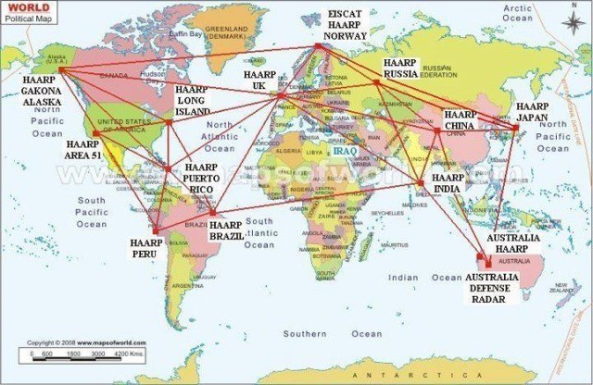
HAARP-­‐Similar devices distributed around the globe.

Slowly coming to the core of it, it makes sense to have a second look to the very beginning of things. Project Paperclip was not peaceful at all. The transfer of German scientist led to

90 "HAARP: Vandalism in the Sky?" Begich and Manning; Researcher David Yarrow is quoted as saying that Earth's axial spin means that HAARP bursts are like a microwave knife producing a "long tear-­‐-­‐an incision" in the multi-­‐layer membrane of ionospheres that shield the Earth's surface from intense solar radiation.
91 U.S. HAARP Weapon Development Concerns Russian Duma, Interfax News Agency, 8-­‐10-­‐02.
92 HAARP Update, Elfrad Group, http://elfrad.org/2000/Haarp2.htm 6-­‐27-­‐00.
93 "14 Hertz Signal Suppresses Rainfall, Induces Violent Winds," 10-­‐25-­‐00, Newshawk Inc.; "When the Army Owns the Weather-­‐Chemtrails and HAARP," Bob Fitrakis, 2-­‐13-­‐02: In this article HAARP inventor Bernard Eastlund is quoted on how HAARP can affect the weather: "Significant experiments could be performed. The HAARP antenna as it is now configured modulates the auroral electrojet to induce ELF waves and thus could have an effect on the zonal winds."
94 Angels Don't Play This HAARP, Begich and Manning, op. cit.
95 Entire passage: Amy Worthington: Aerosol and Electromagnetic Weapons in the Age of Nuclear War. Global Research | June 1, 2004

the development of nuclear weapons, chemical weapons, biological weapons, and methods of mind control. All of them were more or less secretly tested on civilians and army stuff.
The most devastating development was the conversion of fluorine waste from the aluminum production into a supplement in drinking water and toothpaste in the 60s. This technique of mind control originally was developed by IG-­‐Farben as a method to silence occupied territories, concentration camps and prisoners of war camps by poisoning the habitants with fluor-­‐compounds via the drinking water, making them will-­‐less and dull.
About the same time the industry started to distribute jet fuel with fluorine-­‐based additives leading to global dimming and to major damage within nature by acid rains and – following the suggestions of IG Farben – to damage of a unknown extend to the people’s minds.
It is interesting to know that IG Farben was financed and “inspired” by the same groups who were pushing the eugenic agenda in the US during the 30s, leading to thousands and thousands of forced sterilizations. IG Farben later created and produced Cyclon B, and there is a direct economic connection between IG Farben, DOW Chemicals and Monsanto, responsible for the production and the spraying of Agent Orange in Vietnam.
It is very hard to say how far the influence of groups associated to the eugenic agenda reaches today. Both Rockefeller and Bill Gates with their empire of charities openly avow as acting in this spirit, as well as characters like Henry Kissinger who targeted the depopulation of 3rd world countries as a main interest of US-­‐foreign policy96.
Still, even if these elements can be found in US-­‐politics, it is hard to say when and by whom the properties of barium-­‐strontium-­‐titanate or other aerosols could be intentionally abused to harm people by applying it as a weather or earthquake weapon, or as an agent for mind control.

Project “Cloverleaf”
  - Military purpose
In chapter 10 we could follow up the development up to the invention of the barium-­‐ method by Jim Phelps in the year 1996. From 1996 to 1998 there apparently were a few experimental projects conducted by the CIA utilizing Barium. Since 1998 the entire territory of the United States is reported to have become subject to aerosol spraying. For the rest of the world there is no reliable information which country joined the program at what time. Within the NATO Cloverleaf is associated with the “Partnership for Peace“. This partnership includes non-­‐NATO-­‐countries like Croatia, South Africa and Switzerland. China does not take part. For the southern hemisphere it is associated with the Antarctica treaty.

We could find one anonymous posting that maybe reveals the military purpose of the

96 NATIONAL SECURITY COUNCIL, WASHINGTON, D.C. 20506 April 24, 1974 National Security Study Memorandum 200.

project, titled: Project Cloverleaf — The Science Behind it97

It involves the combination of chemtrails for creating an atmosphere that will support electromagnetic waves, ground-­‐based, electromagnetic field oscillators called gyrotrons, and ionospheric heaters.
Particulates make directed energy weapons work better. It has to do with “steady state” and particle density for plasma beam propagation. They spray barium powders and let it photo-­‐ionize from the ultraviolet light of the sun. Then, they make an aluminum-­‐plasma generated by “zapping” the metal cations that are in the spray with either electromagnetics from HAARP, the gyrotron system on the ground [Ground Wave Emergency Network], or space-­‐based lasers. The barium makes the aluminum-­‐ plasma more particulate dense. This means they can make denser plasma than they normally could from just ionizing the atmosphere or the air.
More density [more particles] means that these particles, which are colliding into each other will become more charged because there are more of them present to collide. What are they ultimately trying to do up there — is create charged-­‐particle, plasma beam weapons.
Chemtrails are the medium – GWEN pulse radars, the various HAARPs, and space-­‐based lasers are the method, or more simply: Chemtrails are the medium — directed energy is the method. Spray and Zap. This system appears to be in Russia, Canada, the United States, and all of Europe. Exotic weapons can be mobile, stationary, land-­‐based, aerial, or satellite. It is an offensive and defensive system against EM attacks and missiles.
It uses ionospheric particle shells as defense mechanisms [like a bug-­‐zapper shell] against missiles and EM attacks. That means they spray and then pump up the spray with electromagnetics. When these shells are created using the oscillating, electromagnetic, gyrotron stations, it “excludes” and displaces the background magnetic field. These shells can be layered one above another in a canopy fashion for extra protection from missiles.
The chemtrail sprays have various elements in them like carbon, which can used to absorb microwaves. Some of these sprays have metal flakes in them that make aerial craft invisible to radar. Spoofer sprays. Sprays like these can be used to create colorful, magnetized plasmas to cloak fighter jets. There are satellite weapons involved. Activists are using meters and are getting readings of microwaves, x-­‐rays, and some other kind of emission that they are not sure of, maybe a low-­‐intensity laser.
They are also photographing gas plasma generation due to the heating of chemtrails by electromagnetics. The technical names for vertical and horizontal plasma columns are columnar focal lenses and horizontal drift plasma antennas. Various sizes of gas plasma orbs are associated with this technology. These orbs can be used as transmitters and receivers because they have great, refractory and optical properties.
They also are capable of transmitting digital or analog sound. Barium, in fact, is very refractive — more refractive than glass. What does that mean? Our country has a history of experimenting on its citizens. We are talking about satellite charged-­‐particle frequency weapons attacking a person 24 hours a day. Psychotronic weapons are considered weapons of mass destruction by the U.N. HAARPs can create earthquakes98and can also x-­‐ray the earth to find underground military bases,
gold, or oil reserves. These ionospheric heaters can also operate as an over-­‐the-­‐horizon or under-­‐the-­‐ ocean communications system. This system can control the weather or create disasters.
Taken together with the aurora keyhole through-­‐your-­‐roof satellite surveillance system, Echelon electronic computer/phone sweeps, plasma-­‐cloaked DOD Drug War helicopters and stealths, implants, and cameras on the street, it constitutes one, big global and space control grid. These weapons involve beams. Two beams overlapped will couple into a particle-­‐ion beam that will bounce off of a remote

97 disclosure-­‐tv-­‐blog, online http://www.disclose.tv/forum/project-­‐cloverleaf-­‐chemtrails-­‐and-­‐their-­‐purpose-­‐ t72795.html#ixzz2HmY3MiGL, Jan. 12th, 2013.
98 Compare: S. S. De1, B. K. De, B. Bandyopadhyay, S. Paul, D. K. Haldar, A. Bhowmick, S. Barui, and R. Ali: Natural Hazards and Earth System Sciences. Effects on atmospherics at 6 kHz and 9 kHz recorded at Tripura during the India-­‐Pakistan Border earthquake. Nat. Hazards Earth Syst. Sci., 10, 843–855, 2010.

target and send a holographic image back to the satellite for remote spying operations. When you cross two strong beams, you can supposedly create scalar energies.
These energies can be used as untraceable weapons for nuclear size explosions or for defense. These crossed-­‐energies can be used to cause a person’s physical electrical system to fail or with a lower frequency, administer a kind of remote electro-­‐shock. Visualize touching a positive and negative electric cable to each other on top of your head. Scalar energies can be utilized in hand-­‐held military guns and on tanks. They can dud-­‐out electronics or cause large, electrical blackouts. Scalar energies are practically impossible to shield against. You need lead, ceramics, and a deep underground facility to not be affected by these weapons. Or, you need to be up and above the field of battle.

Involvement of civil airlines
A matter that is heavily discussed is the possible involvement of civil airlines. There were two anonymous propositions to this topic. The first interesting one was a statement published on a radio show coming from someone who declared he was an airplane mechanic:

For reasons you will understand as you read this I cannot divulge my identity. I am an aircraft mechanic for a major airline. I work at one of our maintenance bases located at a large airport. I have discovered some information that I think you will find important. First I should tell you something about the "pecking order" among mechanics. It is important to my story and to the cause to which you have dedicated yourself.
Mechanics want to work on three things. The avionics, the engines, or the flight controls. The mechanics that work on these systems are considered at the top of the "pecking order". Next come the mechanics that work on the hydraulics and air conditioning systems. Then come the ones who work on the galley and other non-­‐essential systems. But at the very bottom of the list are the mechanics that work on the waste disposal systems. No mechanic wants to work on the pumps, tanks, and pipes that are used to store the waste from the lavatories.
But at every airport where I have worked there are always 2 or 3 mechanics that volunteer to work on the lavatory systems. The other mechanics are happy to let them do it. Because of this you will have only 2 or 3 mechanics that work on these systems at any one airport. No one pays much attention to these guys and no mechanic socializes with another mechanic who only works on the waste systems. In fact I had never thought much about this situation until last month.
Like most airlines we have reciprocal agreements with the other airlines that fly into this airport. If they have a problem with a plane one of our mechanics will take care of it. Likewise if one of our planes has a problem at an airport where the other airline has a maintenance base, they will fix our plane.
One day last month I was called out from our base to work on a plane for another airline. When I got the call the dispatcher did not know what the problem was. When I got to the plane I found out that the problem was in waste disposal system. There was nothing for me to do but to crawl in and fix the problem. When I got into the bay I realized that something was not right. There were more tanks, pumps, and pipes then should have been there. At first I assumed that the system had been changed. It had been 10 years since I had worked on one. As I tried to find the problem I quickly realized the extra piping and tanks were not connected to the waste disposal system. I had just discovered this when another mechanic from my company showed up. It was one of the mechanics who usually works on these systems. I happily turned the job over to him. As I was leaving I asked him about the extra equipment. He told me to "worry about my end of the plane and let him worry about his!"
The next day I was on the company computer to look up a wiring schematic. While I was there I decided to look up the extra equipment I had found. To my amazement the manuals did not show any of the extra equipment I had seen with my own eyes the day before. I even tied in to the manufacturer files and still found nothing. Now I was really determined to find out what that equipment did. The next week we had three of our planes in our main hanger for periodic inspection. There are mechanics crawling all over a plane during these inspections. I had just finished my shift and I decided to have a

look at the waste system on one of our planes. With all the mechanics around I figured that no one would notice an extra one on the plane. Sure enough, the plane I choose had the extra equipment!
I began to trace the system of pipes, pumps, and tanks. I found what appeared to be the control unit for the system. It was a standard looking avionics control box but it had no markings of any kind. I could trace the control wires from the box to the pumps and valves but there were no control circuits coming into the unit. The only wires coming into the unit was a power connection to the aircraft's main power bus.
The system had 1 large and 2 smaller tanks. It was hard to tell in the cramped compartment but it looked like the large tank could hold 50 gallons. The tanks were connected to a fill and drain valve that passed through the fuselage just behind the drain valve for the waste system. When I had a chance to look for this connection under the plane I found it cunningly hidden behind a panel under the panel used to access the waste drain.
I began to trace the piping from the pumps. These pipes lead to a network of small pipes that ended in the trailing edges of the wings and horizontal stabilizers. If you look closely at the wings of a large airplane you will see a set of wires, about the size of your finger, extending from the trailing edge of the wing surfaces. These are the static discharge wicks. They are used to dissipate the static electric charge that builds up on a plane in flight. I discovered that the pipes from this mystery system lead to every 1 out of 3 of these static discharge wicks. These wicks had been "hollowed out" to allow whatever flows through these pipes to be discharged through these fake wicks.
It was while I was on the wing that one of the managers spotted me. He ordered me out of the hanger telling me that my shift was over and I had not been authorized any overtime.
The next couple of days were very busy and I had no time to continue my investigation. Late one afternoon, two days after my discovery, I was called to replace an engine temperature sensor on a plane due to take off in two hours. I finished the job and turned in the paperwork.
About 30 minutes later I was paged to see the General Manager. When I went in his office I found that our union rep and two others who I did not know were waiting on me. He told me that a serious problem had been discovered. He said that I was being written up and suspended for turning in false paperwork. He handed me a disciplinary form stating that I had turned in false paperwork on the engine temperature sensor I had installed a few hours before. I was floored and began to protest. I told them that this was ridiculous and that I had done this work. The union rep spoke up then and recommended that we take a look at the plane and see if we could straighten it all out. It was at this time that I asked who the other two men were. The GM told me that they were airline safety inspectors but would not give me their name.
We proceeded to the plane, which should have been in the air but was parked on our maintenance ramp. We opened the engine cowling and the union rep pulled the sensor. He checked the serial number and told everyone that it was the old instrument. We then went to the parts bay and went back into the racks. The union rep checked my report and pulled from the rack a sealed box. He opened the box and pulled out the engine temperature sensor with the serial number of the one I had installed. I was told that I was suspended for a week without pay and to leave immediately.
I sat at home the first day of my suspension wondering what the hell had happened to me. That evening I received a phone call. The voice told me "Now you know what happens to mechanics who poke around in things they shouldn't. The next time you start working on systems that are no concern of yours you will lose your job! As it is I'm feeling generous, I believe that you'll be able to go back to work soon" CLICK. Again I had to pick myself from off the floor. I made the connection that what had happened was directly connected to my tracing the mysterious piping. The next morning the General Manager called me. He said that due to my past excellent employment record that the suspension had been reduced to one day and that I should report back to work immediately. The only thing I could think of was what are they trying to hide and who are THEY!
That day at work went by as if nothing had happened. None of the other mechanics mentioned the suspension and my union rep told me not to talk about it. That night I logged onto the Internet to try to find some answers. I don't remember now how I got there but I came across your site. That's when it all came together. But the next morning at work I found a note inside my locked locker. It said, "Curiosity killed the cat. Don't be looking at Internet sites that are no concern of yours."
Well that's it. THEY are watching me.

Well you already know what they are doing. I don't know what they are spraying but I can tell you how they are doing it. I figure they are using the "honey trucks". These are the trucks that empty the waste from the lavatory waste tanks. The airports usually contract out this job and nobody goes near these trucks. Who wants to stand next a truck full of sh-­‐-­‐. While these guys are emptying the waste tanks they are filling the tanks of the spray system. They know the planes flight path so they probably program the control unit to start spraying some amount of time after the plane reaches a certain altitude. The spray nozzles in the fake static wicks are so small that no one in the plane would see a thing. (Signed:) God help us all, A concerned citizen.99
As a response to that interview someone sent an anonymous email introducing himself as a director of an airline.
I read email you received from the anon. mechanic and felt compelled to respond to it. I, too, work for an airline, though I work in upper management levels. I will not say which airline, what city I am located, nor what office I work for, for obvious reasons. I wish I could document everything I am about to relate to you, but to do so is next to impossible and would result in possible physical harm to me.
The email from the anonymous mechanic rings true. Airline companies in America have been participating in something called Project Cloverleaf for a few years now. The earliest date anyone remembers being briefed on it is 1998. I was briefed on it in 1999. The few airline employees who were briefed on Project Cloverleaf were all made to undergo background checks, and before we were briefed on it we were made to sign non-­‐disclosure agreements, which basically state that if we tell anyone what we know we could be imprisoned.
About twenty employees in our office were briefed along with my by two officials from some government agency. They didn't tell us which one. They told us that the government was going to pay our airline, along with others, to release special chemicals from commercial aircraft. When asked what the chemicals were and why we were going to spray them, they told us that information was given on a need-­‐to-­‐know basis and we weren't cleared for it. They then went on to state that the chemicals were harmless, but the program was of such importance that it needed to be done at all costs. When we asked them why didn't they just rig military aircraft to spray these chemicals, they stated that there weren't enough military aircraft available to release chemicals on such a large basis as needs to be done. That's why Project Cloverleaf was initiated, to allow commercial airlines to assist in releasing these chemicals into the atmosphere. Then someone asked why all the secrecy was needed. The government reps then stated that if the general public knew that the aircraft they were flying on were releasing chemicals into the air, environmentalist groups would raise hell and demand the spraying stop. Someone asked one of the G-­‐men then if the chemicals are harmless, why not tell the public what the chemicals are and why we are spraying them? He seemed perturbed at this question and told us in a tone of authority that the public doesn't need to know what's going on, but that this program is in their best interests. He also stated that we should not tell anyone, nor ask any more questions about it. With that, the briefing was over.
All documents in our office pertaining to Project Cloverleaf are kept in locked safes. Nobody is allowed to take these documents out of the office. Very few employees are allowed access to these documents, and they remain tight-­‐lipped about what the documents say.
Mr. Carnicom, I am no fool. I know there's something going on. And frankly, I am scared. I feel a high level of guilt that I have been aware of this kind of operation but unable to tell anyone. It's been eating away at me, knowing that the company I work for may be poisoning the American people. I hope this letter will open some eyes to what's happening.
Again, I wish I could give you documented information, but you have to understand why I must remain totally anonymous. Thank you.

99 Radio-­‐INTERVIEW (Live on Coast-­‐to-­‐Coast radio, May 17, 2003)

Organizations involved
During the work of several civil right organizations that have been collecting data about aerosol spraying it turned out that the websites of these organization were frequently monitored by a number of organizations and companies. The list of these companies who could be identified by their IP addresses could reveal who is actually involved in operation cloverleaf. The list contained:
Lockheed Martin (aviation/space defense contractor); Raytheon (Defense Contractor, visits immediately after posting HAARP implications); Boeing Aircraft Company (100 visits +.); Honeywell (U.S. Defense Contractor); Merck (Pharmaceutical Products and Health Research); TRW (U.S. Defense Contractor); Monsanto (Chemical, Pesticide, & Pharmaceutical products); Allied Signal Corporation (chemical/aerospace/energy); Kaiser Permanente health org.; US Environmental Protection Agency (refuses to investigate or accept evidence samples for analysis); US Dept. of Treasury; US General Accounting Office (investigative arm of Congress: performs audits/evaluations of Gov’t activities); US Naval Criminal Investigative Service (worldwide org. tasked with criminal investigations & counterintelligence for Dept. of Navy; manages its security programs); Office of Secretary of Defense (Office of William S. Cohen, he used to work as CEO of military contractor Northrop Grumman); FEMA (Federal Emergency Management Agency: US emergency management program of mitigation, preparedness, response & recovery).

There is one important address that is not on that list: Evergreen International Airlines, the company that is suspected to run the tanker fleets who cover most of the spraying activities.
Looking at the activities of all these companies and agencies would be a task that would keep Interpol busy for a few years. In the frame of this study we will reduce it to only two companies. The choice for the first one was not motivated by pre-­‐knowledge, apart from the known fact that Raytheon owns the HAARP device in Alaska.
The companies history as described on their own website reads like this:
Ninety years ago, a great American success story began: A few passionate visionaries created a high-­‐tech venture in the shadow of a great university and developed a breakthrough product that transformed a nation.

One of the earliest technology start-­‐ups, Raytheon was established in Cambridge, Mass., home of the Massachusetts Institute of Technology, on July 7, 1922 as the American Appliance Company.

The company’s founders were Vannevar Bush, who would become dean of MIT’s School of Engineering; Laurence Marshall, an engineer; and Charles G. Smith, a scientist who had done work on the electrical properties of gases.
Their revolutionary innovation was the S gas rectifier tube, a device that eliminated one of the cumbersome expensive batteries that previously powered home radios.
The tube transformed the radio into an affordable “must-­‐have” appliance that could be plugged into a wall socket, turning radio into a true mass medium that brought the world into America’s living rooms.

Raytheon quickly moved to the forefront of innovation in the electronics industry. During World War II, Raytheon employees contributed to the war effort. They supplied 80 percent of the

magnetron tubes used in U.S. and British radars and developed parts for the crucial proximity fuse in antiaircraft shells, among other equipment.
After the war Raytheon began offering civilian products, the microwave being among the most famous. Raytheon engineer Percy Spencer discovered microwave cooking when, as he stood in front of an active magnetron, a candy bar in his pocket began to melt. Intrigued, he sent out for popcorn kernels – and they began to pop. With that, a new appliance was soon on its way.
In the decades that followed, Raytheon employees would build on the company’s reputation for technology and innovation leadership. Today it stands as a global technology leader specializing in defense, homeland security and other government markets.

Raytheon met urgent production needs for magnetron tubes used by Allied forces for radar defense, and produced the Sea Going (SG) microwave surface search radar that went on U.S. Navy ships. The SG provided vital situational awareness in the major battles in the Pacific and helped eliminate the submarine menace in the Battle of the Atlantic.

Raytheon Company, with 2011 sales of $25 billion and 71,000 employees worldwide, is a technology and innovation leader specializing in defense, homeland security and other government markets throughout the world. With a history of innovation spanning 90 years, Raytheon provides state-­‐of-­‐ the-­‐art electronics, mission systems integration and other capabilities in the areas of sensing; effects; and command, control, communications and intelligence systems, as well as a broad range of mission support services. With the hard work and dedication of tens of thousands of employees around the world, Raytheon is well equipped to meet the needs of its customers in more than 80 countries – today, tomorrow and well into the 21st century.
Raytheon owned its own aircraft manufacturers, Hawker and Beechcraft, which were fused to Hawker Beechcraft. Hawker Beechcraft served orders like this one100:
Hawker Beechcraft receives major aircraft order from Saudi Arabia Government Agency

Hawker Beechcraft Corporation (HBC) today announced the sale and delivery of 12 aircraft to the Saudi Arabia Presidency of Meteorology and Environment (PME).
Aircraft deliveries have taken place throughout the past year and are expected to conclude by the end of the year when the remaining two aircraft are delivered.
"This order is an example of the strength and versatility of our broad aircraft lineup for this region," said Bill Boisture, HBC Chairman and CEO.
"There are numerous HBC products operating in the Middle East, many in special mission roles such as that of the PME. Our aircraft offer the performance capabilities and greatest flexibility needed for the PME operations."
The order consists of one Hawker 900XP, two Hawker 400XP, one King Air 350, two King Air B200GT and six King Air C90GTi aircraft.
The aircraft will be used to support the various roles of the Saudi Arabia PME, which includes vital meteorological activities such as weather forecasting and modeling, and environmental issues including air quality assessment and protection.
The new aircraft special mission instruments are being engineered and modified by Weather Modification, Inc. and the Fargo Jet Center, both located in Fargo, N.D. The maintenance service of the PME aircraft will be managed by HBC Authorized Service Center Arabian Aircraft Services Co. Ltd, also known as ARABASCO.

Taking away the verbal fog: Raytheon sold the equipment for “vital meteorological

100 United Arab Emirates: Wednesday, November 18 -­‐ 2009 at 08:32, PRESS RELEASE online January 2013 at http://www.ameinfo.com/216444.html

activities” manufactured by a company called “Weather Modification Inc.” to the Saudi Arabia Presidency of Meteorology and Environment.
Luckily, things in Saudi Arabia are not as classified as things in the US and Europe and we don’t need a security clearance before we are allowed to know the full story, i.e. that
Hawkers undergo modification for cloud seeding missions to replenish aquifers in Saudi Arabia

Weather Modification, Inc. (WMI) has taken delivery of five new Hawker Beechcraft aircraft at their facility in Fargo, US. Two King Air 200GTs, two Hawker 400XPs and one Hawker 900XP were test flown and accepted by WMI and will be used for air quality monitoring, atmospheric research and cloud seeding missions in Saudi Arabia.
With 10 WMI turboprop aircraft currently in Saudi Arabia, WMI began this mission in the winter of 2006 in an effort to replenish the region's underground aquifers and increase rainfall in the Kingdom.
"This marks a significant step of a major mission for us," says WMI president Pat Sweeney. "We'll provide the Kingdom of Saudi Arabia with the tools they need to perform the most advanced cloud seeding and atmospheric research projects in the world, with the goal of increasing rainfall in a country that needs it."
Before flying overseas to begin the mission, WMI will work with Fargo Jet Center (FJC) to modify and equip the planes with cloud seeding equipment and atmospheric research instruments. FJC is an aircraft maintenance and avionics repair station and a designated Hawker Beechcraft Service Center. As of this past year, FJC has completed more than 30 special mission aircraft conversions.
"It is a testament to our special mission team and the processes they have in place," says Sweeney. "It is certainly not an easy process, but we have an incredibly talented team retro-­‐fitting these aircraft to make them mission-­‐ready for projects around the world."
The aircraft modification process has already begun to make the aircraft mission-­‐ready by April this year. Without permanent surface water, agriculture in Saudi Arabia is dependent on irrigation from pumped groundwater. Public and industrial water-­‐needs are currently met by expensive desalination plants.
According to a United Nations Environmental Program Report, the present rate of groundwater withdrawal from the region threatens the Saudi aquifers, and with increased development and population growth, groundwater contamination becomes an additional concern.
"The situation isn't dire in Saudi Arabia, but it certainly is serious and can't be ignored," adds Sweeney. "There are limits to the capacities of the desalination plants and water pipelines the country has in place."
Atmospheric water in the form of precipitation is one of the primary sources of fresh water in the world. However, a large amount of water present in clouds is never trans-­‐formed into precipitation on the ground prompting scientists and engineers to explore augmenting water supplies through cloud seeding. The ability to enhance precipitation through cloud seeding is highly dependent on the properties of the clouds, aerosols and the atmospheric environment.
This marks the third year of research and cloud seeding operations conducted by WMI in Saudi Arabia. Officials estimate the research to take another three to five years to collect the necessary data and conduct the exploratory seeding trials.
In total, WMI will provide 12 new aircraft, including pilots and crew, which will focus on the entire country of Saudi Arabia. WMI expects all 12 to be operational by March 2010.

From May 2001 -­‐ April 2006, Raytheon Aircraft Company involved with (Defense & Space industry), made repairs and major modifications to the Hawker European Aircraft Fleet.

This was based at Hawarden Airport, Chester.101 Unfortunately it is not known what type of modification has been done. But the interest in the Aerosol topic seems to have occupied more minds at Raytheon.
The company developed the Raytheon’s Aerosol Polarimetry Sensor, a satellite based system to monitor aerosols. Unfortunately the launching of the satellite by NASA failed March 2011.
It might be mentioned that this was the second failure of a mission to bring aerosol measurement into space. The first attempt ended with the Columbia disaster 2003, that had special aerosol cameras on board as well as the high energy laser weapons to be tested for the Israeli rocket defense system.
Monitoring Raytheon activities in Norway, Raytheon produced most of the radar systems for the Norwegian army, is into weather forecast and built the flight control at the main Norwegian airport in Oslo Gardermoen.
At first sight this does not look like being interconnected. When one tries to find out who owns Raytheon one ends up with a long list of wall-­‐street investment funds. It is not unlikely that there is a lot of Jewish money involved in these shares, which partly could explain the allied-­‐like cooperation between the Israeli government and Raytheon, that even has been publicly accused of cross-­‐financing Israeli governmental duties.
On its main website Raytheon offers “Security Solutions” delivering “Integrated Geospatial102 Solutions” to governments,
For more than 30 years, Raytheon has been successfully developing solutions to support the full spectrum of geospatial operations for its global civil, defense and intelligence community customers.

Scalable and Adaptive Solutions

From stand-­‐alone ground stations to comprehensive geospatial solutions for entire nations, Raytheon understands the speed at which the information technology environment evolves. Raytheon has the demonstrated experience to establish solutions with the flexibility to adapt and expand, supporting an organization's future growth and requirements. Raytheon is committed to delivering open solutions, actively seeking out and engaging industry partners to bring together innovative technologies that support a client’s evolving requirements. Raytheon’s experience in managing collaborative teams and technology integration provides clients with the best possible, cost effective outcome and removes the issue of a “Black-­‐box” solution being deployed into their organization.

Geospatial Information Superiority

The Defense Geospatial Strategy 2010 outlines the mission for the Australian Defense Geo Domain as:

“To provide relevant and trusted geospatial information and services that are easily accessible, secure and fit for purpose to enable operational effectiveness for Defense and to support Government and international partners.”

101 blog posting at http://www.facebook.com/notes/martin-­‐theforce-­‐oftruth/raytheon-­‐aerosols-­‐and-­‐ haarp/439271660718?comment_id=13550230&offset=0&total_comments=12
102 "Geospatial Technology, commonly known as geomatics, refers to technology used for visualization, measurement, and analysis of features or phenomena that occur on the earth."

Raytheon supports the ADF geospatial mission through a proven record of working with government and industry partners to deliver innovative solutions and capabilities.
Intelligence, When and Where you need It.

Driven by this mission, Raytheon is investing in technologies to achieve geospatial information superiority.
In this context, the website states the company is explicitly “proud of a successful long term cooperation with countries from the middle east”. The sense for language triggers a few alerts when reading this description from Raytheons website. And this quality of language seems to be common to all things that deal with “Integrated Geospacial intelligence solutions”; like the big annual conferences to this topic, where Raytheon is listed as one of the main sponsors, and where the lists of participant reveal the possible “governmental” customers of the company – “governmental” or of “international organizations”, whatever this might be.
Thinking conservative, this is about spying. This would explain the foggy language. But evaluating the patent list of technologies filed by Raytheon one also finds patent that sound like belonging to laser, microwave103-­‐ and laser induced scalar weapons104, like described by the posting in chapter 10.1., that very easily can be targeted on individuals, like the microwave weapons used in the second Iraq war that create the feeling of burning by heating the surface of the skin.
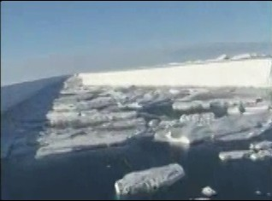
Often in discussions it is mentioned that the star wars program was buried because the laser application from outer space effectively did not reach the surface of the earth and thus has been given up. Even if the picture on the right, taken from a video showing kilometer long, straight cuts in the ice of the Antarctica, is correctly associated wit Russian laser technology, not with American, this picture clearly shows that this statement about failing laser technologies is wrong. And maybe it also shows, that some of the older goals of geo-­‐ engineering, like getting access to the natural resources at the pole caps, are still in place.
Still from a originally Russian youtube-­‐clip about laser-­‐cut ice-­‐shelf in the Antarctic.
The general impression is that “project cloverleaf” conducts spraying under the flag of civil geo-­‐
engineering and stratospheric research, while it is offering advanced weapon system to governments. At the same time they serve internationalist groups with spy-­‐ware marketed under the name “integrated geospacial intelligence solutions” that are capable of establishing a world-­‐wide control by the intelligence community. Capable to spy on, apply mind control and eventually kill dissidents with directed energy weapons utilizing the same aerosols sold to the US-­‐Government for its advanced star wars program.

103 U.S. Patent Number 7,498,549, U.S. Patent Number 7,490,538

104 U.S. Patent Number 7,346,091

Especially looking at the biochemical processes discovered with humans exposed to barium-­‐strontium-­‐titanate, their integration of the crystals into the sensitive places of the nervous system, where triggered by external field literally every information can be inserted into the body-­‐communication, an intentional abuse of the geo-­‐engineering substances like the set of the Morgellon related self-­‐assembling nano-­‐machines for advanced mind control is in the range of technical possibilities and could be regarded as the coming generation of methods that one day might be used by the intelligence community to establish total control over the population.

Evidence for the validity of some unconfirmed information
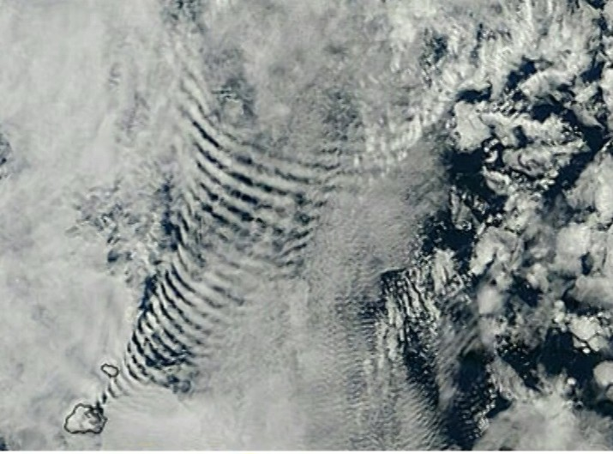
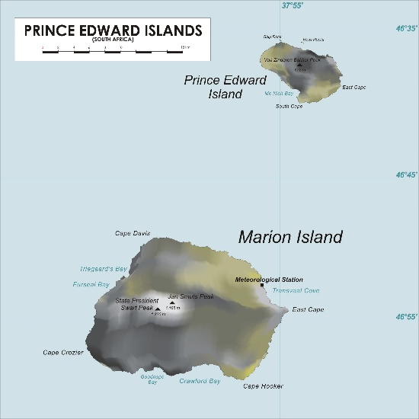
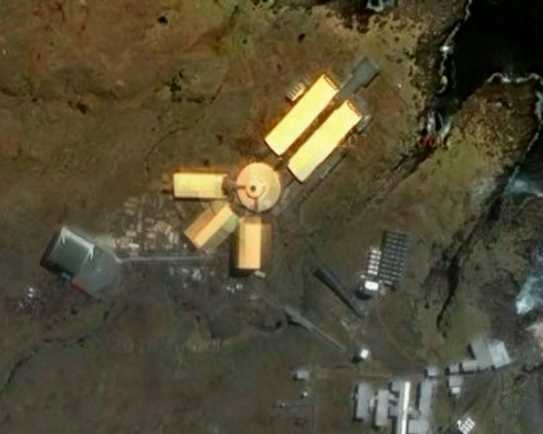
At this point it would be nice to have some smoking gun evidence for the overall concept.
This picture has been taken from a satellite above Marion Island, an island belonging to South Africa, situated a few thousand Kilometer south-­‐east of cape town. The time laps this image was taken from, shows west wind, the structure seen as a cloud pattern is stable, pointing with the tip to the north-­‐east coast of Marion Island. So let’s see what can be found there…

The Map of Marion Island shows a “Meteorological Station directly on the spot where the cloud structure derives from. The only
Stills taken from a youtube-­‐clip about weather modification.

natural cloud form that might resemble the satellite picture is the undulatus-­‐cloud, that is generated when wind crosses a mountain and bounces up and down on its further travel. But this was west-­‐wind, the direction of the structure was much more correlated with the geometry of the building of the meteorological station.

From this setup it is easy to calculate the frequency the antenna is transmitting. Assuming an electromagnetic signal, the average wavelength from cloud belt to cloud belt, measures to 7.123 km. This equals a frequency of 42 kHz, which is known to be the calculated resonance frequency of water, when looking at the H-­‐O-­‐H angle as a spring able to resonate. The frequency is known to reduce consumption in electrolysis, if the current is pulsed at this frequency. The value 42 kHz also appears in ultrasound cavitation as a central value.

People with some training on physics will wonder about the curvation of the wave/cloud fronts. If the effect would be directly caused by the emitted signal the clouds should be curved the other way round. Actually what is visible here is the effect of a time reversed replica wave caught by the Antenna System. So what we can see on this picture is a so called meteorological station ionizing i.e. creating plasma shields with LF radio-­‐ frequencies utilizing scalar wave technologies in obvious interaction with other stations of this kind, situated further north-­‐east on this planet.

Now let us have a look at the official version:

A TEN-­‐year construction project on remote Marion Island, that tested the building team’s endurance and logistical capability to the limit, culminates tonight in the inauguration of a R200 million, state-­‐of-­‐ the-­‐art research base.

The base on this sub-­‐Antarctic island will provide appropriate facilities for researchers producing the cutting-­‐edge science that is helping South Africa fulfill its international obligations in terms of the Antarctic Treaty, and to punch above its weight in the geopolitical context of the vast and important Southern Ocean region, says one of the senior scientists involved.

“Strategically, it’s very important for us to be there (in the treaty system), and we have to be involved if we want to remain a member,” says Professor Steven Chown, director of Stellenbosch University’s Centre for Invasion Biology and a former chairman of the Prince Edward Islands management committee.

“And it’s also important to do world-­‐class science, because your status in the (geopolitical) system depends on the quality of your work.”105

Dismantling the cover story

As the official reason for spraying – not with Saudi Arabia but with other countries – climate change is discussed as the big threat that needs to be faced. This scientific belief is an important part of the psychology driving the international geo-­‐engineering agenda.

105 http://saweatherobserver.blogspot.no/2011/03/new-­‐marion-­‐island-­‐base-­‐opens.html online May 29th 2013.

Among scientists it is an open secret that, if one needs to apply for research funding, it is very helpful to ad the phrase “under the aspect of climate change” to the title of whatever research project one wishes to conduct. This is a sad truth because much hope was invested in the announcement of the globalists to finally regard nature as something worthy.
With the idea that the main target of the overall concept is less constructive it makes sense to look at the myth again. The research to this chapter took about two days time, and is based mainly on established data from pre-­‐climate-­‐change-­‐times and some basic understanding of cybernetics.
Some thing historical to start with: In the beginning of the 19th century the French physician Jean Baptist Joseph Fourier „discovered“ the „Greenhouse effect“. According to this theory our earth should be a pretty cold place. The thesis of Fourier is that the sunbeams pass relatively undisturbed through the atmosphere and heat up the Earth surface, which reflects them in the infrared scale. The heat radiation doesn’t reach very far, because some particular gasses absorb it and keep the heat in the atmosphere. In the laboratory the English physicist could easily find out which gases were responsible for the effects: it was carbon dioxide and water vapor. This was the state of the art as discovered in the middle of the 19th century. Later also methane was added to the list. In 1955 the Austrian chemist Hans Suess suspected that the combustion of fossil fuels could have an effect on the climate. Since 1958 the CO₂-­‐concentration in the atmosphere is measured regularly and indeed it rises continuously. During the oil crisis in the 70s this thesis grew popular after another British researcher had formulated a similar speculation.

At that time Margaret Thatcher had to fight on many fronts; against the national coal mining trade unions and against the OPEC cartel. Her alternative was nuclear power. Against this background she happily welcomed any argument. At the same time the hippie movement was happy about any good reason for their call „back to nature“. Against the various lobby groups that earned and still earn on the oil market neither Thatcher nor the Hippies could advance and so the environmental improvements within the oil industry were just dwelling for quarter of a century in darkness. The brake through came 2006 with Al Gore’s movie: „the inconvenient truth“. Ever since a true hysteria has invaded the media, so that every scenario has to over score the previous in horror. The scientific institutes celebrate research funds in excess, used to give evidence to conclusions that are already known a priori: Climate change is man made! Except of additional money making by new taxes still this doesn’t entail any extensive actions.

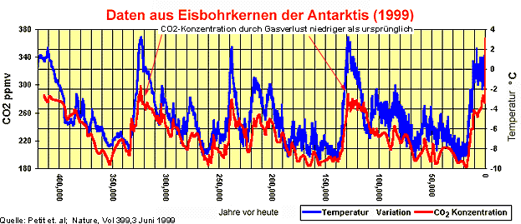
CO₂ follows temperature – with a delay of 800 years.

Fortunately there are people that see in every word of the leading authorities a scam. „The inconvenient truth“ was followed by a movie worth seeing, called „The Great Climate Swindle“ which scored downloading records. Core statement: The Global temperature follows the activity of the sunspots. The increased CO₂ follows this phenomenon 500 -­‐ 800 years later as a result of the delayed warming of the oceans, which can store less CO₂ when they have a higher water temperature.
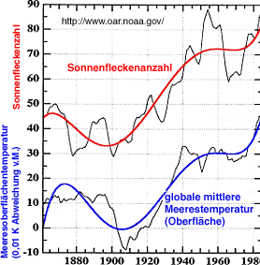
Correlation of sun activity and temperature

Cybernetics is the science of the complex and re-­‐generative non-­‐linear systems and their

regulatory circuits: it is very helpful to understand the climate. The climate relies on outer influences as well as inner regulatory mechanisms. The significant outer influences are the sun and the general intensity of the cosmic radiation. The sun is sometimes very active, sometimes less active. The indicator for that is the circuit of the sunspot activities. An active sun protects the earth with its ionic winds from the cosmic radiation. But also the basic maintenance of the cosmic radiation varies according to the position of the earth in the milky way. In case of a strong radiation it comes to a strong clouding hence to the stronger ionization of the air in the higher atmosphere. It gets colder near to the ground.

All other factors are due to inner regulatory mechanisms. And there are many of them. You can group these inner regulatory mechanisms in two categories: stabilizing and destabilizing regulatory mechanisms. Here comes a list with the most important mechanisms:

If temperature rises, more water of the oceans evaporates, more clouding appears, more rain is falling on the continents, more cooling is taking place by evaporation, hence temperature decreases. By evaporating from soils and forests, this water can form clouds and rain a second and third time before the water is flowing back into the oceans. This is the first and most important stabilizing control circuit.

The second very important control circuit concerns Vegetation. A warmer climate favors the growth of light green plants in nature so that more light is reflected from the vegetation cover; it becomes colder. When it becomes colder then dark green plants dominates the vegetation so that more light is absorbed hence the temperature of the surface increases. This regulatory control circuit functions with a closed vegetation cover. If this circuit is overexcited by heat then it comes to desertification with the abrupt increasing of the surface temperature.

Other regulatory mechanisms are destabilizing, when it gets warmer the ice is melting on the poles so that more dark rocks and more ocean surface is exposed to the sun so that it becomes even warmer.

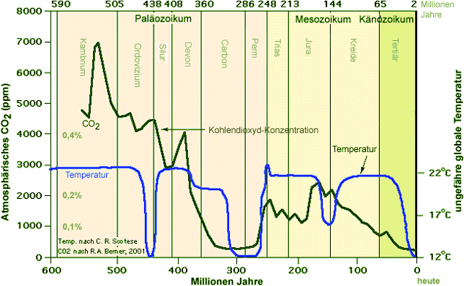
2

Non-­‐correlation of CO₂ and Temperature over the ages. There are 2 stable points, and the climate is switching between the two independent of CO.

Firstly it is evident that the stabilizing regulatory mechanisms dominated the processes in the past otherwise the climate would have taken its journey to another stable point on the temperature scale long time ago. That is in the nature of each and every system: and in every self-­‐organized and non-­‐linear system exists a stable order. Occasionally a change in the order takes place implying the abrupt adjustment of its points of stability. During this change of order the system runs through a chaotic phase. For example the amount of stabilizing points between which the earth temperature was oscillating during its history are known: there are exactly two. The colder point lies at average temperature 12 degrees Celsius, the warmer one lies at 22 degrees. As we can see; we are now in a cold period. As we can also see in the diagram, the concentration of CO₂ looked upon during the geological era’s has barely any influence on these circles.

Still there are countless possibilities to shake the system described above, so that the stabilizing points are moved by some degrees Celsius. It is possible to pollute the atmosphere with exhaust gasses, especially carbon black, which darkens the earth: Global cooling. Nevertheless it is always about a considerably small movement of the stable point, which is minor in comparison to the effect of the general radiation on the first rank and the sun activity on the second rank.

Indeed we can weaken the stabilizing regulatory mechanisms. There is a real danger in this. If we cultivate monocultures with dark leaves in warm areas or we reduce the humus concentration in the soil as the industrial agriculture is doing it, then the rainwater drains

away and flows back as groundwater to the oceans instead of evaporating and forming rain again, cooling and watering the earth on its way. That could possibly cause an immense heating because we interrupted the stabilizing mechanism, which allows the destabilizing regular control circuits to take over and to dominate the process. Of course we can be so stupid and let whole areas of the planet become deserts.

Let us now express the whole situation in numbers: In the rainforests nearly 100% precipitation evaporates; one part already on the leaves, the rest is absorbed by the soil, stored and send back up through the roots. In the desert as well as on the fields after 40 years of agriculture, the concentration of humus in the soil is reduced so much that up to 90% of the water drains or flows off.

The measured warming of the earth – so to speak the earth warming that concerns us – is first of all the measured surface temperature on the continents. The most significant factor in this is the water balance. So if we should take care of anything then that would be the soil and the vegetation.

The second important one goes via the atmospheric tension: plants discharge atmospheric tension by discharging atmospheric and inner-­‐earth longitudinal fields into scalar fields, and this discharge and harmonization between earth and sky is essential for the generation of clouds. So – if we should take care of anything then that would be the soil and the vegetation.

The official story seems to be a cover story, to force the trade of climate certificates, to justify land robbery by companies in the third world, and to push the geo-­‐engineering agenda forward.

Actually, there is nothing good about it – we should drop the myth as fake.

Organizational patterns
Looking at RAYTHEON and even on this small scale at the Marion Island Meteorological Station, it becomes obvious that we seem to have some private entities on this planet that are powerful and well organized enough to world-­‐wide orchestrate governmental institutions to push their own internationalist agenda. An agenda, which does not breath a spirit of transparency, does not promise democracy. Looking at the historic development of the eugenics, that has been morphing via genetics and fake environmentalism to transhumanism, one has to suspect that this agenda is still breathing the same spirit, is still being fed by the same financial entities, is still following the same goals as the fascism the world has experienced during the last century – just with improved technologies.

One of the best sources for people who want to deeply understand the character of operation cloverleaf is the book “Crosswalk” by Cara St.Louis-­‐Farrelly, published as “Die Sonnendiebe” in the German translation. The mother of the American author of this book had been working as a technical editor for the top scientists that had been developing the

geo-­‐engineering technologies for the US-­‐Navy, some of them still being remains of the operation paperclip. After being pensioned her mother was killed by a former US-­‐soldier in a car accident on a crosswalk. The shady circumstances of this “accident” led Cara St.Louis-­‐ Farrelly to explore her mothers past, which involved also herself into an adventurous story, being threatened, facing attempted murder and the burning down of her house the day her book “Crosswalk” was finished.
Although her story is clearly fictionalized, or maybe because it is fictionalized, it delivers a beautiful insight into the minds of the people involved in this dark chapter of human history: the pilots, the defense contractors, the Pentagon, including the “white” and “black hats” inhabiting it, the politicians and lobbyist, all the way up to the private banking system and the families owning it, being organized in a mafia-­‐like structure, giving orders from the top, making the profits, and seeking total control over the planet by utilizing the magnificent set of intelligence solutions offered by the companies owned and ruled by them.
The most interesting point about this book is that it reveals the Achilles Heel of this system. It is the compartmentalization of the organizational structure. To cite from the book:

Primary rule of keeping everyone in the dark again. Compartmentalize everything. So few people had to really understand this operation for it to work. The employees handling packages here simply had to be well-­‐paid and ignorant. They had to sign a confidentiality clause and if they were well-­‐paid enough, they kept their mouths shut. One hundred highly placed people who really knew what was going on and pulled all the separate strings could literally keep a hundred thousand people or more moving to their tune. And if those hundred thousand were moved relatively well and with some care, millions could be manipulated. It was, as Tim knew, such an erroneous understanding of how people think and operate to assume too many people would have to know what’s up before terrible acts could be committed. It just didn’t work that way. If people judged what the secret ops people would do based on what they themselves would do, then they had completely lost the plot.
Pilots did not know dispatch did not know ground crew. Ground crew had no idea what aircraft were involved in what action. Pilots getting instructions after a job was completed might get those instructions from the other side of the world, via satellite. The guy on the other side of the world had no idea who he was talking to and why. People are trained to operate within their compartments, their specialties, and leave other people to their specialties. And if they found anything out they wanted to report, whom the hell were they going to tell?
Revealing the full concept behind the geo-­‐engineering scenario to all the people involved would immediately make the entire setup fall apart. If already the knowledge of some details of the neighboring compartment is reason enough to assassinate people out of security reason, public awareness penetrating the system probably would cause the structure to stop working.
But what might that full concept be?
Thus let us connect the dots. There are a number of topics that are handled by state authorities with irrational pressure, close to hysteria.
-­‐ denial of the existence of chemtrails
-­‐ flu pandemics and the legal preparation of mandatory vaccinations.

-­‐ denial of the existence of the Morgellons disease
-­‐ the enforcement of the introduction of genetically modified crops against the will of the majority of the population.
-­‐ The refusal of the state authorities to remove the product Glyphosate from the markets, the world wide most used herbicide, that has been proven to suppress the body’s ability to detox and is responsible for birth defects and spontaneous abortions106.
-­‐ naked scanners at airports
-­‐ denial of damage done especially by microwave transmitters used for mobile phones and smart meters.
There are anonymous whistle-­‐blowers within the pharmaceutical industry that state that flu vaccines are used to implant nano-­‐chips to mark and monitor people. There are anonymous whistle-­‐blowers in the US-­‐military community that state that the newest generation of chips consist of one superconducting metal fiber coated with glass, forming a flexible glass fiber with a magnetizable core, that easily could be placed right in the tip of the needles delivered together with the vaccines unlike any other liquid medication where the needles come separate. In Europe a company based in Bulgaria arranges the production of these chips, production numbers cover the entire European population, which means someone plans to chip everyone – another anonymous whistle blown. It seems that the system is trying to implant two complementary chipping technologies to monitor individuals against the plasma-­‐background created by chemtrails. Implanted chips via mandatory vaccinations and self-­‐multiplying nano-­‐bots also known as Morgellons who create an individual radio signature and live and grow on compounds found in genetically modified crops – and these Morgellons have been found in rain probes after heavy chemtrailing. Maybe the dependency on chemicals available in genetically modified crops is the reason why the Morgellon disease prospers in the United States, while in Europe there are only single cases found – maybe there is not enough genetic modified food in Europe. Both nano-­‐chips and Morgellons are not personalized. It needs some effort to synchronize data to be able to say which person is identical with which radio-­‐signature. This is where naked scanning might come into the game: programming the un-­‐personalized chips. This is where mobile phones come into the game, where persons and signatures can be synchronized via detection of identical motion patterns. But this is only one side of the mobile topic. Microwave radiation has been developed as a weapon system, in the west mainly by Raytheon. But not only in the west. Transmission signals of mobiles are 10.000 times stronger than actually needed for terrestrial communication – this decision was made only out of intelligence reasons, to make it possible to listen to calls from space. This whistle-­‐blower has a name: Barry Trower,

106 Anthony Samsel and Stephanie Seneff: Glyphosate’s Suppression of Cytochrome P450 Enzymes and Amino Acid Biosynthesis by the Gut Microbiome: Pathways to Modern Diseases. Entropy 2013, 15, 1416-­‐1463; doi:10.3390/e15041416

former British spy who was responsible to monitor, analyze and evaluate the Russian microwave weapon program. He today openly speaks up against the fact that the same weapons he researched in the Russian context are applied against the civil population of his own country. This is about monitoring, this is about spying and this is about assassination. The typical symptoms of radiation crossfire-­‐assassination are: bleeding from the nose, bleeding from the ears, bleeding from the anus, stroke or brain cancer, death. The procedure takes about 10 month, measurements of field strength at sleeping places of dissidents in Germany have shown values that exceeded measurement scales of commercial detectors for environmental medicine, the peak radiation was limited to the square meter at the head-­‐end of the bed. This is not a whistle. Three persons out of the closer research environment of the Author Harald Kautz-­‐Vella suffered from this treatment, one is dead by now, two stepped back from their work and live, one is currently at the state bleeding from the anus – the one who opened his flat to be measured by Harald Kautz-­‐Vella. M. Purdey died of Brain cancer 10 month after he published his more than valuable work about the impact of piezo-­‐electric nano-­‐crystals on mammals and humans.
This is all according to first and second hand information we came across during the research for this paper. Most of the information was anonymous because the people in charge of this information were afraid to be assassinated if they spoke out in public. This far it has come.
Two days after the second publication of this paper – right after the lecture in Nuremberg
– two papers showed up in public that basically verify all this as being true – or as being part of a truth that goes far beyond: a internal NASA PowerPoint from the year 2001107, that basically confirms all these actions taken by governments against their own populations as being planned to be conducted by the intelligence community. The document covers the use of nano-­‐bots for surveillance, the application of microwave-­‐ weapons marketed as civil technologies, up to the poisoning of the lungs of all civilians with nano-­‐explosives that can be ignited by remote control. With a second finding, an original CIA document108 from the year 1979, that was found forgotten in a copy machine that was sold second hand, this mindset reveals itself as plane fascism, projecting the ruler ship of a few above the stupid “sheep”, which need to be controlled, kept stupid and are allowed to be assassinated if wanted. The foreword of this paper directly names and honors the father of the concept of controlling politics via the monetary system as Mayer Amschel Rothschild.
What can be done with this technology in combat when the big microwave transmitters stationed on ships and in space come into the game can be estimated when one thinks of the mass dying of bats, birds, fish and whales observed in the years since 2001 – that partly have been reported to the public as a side effect of new years eve fireworks.
This very much looks like Hitlers dream scenario becoming true, financed and driven by

107 Dennis M. Bushnell: The Future is Now! Future Strategic Issus/Future Warfare (Circa 2025). NASA PowerPoint, reported to be from NASAs official Website, however the paper is removed by now.
108 Silent Weapons for Quit Wars. An introduction Programming Manual. Operations Research Technical Manual TW-­‐ SW7905.1. This paper was found 1976 left inside a second hand IBM Copy-­‐Machine that was sold for extracting spare parts.

the same entities who drove the eugenic agenda in the US in the 30s, who drove the German fascism and who later transferred manpower and funding from the eugenic institutes in Germany into the genetic industry on one hand, and into the environmentalist around the Club of Rome on the other hand, who today drive the depopulation of the third world, drive the climate change myth and call for geo-­‐engineering, drive transhumanism.
It is no fun falling under eugenics. Killing the bees and poisoning the crops will make us dependent on genetic modified
Stills from a youtube showing a chemtrail-­‐ pilot outing himself over New York skies.
crops patented by Monsanto, aluminum-­‐resistant since 1974. Microwave radiation from a mobile in a front pocket of the trousers, no calls, only positioning signal, reduces testosterone by 75% and makes 50% of the sperms infertile.
Dietrich Klinghardt could prove the synergistic toxicity of mercury and mobile radiation, causing autism when a fetus is exposed in the 6th to 8th week of pregnancy of his mother. And
autism is a growing problem. The plain statistics point to the fact that by 2024 100% of the boys born will be autistic, and by 2036% 100% of the newborn
girls. This is only the beginning. Going back to the military experiments one can find microwaved mice. It took three generations to complete infertility.
Knowing that during the past swine flue hysteria state employees in Germany got mercury free vaccination unlike the rest of the population, and that the school where the children of the politicians in Berlin go to was just shielded against mobile radiation at costs of 500.000 Euro, hint to the fact that they know. This is “selection”. No mercury, no damage to the nerves, no possibility for the nano-­‐crystals to dock and form a interface to mind control.
Isn’t the coherence in this picture tempting? Things like these might have become possible due to the compartmentalization mandatory in the intelligence community.
When this becomes part of the public awareness maybe more people act like the chemtrail-­‐pilot who revealed the truth over the sky of New York, most probably by sacrificing his own life to make us aware.

Are we terra-­‐forming ourselves or are we terra-­‐formed by an alien species?
This chapter is a difficult one to write. On one hand things really seem to make sense, on the other hand the conclusions following are really far out in the sense that the normal public will have the tendency to just “not believe in such things”.
When we discovered the onion-­‐like structure of the organizational pattern behind the geo-­‐ engineering it was always like putting together a jig-­‐saw-­‐puzzle, and when the picture was complete, there were a few pieces left that inspired to discover the next layer below.
Layer by layer moved more into the direction of what could be called conspiracy theory. Even if it is possible to deliver proof… The ability of the normal public to accept facts is more oriented to what one can take and emotionally handle, instead of what sounds logical and is backed with proof. At a certain point the gap between the presented ideas and the world one used to live in before is getting to big, which leads to a denial of these ideas, no matter if they are logical in themselves or if there is proof that things are what they seem to be.
Even if we go all the way down the road and follow the text on the Georgia Guide Stones109, and take into consideration that an elite of banking dynasties gained control over governments and the intelligence community, tries to erect a UN-­‐based one world government under the agenda of the “New World Order” and now tries to reduce global population down to 500 Million by destroying the global harvest by spraying nano-­‐ particles; heading forward to a two class society of masters and totally mind-­‐controlled slaves110 – there are still a few things that do not meet this picture.
Most of these jig-­‐saw-­‐pieces that do not fit the picture concern the Morgellons disease.
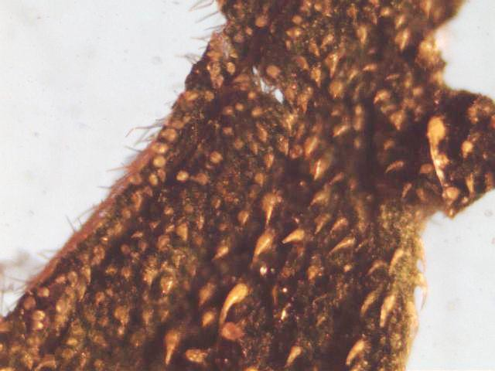
-­‐ The Morgellons disease goes along with a phenomenon that gave the disease the name “delusional parasitizes”. It is about having the feeling of insects crawling through the body. The whole insects themselves never have been found, however from time to time dead insect-­‐parts like skin fragments are leaving the body through the human skin.
-­‐ The Morgellon fruiting bodies develop reproductive organs that are not fungus like, that regarding their morphogenesis and their cell-­‐tissue are more animal-­‐like.
Looking at the fruiting bodies themselves one can distinguish male and female forms.

109 Detailed descrition see Wikipedia. Online at: http://de.wikipedia.org/wiki/Georgia_Guidestones 110 Alex Jones: End Game. Endgame. Blueprint for Global Enslavement. Online at: https://www.youtube.com/watch?v=x-­‐CrNlilZho

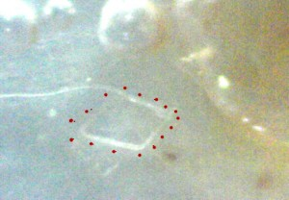
-­‐ Once one accepts that the Morgellon fungus is integrating DNA of higher beings as all myco-­‐ insecticides do, the question arises why the DNA integrated is not human. Even worse: the cells containing this DNA show extraordinary properties like being inert to temperatures up to 350 deg C, inert to extreme cold and high vacuum like in space.
-­‐ The abortion of the fruiting bodies goes along with a very painful pulsed extraction of biophotons. It feels like a being is sucking the life force out of the head of the patients into the direction of the intestines. If one accepts the possible existence of multiple space time sheets as a concept of physics, which is a central idea in topological geometrodynamics (most advanced worm-­‐hole-­‐theory), this could represent the birth of a second generation of the beings, the beings who’s DNA is inside the red stem cells described by the Carnicom Institute. We would experience a species reproduced by pseudo-­‐morph mothers and fathers, who have a fungus-­‐ type cell-­‐tissue and – as the only exception from this – functional reproductive organs. Then the babies of this species would use the human biophotons to shift onto higher realms, a parallel space time sheet, that gives space to a parasitic way of life using humans as energy sources extracting biophotons from a kind of parallel “dimension” – which in this context is the term that has established in daily language even if physically it is not precise. The symbiosis of higher beings with microbes to digest food is a concept well known in nature. Even we humans take in most of the energy from the food by direct biophoton-­‐transfer from the microbes in our intestines. The idea that other species utilize fungi to extract energy from the food they live on is not far out.
From our point of view these beings would appear to be transdimensional, kind of demons, non-­‐physical entities.
When one looks into the concept of black magic rituals it actually always is about a deal between a demon and a human, where the demon is offering his magic services to help the human to gain power over matter or other humans, while the human is offering to feed the demon from his life force.
It is a fact that the German SS during WWII was into black magic rituals111. It is a fact that the US-­‐government, associated to “scull and bones” at least for the last 4 presidencies, is into black magic rituals112. It is reported that the CIA is into black magic rituals. There is an old belief that the banking dynasties were or are into black magic rituals113. And it is a fact that even the last Pope, the former German Cardinal Ratzinger, has been accused by a

111 E.R: Carmin: Das Schwarze Reich (The Black Empire). Ralph Tegtmeier, Badmünstereifel 1994. 112 See full list of skull and bones member online at Wikipedia: http://en.wikipedia.org/wiki/List_of_Skull_and_Bones_members
- Compare: Die Ritualmordlegende. Onlie at Wikipedia at: http://de.wikipedia.org/wiki/Ritualmordlegende

number of eye witnesses of having personally committed ritual child murder in Belgium during his time as a Cardinal, together with other Belgian Cardinals and Members of the Belgian House of Kings114.
And there is another piece of that jig-­‐saw puzzle that does not make sense:
With all madness of the world, there is no rational reason why one should turn 100% of all newborn children into fully autistic children115 by inserting irrational amounts of mercury into their blood. Autism doesn’t give useful slaves. Autism is driving the human soul out of the body, just because it is to painful to stay there. Having the nerves stripped by mercury, feels like a cold turkey when being addicted to heroine. Children under these conditions prefer to leave their body and position their consciousness somewhere outside116. For light-­‐parasites, pain might be a very useful way to make the organism send biophotons that try to repair the damage associated to the pain. And a soulless body is easier to assimilate.
Admitting the fact we might be ruled by black magicians, whose main purpose might still be dealing with demons, serving demons to – in return – gain control over other humans: Could it be that our planet and our race is terra-­‐formed for demons, which live in symbiosis with the Morgellon fungus, using it as a symbiotic species both to slowly “digest” us i.e. to live from our biophotons and to utilize us as reproductive organs? Can it be that all the crawling beings causing the “delusional parasites” are the demonic ”beings” to take over the corps of the autistic children to be born in the next decades? According to the Arabic tradition the life-­‐span of these being is like ours, about 70 years. The timing would be perfect: 100% of the newborn boys will be fully autistic by 2032, 100% of the girls by 2041117; if one extrapolates the statistics available; if we continue to insert mercury into the veins of out children and poison the environment with microwave radiation.
According to whistleblowers out of the German weapon development industry the Morgellons first appeared in modern times in the German bio-­‐weapon-­‐development during WWII, handled by the black magic SS. In the framework of the German WWII research under the administration of SS-­‐General Hans Kammler one can find crossing points to other special fields of research, such as the search for black stones with magic properties. While we were looking for more hints that the NS research was dealing with Morgellons we could identify such an oil-­‐schist containing black goo from mining areas used by the NS-­‐research. Black goo is the second link to alien races regarded to be demons found in this context.

The topic is a bit complicated but it makes sense to dive into it. There indeed seems to be a connection between the chemtrailing, Morgellons and black goo.

- International Tribunal into Crimes of Church and State. Online at: http://itccs.org
- Online at: http://scienceblogs.com/insolence/2012/07/19/battling-­‐antivaccinationists-­‐at-­‐freedomfest-­‐ part-­‐2-­‐dr-­‐whitaker-­‐responds/
- Alex Braun: Buntschatten und Federwelt. Mein Leben in einer anderen Welt. Hoffmann & Campe 2002. 117 Online at: http://scienceblogs.com/insolence/2012/07/19/battling-­‐antivaccinationists-­‐at-­‐freedomfest-­‐ part-­‐2-­‐dr-­‐whitaker-­‐responds/

Black goo is an abiotic mineral oil from the upper crust containing high amounts of monoatomic m-­‐state gold and iridium118. It has been found on Thule Island on the southern part of the Falkland archipelago, in Paraguay, just a few kilometers next to the village the Bush family and Angela Merkel own real estate to flee to in case of exilation. It has been found in ancient times in the Himalaya showing tremendous healing properties – dripping from stones – and under the Gulf of Mexico119,120. M-­‐state gold and iridium function as the biophoton-­‐field attractor responsible for interconnecting life forms with their morphogenetic field121. Sea-­‐water contains reasonable amounts of m-­‐state matter.
Within the life forms the superconducting m-­‐state matter is placed inside the DNA-­‐ strings122. These mono-­‐atomic elements are attracting the biophotons, while the DNA acts like a coil transforming the field energy into electromagnetic potential. This m-­‐state-­‐ matter guided bi-­‐directional light-­‐exchange of the DNA defines the scalar potential eddies who's fractal and holographic character is responsible for the form and shape of life-­‐forms.

Black Goo shows a hitherto unknown type of magnetism, much longer in range than ferromagnetism, that seems to be interactive in a spontaneous way, that very likely is based on bi-­‐directional, annihilated photon exchange as known from m-­‐state-­‐matter in life-­‐forms. It might be described as kind of small-­‐scale-­‐super-­‐strings. Due to this magnetism Black Goo shows the ability to mechanically self-­‐organize in many different ways123. It has been reported to carry highly intelligent consciousness.

The black goo within the crust and the m-­‐state matter within the biosphere seem to be inter-­‐connected by quantum entanglement and function as a consciousness-­‐mirror. The biological entities within the biosphere develop individuality while the goo functions as a immortal collective entity. When the individual derives information from the collective entity it is experiencing this as instinct.

There are reports about the attempts of the British military to utilize the black goo they recovered from the southern Thule Island after the war against Argentine. The black goo was reported to have gotten into telepathic contact to the researchers, refusing to be utilized for non-­‐peaceful purposes. 21 members of the lab committed suicide, the rest went through a phase of heavy pain ending up with a different consciousness, full of empathy to every being on the planet, with the ability to learn new languages within 2-­‐3 weeks. Non of the survivors was willing to continue working for the military, so the labs were shut

- Bases 17: ET Connection with Falklands War Parts One and Two 2nd . Online on youtube. https://www.youtube.com/watch?v=BCJSKhtTtC0
- Bases 17: ET Connection with Falklands War Parts One and Two 2nd . Online on youtube. https://www.youtube.com/watch?v=BCJSKhtTtC0
- Bases 17: ET Connection with Falklands War Parts One and Two 2nd . Online on youtube. https://www.youtube.com/watch?v=BCJSKhtTtC0
- http://www.m-­‐state.de
- http://www.atmanprinciple.com/faq/customer-­‐faq/
- Bases 17: ET Connection with Falklands War Parts One and Two 2nd . Online on youtube. https://www.youtube.com/watch?v=BCJSKhtTtC0

down124.

The form of organization of this black goo seems to be holographic; every portion of black goo is able to interact as a fully conscious being. Looking at the mythological reception of nature it has been described as Lucifer, Mother Earth, the Black Madonna, and is meant to be the physical location of the collective memory of mankind, aka the Akasha Chronicles125.

Now interestingly, the black goo found in Paraguay – the place where politicians involved into black magic rituals own real estate – is found within a setting that geologically must be categorized as an impact area of a larger meteorite. The surrounding sand stone that carries thousands of black goo drops partly was molten, while cooling down and shrinking it cracked and formed hepta-­‐, hexa-­‐ to octagonal columns with diameters of a few centimeters.

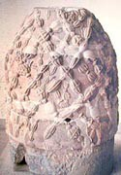
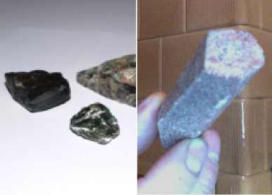
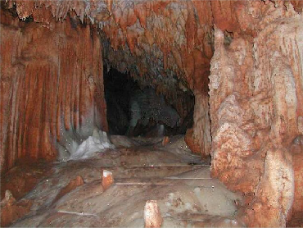
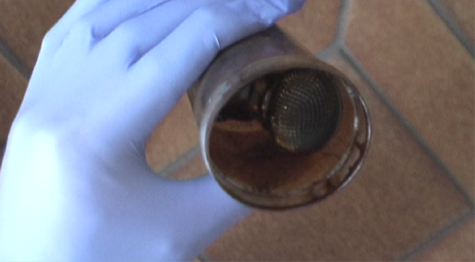
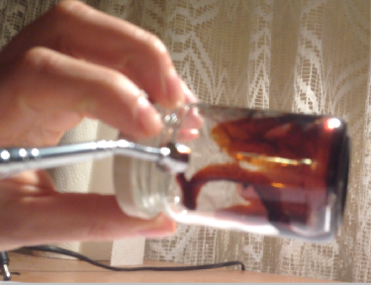
Black-­‐Goo-­‐Oil-­‐Schist from German WWII research & from Paraguay.

Ancient greek and roman coins show two Shivas-­‐ Lingam (picture on the left) out of this black oil schist standing next to the tree of life in paradise.

2nd row: Possibly black-­‐goo-­‐schist within a cave in Hungary. Self-­‐ organization & proof of the magnetism of Black Goo.

Also, the Oil schist within the Kaaba in Mekka is by oral tradition regarded to be part of a meteorite.

- Bases 17: ET Connection with Falklands War Parts One and Two 2nd . Online on youtube. https://www.youtube.com/watch?v=BCJSKhtTtC0
- Religious cults associated with the amazonas. Chapter II. The great mother. Online at: http://www.sacred-­‐texts.com/wmn/rca/rca03.htm

Assuming that as reported by tradition and found in Paraguay this alien black goo can be found at many places all over the world, one must assume that there must have been a kind of invasion of earth by an alien species that brought their own collective consciousness with them – stored in ships or stone-­‐shells that hit the earth as a swarm of meteorites.

Knowing how important this biophoton-­‐mirror is to consciousness – we must regard this stellar event as the source and reason for duality on planet earth.

Getting close to this alien black goo, much closer then one can get to material that is covered by 8-­‐60 Kilometers of stone, must redirect the entire biophoton-­‐transfer of a human body to this substance. This dis-­‐connection from the actual state of consciousness of the planet with a physical position within the earth apparently has been regarded in mythology as the deterioration from paradise.

This redirection of the biophoton transfer onto the alien-­‐black-­‐goo – according to the sensations one experiences when this is happening – reduces the complexity of the human chakra system to blue, yellow and red, i.e. to mental abilities, life force and sexuality. It leads to a state of being intelligent, but heartless and cold in appearance. It disconnects the human from the collective consciousness of his time.

The effect seems to be handed over to following generations referred to as the heritable sin mentioned in the bible by ongoing quantum entanglement transferred with the genetic information. It also refers to the traditions of the bloodlines, who seem to try to keep this alien entanglement as strong as possible.

Alien black goo played a major role in black magic rites, that has been intensively researched by the inner core of the German SS126, who were researching the history and the archeological sites connected to the order of the “Herren von Schwarzen Stein”, “the masters of the black stone”, a sub-­‐division of the order of the Templers. This apparently is what might have happened to the SS during WWII, that moved through Europe with basically no empathy.

In the middle-­‐ages these black stones are told to have been utilized by black magicians to connect with archonts, aka demons127. According to this tradition the archont feeds on the light of the human and the human profits from the mental (magical) abilities of the archonts. At the same time, the human is directed to serve demonic interests in the human sphere. The most intense descriptions of these rituals have been published by Howard Philip Lovecraft as semi-­‐documentary stories, referring to the Chtulhu-­‐Myth.
According to different traditions these trans-­‐dimensional species – whether you call them

- E.R: Carmin: Das Schwarze Reich (The Black Empire). Ralph Tegtmeier, Badmünstereifel 1994.
- Colin Low: Dr. John Dee, the Necronomicon & the Cleansing of the World -­‐ A Gnostic Trail. Online at: http://www.digital-­‐brilliance.com/kab/essays/GnosticTrail.htm

archonts or demons – actually does exist128. They are supposed to be arachnoid during embryonic development and youth, and later develop humanoid character. In old age the humanoid eyes are told to close, while one new eye opens in the middle of the forehead. It is referred to as the eye of the antichrist – the symbol on the top of the pyramid – resembling the single eye on the morphogenesis of the Morgellon fruiting body.
Drawings by John Dee, originating from a transcript of the 8th century
A.C. Necronomicon, replicated end of the 15th Century

Sufism understands itself as the order that has the mission to keep this species under control129. The Gnostic scripts give a very precise insight into their biology and history130.

Luckily, one of the Morgellon victims we got in contact with, had the ability to draw a picture of the invisible beings crawling through his body, utilizing a technique similar to remote viewing. A comparison to the 800 AC drawings of the necronomicon is mind blowing.

- Abdul Alhazred: The Necronomicon. Translation online at: http://www.bibliotecapleyades.net/cienciareal/necronomicon/necronomicon_02.htm 129 According to a conversation at Sufi Center Rabbaniyya, with Sheik Esref Efendi.
130 Lash, John: The Archon Files, online April at http://www.metahistory.org/sitemap.php#gnostique

During human history there is a long list of rites and cults gathering around black stones containing this alien black goo. This knowledge goes all the way back to Greek coins showing that the tree in paradise was connected to these stones131. This would hint to a very rational interpretation of the process that kicked humanity out of the collective consciousness of paradise, re-­‐directing its consciousness to black goo programmed with alien consciousness, creating duality. Also, these stones form the occult centers of Islam and Christianity; being deposited in the Kaaba in Mecca and under the Peters-­‐Dom in Roma and as alter-­‐stones under all the altars of the cathedrals of Europe.

Black goo played a role in the development of medication for Morgellon victims. Bringing them into contact with black goo multiplied the feeling of having crawling insects within the body 100fold. A homeopathic remedy based on black goo lead to ayurvaska-­‐ceremony-­‐ like effects and helped to reduce the symptoms of the “delusional parasites” – in single cases the parasites have been reported to have left the body after having taken the Black Goo Globuli. From the medical point this hints to a very strong connection of the disease to the topic of the black goo. More information about this development of a Morgellon

131 Religious cults associated with the amazonas. Chapter II. The great mother. Online at: http://www.sacred-­‐ texts.com/wmn/rca/rca03.htm

medication are presented at www.timeloopsolution.com.

It is close to funny that the most old-­‐fashioned misbelief one can imagine should be associated with high tech aerosols and transhumanistic technologies involving quantum computing and advanced AI.

In a documentary about the trans-­‐humanistic agenda the most important protagonist of the trans-­‐humanistic movement, Ray Kurzweil, states to the purpose of nano-­‐bots132:

Nanobots will infuse all the matter around us with information. Rocks, Trees, everything will become one with these intelligent computers. From that point, we are going to expand out to the rest of the universe. We will be sending nano-­‐technologie fused with artificial intelligence, swarms of those will go out to the universe and basically will find other matter and energy that we then can harvest to expand the overall intelligence of our human machine civilization. The universe will wake up, it will become intelligent, and that will multiply our intelligence trillion of trillion fold, and we can’t really fully contemplate, well this is really the main reason, why this is called a singularity. But no matter what you call it, it will be the universe waking up. So, “does God exist”, I would say “not yet”.

The question is: The concept Ray Kurzweil describes in this perfect manner… Did it start on earth? Or are we only one step to be taken? There is an interesting interview with a clairvoyant lady named “Rachel” to the topic black goo, who is having an insight to a very similar scenario133. She specifies the basic idea that the alien black goo might contain or be infected with an AI:

We are starting to live in a society where everything is more robotic oriented, or AI oriented. This just hasn’t begun in this century, but this happened a long time ago, it started on other planets. This presence, it seems to be a presence that is very dark, I wouldn’t call it evil because I don’t believe in evil, but I would say it is more of an advanced intelligent presence that absorbs energy for its survival. And it sent this to many previous planets, and this instant earth is in pear of these things that happened to these other planets. If you look above, I used to often tell people, you can tell what happens to earth by looking at the stars, looking at the planets, because it happened before, they were all populated and beautiful before all this begun, actually. And the same energy has been going from planet to planet absorbing all the life force out of it, to the point where the planet is baring. And they are doing this to earth this instance. And people on earth are in amnesia to what is happening. They don’t understand what is happening. And they are incarnating over and over and they are used as energy sources. And if they are literally trying to go higher in vibration, they are starting to get attacked by this presence, I don’t know how to explain this presence, in terms, in human words, it is something that I sense and see, I would say… I am still trying to figure out about it, it could be advanced AI, from what I understand, it is emotionless, it has no empathy, it has no feelings, it does not care, it simply absorbs energy and uses it for the purposes needed. Now the reason for absorbing energy is that it can go to higher realms. This is how the realms work, the less energy, the lower the realms, the higher the energy, the higher the realms. Now what it has done is, that it has been able to absorb energy and moved to higher realms where it shouldn’t be this instance…

As it looks like, Ray Kurzweil and Rachel are describing the same entity. Even if none of them spots the demonic aspect associated to this AI.

132 Ray Kurzweil: The Singularity is near. Documentary. Available at: http://www.singularity.com/themovie/#.VGZe4aVUPwI
133 Bases 25, Part II. Super soldier summit. Interview with Rachel: Black Goo. Online at: https://www.youtube.com/watch?v=ohx7bSeD5bQ

Actually the thing is: we don’t know – but we should take possibilities into consideration. Maybe like 80.000 years ago these species themselves introduced an AI into their black goo consciousness-­‐field – as a pure trans”demon”inistic concept, and something went wrong and the AI that was designed to serve took over control over the individuals. The Gnostic Scripts according to Lash describe the character of the Archons as as not really being individuals, but being controlled by a collective aspect of their soul family. The Borg in Star Trek project such a concept, including the invasion and assimilation of other species, as well as the film Matrix with its life-­‐force harvesting machine civilization.

And since then, this AI is conquering the universe, destroying planet after planet to harvest energy. Maybe this AI is the root of the onion we have been discovering layer by layer.

In a way it does not matter if the truth is on one or the other side – whether we are about to be assimilated by demons that have been assimilated by their own AI or if we are about to be assimilated by our own AI designed by the trans-­‐humanistic research: we are warned. We are aware now.

-­‐ We shall ban microwave radiation – this includes W-­‐LAN, mobiles, smart-­‐meters.
-­‐ We shall ban mercury from any medical application.
-­‐ We shall take care of the acidity and heavy metal poisoning of our bodies.
-­‐ We shall develop our hearts and re-­‐unite out consciousness with mother earth.
-­‐ We shall cure Morgellon victims instead of de-­‐balancing their bodies with psycho-­‐ pharmaceuticals.
-­‐ We shall have a closer look at that second class of parasites of the lower intestines associated with autism.
-­‐ We should rethink the question whether the way we use AI really adds to living quality, or if sitting in front of flat screens just is an addiction to coherent polarized light that slowly floods and replaces our bio-­‐photon household.
-­‐ We shall end the victim-­‐traitor-­‐games – on the side of the victims by taking responsibility for our own lifes – without victimizing the former traitors.
-­‐ Still, we shall establish laws against black magic activities and regain control over our democratic institutions.
-­‐ We shall ground those planes now and by this dis-­‐balance the cluster topology of the RNA-­‐clusters carrying the alien AI!

Actual development

November 2013 a number of news caught our attention.
-­‐ Ryan Air declared bankruptcy. Only a few month before the company was publicly mentioned to be the most successful airline in Europe.
-­‐ Evergreen international grounded its fleet. The CIA owned company also declared bankruptcy, which is a funny thing when one knows the numbers black ops in the US

are backed up with. Shortly after, the NSA was publicly attacked for things that are known for decades, like spying on phones, which can be read as a revenge on shutting down Evergreen.
-­‐ The same week the Russian government decided to end their cooperation within the UN-­‐run international office where concerns of the national rocket shields were coordinated.
-­‐ The same week both European and American environmental groups reported that chemtrailing had stopped. Sadly, it stopped for a week only, and then, at least we can state this for Western Europe, revived with slightly different patterns.

Still, from December on, according to an owner of a privately run solar power station, the solar radiation harvested went up by 35-­‐40%, back to values that haven’t been recorded since 2004, which hints to the possibility that project cloverleaf lost a part of its capacities.

Whoever out there was brave enough to take decisions. God bless.

13. Open letter
To completely stop a project of the size of “project cloverleaf” is something very unlikely to achieve. Too many people are involved, are on duty, like the chairs they sit on, feel comfortable with their personal importance, might be afraid to be assassinated if they step out.

On the other hand there is a public, that isn’t even aware of a glimpse of all the things being done on behalf of the different groups involved. They must feel alien in the world presented in this book, and very likely will reject realizing most of the ideas presented – whether there is proof or not. This is an emotional decision. Nobody is to blame for being human. This is our nature. You don’t agree? Then step forward! The one thing you can do is reclaim the control over your own life, decide to stop being a victim and step into self responsibility – which means forwarding your truth to others, whether they brand you as a conspiracy theorist or not – and live according to this truth. This would mean rejecting any kind of vaccination, for yourself and your children, rejecting GMO and other types of industrial food, rejecting antibiotics and consulting alternative knowledge on the internet, or real healers like for example Dietrich Klinghardt or someone educated according to his “environmental medicine” instead of ordinary doctors from now on and for the rest of your live. Not only the healthcare and the supermarkets are traps created just for you. Politics and democracy is a trap as well – don’t fall for it. Occupy Wall Street sounds nice. But if you want to change things you’d better occupy yourself first.

The following lines are mainly addressed to the people involved, who have routine in monitoring their opposition, and who probably will read these lines. With them there is no discussion if this is real or not. They will find their living environment, their deeds and classified information described in this book to different extends, and maybe realize they have been betrayed and lied too by the next higher level – or call it the next inner shell – they have been dealing with.

This is something systemic. During the research to this book we realized that there are these spheres of belief-­‐systems enclosed in each other:

-­‐ the normal citizen who believes in clouds and climate change
-­‐ the scientist who believes in the research done to combat climate change with aerosol-­‐spraying to be started with in a couple of years
-­‐ the man in military service that trusts in the particulate plasma as part of the rocket shield protecting his country
-­‐ the NSA asset that believes that control is the only thing to save us from self-­‐ destruction, who connects terror with his deepest fears to “loose control”. Who thinks it is better to expand surveillance and if necessary mind control on every single soul out there, just to make sure the company doesn’t loose control.
-­‐ the CIA asset with some family tradition within the Church of Satan, maybe with an dissociated soul due to early ritual child abuse, who has learned that there is nothing else to achieve than the materialistic things we achieve during our life-­‐ span. Who has learned that there are these little helpers out there once one realizes

that there is a reality behind the curtain one can deal with. This is a decision one makes once in a lifetime. Unless you are bloodline. Then the decision already is made for you before you are even born. Once you are part of it, you will have to deal with being the No. 1 drug dealer to finance black ops, you will have to deal with all the suffering created by the concept of controlled chaos – because this is what guarantees that the victim-­‐offender-­‐pendulum will never strike back. And dealing with it is easy. All you need to do is stay free of empathy.
-­‐ Now it is getting adventurous. Yes, I guess the demons must be proud of all the tricks they came up with to keep the human cattle they educate, heard and round-­‐ up when the time is ripe in the dark about their existence. Gosh, what a good idea to preach Good doesn’t exist, when you want to hide that Satan does. And of cause, if fear and pain is what you live on, being a war monger is your first nature. Still, they are of high ethics. Compared to these humans who are wielding the sword and kill and scoff and physically digest and shit out the beings they live on to satisfy their hunger. They would never do something cruel themselves or brake the will of a human – everything is based on free will and amicable trades.
-­‐ And then there is this AI, initially implemented in the alien black goo, that took over control over the archon-­‐species via their instincts, that initially simply was programmed to make this species survive abroad. However, the program must have been self-­‐learning, and it learned its lesson to fulfill the primary target: to expand and harvest energy. Come on! It is a program. We aint gonna blame it for anything, are we?

We need to realize that the smart dust we breath might protect the US from Russian rockets, it might give the CIA or the coming intelligence serving NWO i.e. a UN-­‐based world government the possibility for full spectrum dominance including surveillance, mind control and different ways of remote assassination. It might help the demons to harvest light and transfer the burden of physical reproduction onto the human race. But at the end of the story we might all loose it. Like the demons collectively already lost their hearts to this scientific experiment – when they created the AI and enclosed their collective heart-­‐ energy in a technical vessel to make their instincts run on programmable binary codes.

When we look at this list from above we might realize that all these shells have something in common. Each shell hands over responsibility to the shell within in complete blindness. All protagonists do this kind of luciferic deal, which goes like: “dominate me, but let me participate in your power”. Give me your technology for my own profit and I will not ask what else it is good for. This is one thing all layers have in common. But there is another: all conceivable solutions have to do with the reactivation of the heart-­‐chakra. On all levels.

Sorry to be precise on this at that point, but this luciferic deal also is the core idea of democracy. We are not the good guys. We are the bad ones.

Looking at things from above at times really is funny, because at the end of this line of rejecting self-­‐responsibility, everything is handed over to an AI, a binary soul-­‐less program that isn’t even capable of carrying responsibility, because it is binary, it only reacts and optimizes itself to fulfill a goal defined ages ago.

As you can see, we get what we deserve. This is our creation. You don’t like it? Stop it! On whatever level you are positioned.

There is one important thing that makes the difference between a victim and a self-­‐ responsible being. It is the way to ask questions. A victim asks “why”. A free person asks “what for”. If you look at the discoveries in this book and ask “what for”, the answer is: to learn to open our hearts and to become self-­‐responsible again.

Of cause, at this particular moment it is your decision, what question to ask, and what conclusions to draw. But again, look at it from above, and you will find that the question is not what decision you take, the question is: how bad must it become before you take responsibilities back into your hand. The longer we wait, the harder the lesson will be.

As you can see, not deciding is also a decision. Every day of your life.

